Title page

Acknowledgements

Declaration

I hereby declare that the presented thesis is my own work and that I have cited all sources of information in accordance with the Guideline for adhering to ethical principles when elaborating an academic final thesis.

I acknowledge that my thesis is subject to the rights and obligations stipulated by the Act No. 121/2000 Coll., the Copyright Act, as amended, in particular that the Czech Technical University in Prague has the right to conclude a license agreement on the utilization of this thesis as school work under the provisions of Article 60(1) of the Act.

In Prague on 12th May 2014 . . . . . . . . . . . . . . . . . . . . .

Abstract

Hlavním cílem této práce je navrhnout levné způsoby jak získat data, hlavně číslice, z pacientského monitoru pomocí kamery v reálném čase. Navržené přístupy by měli být nezávislé na typu a značce monitoru. Každý z těchto přístupů bude dekomponován na jednotlivé kroky, jako jsou: předzpracování, segmentace, výběr kandidátů, klasifikace atd. Pro tyto kroky budou zmíněné různé metody a bude ukázáno jejich použití přímo na snímcích pacientského monitoru. Další částí je implementace jednoho z těchto přístupů, s vhodně vybranými metodami, jako samostatnou aplikaci v programovacím jazyku C#. Aplikace vyextrahuje numerická data ze zachyceného pacientského monitoru a klasifikuje je, pokud to je možné. Také se bude umět vypořádat s běžnými situacemi které mohou nastat v pokoji kde je pacientský monitor umístěn jako zakrývání, změna světelných podmínek nebo jemné pohyby s monitorem. Po samotné implementaci bude aplikace podrobena testům pod různými podmínkami a budou diskutovány možná rozšíření jako extrakce křivek nebo více kamerový přístup. Na začátku zmíním všechny aktuální možnosti pro získávání dat z pacientského monitoru.

Klíčová slova: pacientský monitor, reálný čas, sběr dat, kamera, OCR

Abstract

The main goal of this thesis is to design low-cost approaches for data acquisition, especially digits, from patient monitor via camera in real-time. Designed approaches should be independent to type and brand of the monitor. Both of these approaches will be decomposed in separated steps like preprocessing, segmentation, selection of candidates, classification, etc. For these steps will be mentioned different methods and their use will be demonstrated directly on actual figure of patient monitor. Next part is implementation one of these approaches, with suitably selected methods, as a standalone application in programming language C#. This application will extract digits from captured patient monitor and classify them if it’s possible. Also this application will be able to deal with common situations in a room where the patient monitor is located like covering, change of light conditions or gently moving with patient monitor. After the implementation application will be tested under different conditions and we discuss possible extensions like curve extraction or multi-camera approach. At the beginning I will mentioned all current solution for data acquisition from patient monitor at the moment.

Keywords: patient monitor, real-time, data acquisition, camera, OCR

Contents

1 Introduction 1

2 Patient monitor 2

2.1 Specification of patient monitor 2

2.2 Types of patient monitors 3

2.3 Environment where we can find patient monitors 3

3 Main goals 5

3.1 Sum of actual solutions of data acquisition process from patient monitor 5

3.2 Design a approaches for data acquisition via camera 5

3.3 Analysis of selected approach 5

3.4 Implementation of selected approach 5

3.5 Experiments on selected approach 5

3.6 Discus possible enchantments of application 5

4 Current solutions 6

4.1 Storage directly in patient monitor 6

4.2 Real time cable approach 6

4.3 Optical data acquisition from patient monitors 7

4.3.1 Via grabbers 7

4.3.2 Via camera direct to patient monitor 7

5 Possible approaches 8

5.1 Monitor based approach 8

5.1.1 Requirements 9

5.1.2 Individual steps 10

5.2 Digits based approach 21

5.2.1 Requirements 23

6 Analysis of digits based approach 24

6.1 Selection of area of interest 24

6.2 Recalculation of coordinates in program 25

6.3 Preprocessing 26

6.3.1 Color space 26

6.3.2 Histogram equalization 30

6.3.3 Noise reduction 31

6.4 Segmentation 32

6.4.1 MSER 32

6.4.2 Global thresholding 33

6.4.3 Locally adaptive threshold 35

6.5 Connected-component labeling 37

6.6 Detect the closest right candidate 38

6.6.1 Test for a closest candidate 38

6.7 Selection of candidates connected to selected one 40

6.7.1 Test for candidates in line 41

6.8 Detection of change 41

6.8.1 Change of number 42

6.8.2 Movement of the number 42

6.8.3 Area of interest is covered by something 43

6.9 Classification of candidates 43

6.9.1 Tesseract 43

6.9.2 Difference with stored masks 44

6.10 Saving to file 45

6.11 Backup process 46

6.11.1 Problems 46

6.11.2 Definition of possible candidates 47

6.11.3 Backup process 49

6.12 Summary of used methods in upcoming application 50

6.12.1 Calibration 50

6.12.2 Data acquisition process 51

7 Future extensions 53

7.1 Curves acquisition 53

7.1.1 Curves on patient monitor 53

7.1.2 Problems with curves 54

7.1.3 Curves acquisition 55

7.2 Multi-camera usage 57

7.2.1 Possible situations 57

7.2.2 Use during the backup process 58

7.3 Other extensions 58

7.3.1 Separation of candidates 58

7.3.2 Combining of both approaches 58

7.3.3 Communication along the network 59

7.3.4 Detection of separators 59

8 Implementation 60

8.1 Brief description of implemented code 60

8.1.1 Graphical interface 60

8.1.2 Internal classes 62

8.2 Libraries 63

8.2.1 EmguCv 63

8.2.2 DirectShowNet 63

8.3 Tests 63

9 Experiments 64

9.1 Tracked outcomes 64

9.1.1 Success rate 64

9.1.2 Success rate after correction 64

9.1.3 No text 65

9.1.4 No result 65

9.1.5 Difference with stored masks 65

9.1.6 Difference with stored masks – success rate 65

9.1.7 Tesseract 65

9.1.8 Tesseract – success rate 65

9.2 Experiments 66

9.2.1 One meter – light on 66

9.2.2 One meter – light on – angle 67

9.2.3 One meter – light off 68

9.2.4 One meter – light off – angle 69

9.2.5 Two and half meter – light on 70

9.2.6 One meter – light on - cover 72

9.2.7 One meter – light on - move 73

9.2.8 One meter – light on – move/pause 74

9.3 Performance 75

9.3.1 One meter – light on 75

9.3.2 One meter – light on – cover 76

9.3.3 One meter – light on – move 76

10 Conclusion 77

11 References 79

# Introduction

Patient monitor is widespread equipment. It’s one of the most essential machine for medical sector and we can find it at various places from operating room to room in retirement home i.e. in the whole sector of medical and social support. Patient monitor provide staff of these sectors data about vital functions of the patient like blood pressure, heart rate, pulse, respiratory rate, etc. Staff in medical sector, and the others, use these data to make diagnoses, change dosages of drugs and other things which in the end help the patient, but they usually use only real time data, on the patient monitor, for that.

Only a few patient monitors which are in use at the moment have possibly to save acquired data about the patient and export them for next further processing. That’s a shame, because nowadays we have sophisticated statistical methods and machine learning processes which can possibly extract interesting trends in acquired data. Also application for data processing and computers with appropriate performance are available at a reasonable price now.

Some patient monitors have possibility to save and extract data via cable, but their usage in medical sector is low at the moment. Other way how to acquire data from patient monitor is via their interface, these solutions work quite well, but they are specified to concrete patient monitor model or at least to the brand. Interesting way how to extract data from the patient monitor is optical recognition of the data on patient monitor screen. For this purpose we can use two different ways. One of them extract data on patient monitor screen via connected video grabber. This is a well solution, because extracted frames aren’t burdened by any distortion and we can extract data from them nicely, but these grabbers are relatively expensive. Second optical solution is via camera set in the room, where patient monitor is located, and directed to patient monitor screen. Frames captured by this solution aren’t as good as via grabbers, because they are burdened by many kinds of distortion. Big advantage of this solution is its price, because notebooks and webcams can be buy for affordable price at the moment. Because of that I choose that solution for upcoming implementation.

In this thesis at first I mention available solutions for data acquisition from patient monitor. Design two different approaches how to acquire data from them and analyze these approaches step by step with suitable possible methods for these steps. These approaches will be independent to type or brand of the patient monitor After that I select one of these approaches and implement it as a standalone application which acquire digits from patient monitor via camera in real-time. In the end application will be tested under different conditions and possible extensions will be mentioned. It’s important to say that output from my application is inappropriate to make patient decision, but only for academicals studies.

# Patient monitor

In hospital we can find many different devices which display data about the patient for example ultrasound, microscope, neuro-navigation, patient monitor, etc. The patient monitor is one of the most essential device in hospitals. Sometimes we can find in literature patient monitor called bedside monitor, because the patient monitor is ordinary located beside the patient bed.

Patient monitor is usually used to provide data about patients with life-threating illnesses or injuries at departments like intensive care unit or critical care unit. These data are obtained continually along the time and it’s really important to get them at any moment. Because of that the reliability of patients monitor must be almost total. Reliability of patient monitor is ensured by various number of certification which every patient monitor in use must have [1].

The patient monitor check and show us data about vital function of the patient like: blood pressure, heart rate, saturation, respiratory rate and etc. All these data are observed via sensors on human body to check the condition of patient over time. Amount of shown data correlates with price of the monitor. The ordinary type of patient monitor is shown in Figure 1.

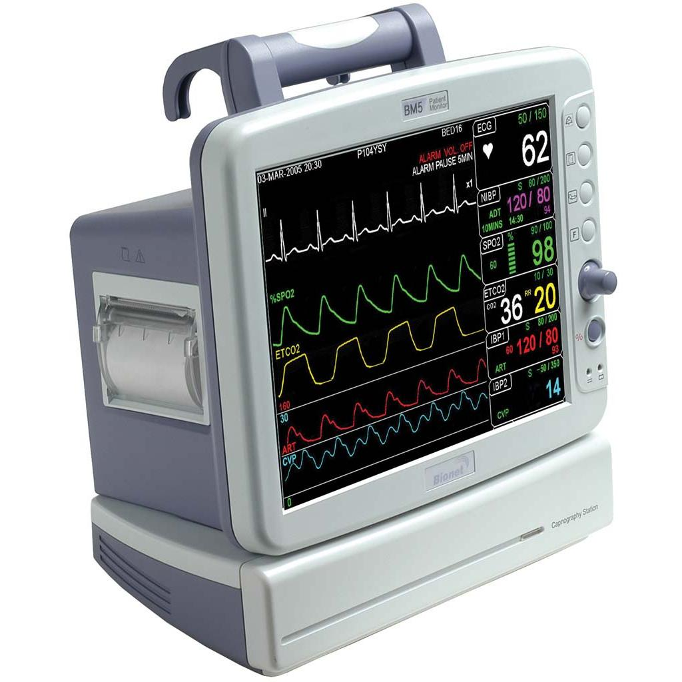

Figure Standard patient monitor. Taken from [2]

## Specification of patient monitor

Patient monitor has a really specific structure. This fact you can see in Figure 1. Some of these characteristics should be useful during the data acquisition process.

First of these facts is black background of the patient monitor screen. This trend has almost all monitors on the market. I went through various manufacturers which made them and I could say about ninety-nine percent of actual patient monitors on the market has black background or at least this possibility.

All numerical values and curves are highly contrasted against the background of the monitor. This fact is comfortable for personal in hospitals or other sectors where we can found patient monitors and also for segmentation process. When we have a big difference between contrast of the background and data on it, it’s easier to distinguish what is background and what are data.

Third Interesting fact about the patient monitor is color consistency. As you can in Figure 1 almost all data on patient monitor has its own color and that color is consistent. That means we can use this information lately during the candidates selection before classification. The consistency is also advantage during the segmentation process, because it’s easier to found the borders of foreground.

Last specification is type of the font used by patient monitor. Usually the font shown by patient monitor is similar to synthetic fonts. The reason for this is easy readability for staff of the medical sector.

## Types of patient monitors

Nowadays there are plenty types of patient monitors on the market. For example when you look at the Figure 2 you can see that position of heart rate is on the first monitor in top left corner and in the second one in right top corner. Some types of patient monitors have possibility to select appropriate area for a concrete parameter.

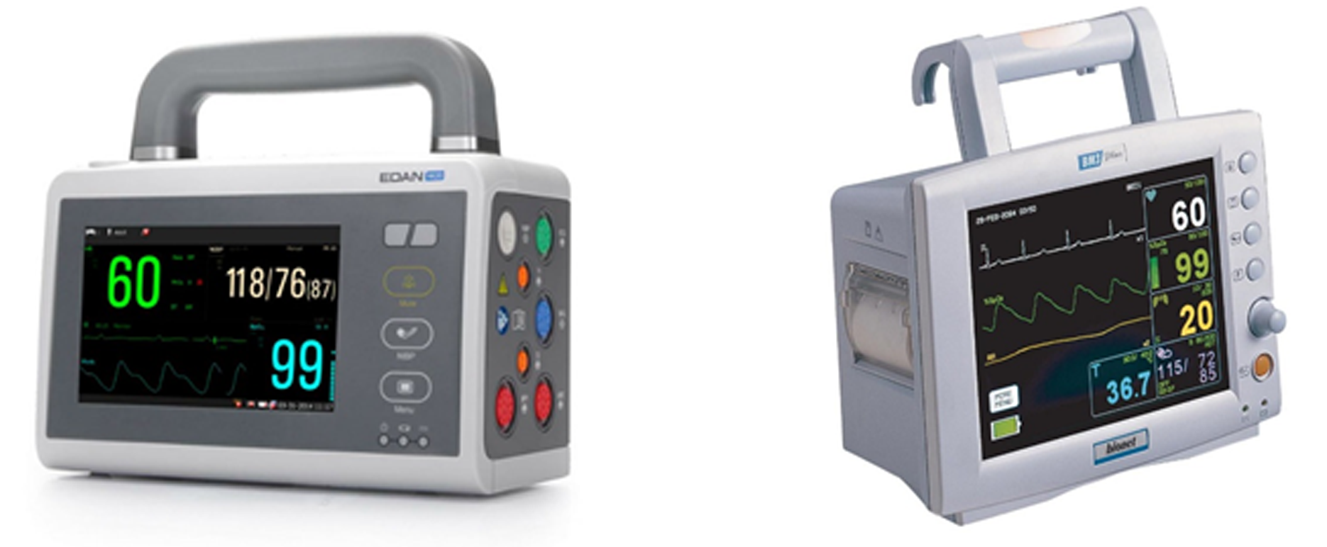

Figure Types of patient monitors. Taken from [3], [4]

Fact that there are many various types of monitor escalate in almost impossibility to cover all these types and use the information about the position of specified data on them for data acquisition. Solution for this problem is universal approach which will be calibrate to specific patient monitor by user before the data acquisition.

## Environment where we can find patient monitors

Patient monitor has various places where can be used from operating room to room in retirement home i.e. in the whole sector of medical and social support. All these places contain various objects and gizmos. Overall diversity of whole scene of the room is complex. Example of patient room is shown in Figure 3.

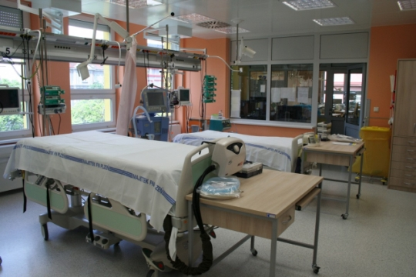

Figure Room with a patient monitor. Taken from [5]

It’s certain that during the data acquisition process someone, like personal or patient, cover the screen by his own body. That means it’s impossible to classify data from patient monitor because they are hidden.

Other problem is gently moving with a patient monitor. For example when doctor comes to a patient room and want to show someone else data about the patient on it, he rotate the monitor by few degrees around the vertical axis.

# Main goals

This diploma thesis has a few topics which should cover. These topics are a sum of available methods for data acquisition of patient monitor to implement basic standalone application. In upcoming subchapters I describe every goal of this thesis.

## Sum of actual solutions of data acquisition process from patient monitor

Task of this part is make a research trough articles and already implemented solutions, which deals with this problem and what kind of methods and hardware are in use now for data acquisition from patient monitor.

## Design a approaches for data acquisition via camera

Another part of diploma thesis is design of approaches which acquire and classify data, especially numeric ones, from patient monitor captured via camera. Basically discuss individual steps of these approaches and propose most suitable algorithms for these individual steps.

## Analysis of selected approach

One of mentioned approaches will be analyzed step by step. These steps corresponds to actual steps in future application. For each of these steps will be presented more possible methods. These method will be analyzed and I discuss their usability for optical data acquisition form patient monitor.

## Implementation of selected approach

Selected approach will be implemented as a standalone application in programming language C#. This application should acquire numeric data from patient monitors across different brands and types. Data will be extracted in real-time by connected camera, afterwards they will be save to external file.

## Experiments on selected approach

Selected approach will undergo experiments under different conditions. Basic conditions are: different light condition in room where patient monitor is located, different angle of camera plane against the plane of patient monitor screen, different distance to the patient monitor. More sophisticated experiments test application under conditions which can happen during the ordinary day in medical sector. These conditions are covering of patient monitor and gently moving with patient monitor. This part of thesis also contain basic performance test of implemented application.

## Discus possible enchantments of application

In this part of thesis I go through possible enchantments of application and generally the whole work. One of the possible future enhancements is segmentation of curves from patient monitor. Other mentioned enchantment is usage of multiple camera to secure better result of whole process. Also other enchantments will be discussed in this chapter.

# Current solutions

Patient monitor is one of the most accurate solution how to noninvasive obtain data about the patient. These monitors are really useful for personal in medical sector. All data on them are nicely readable, but there is problem with their storage. Many monitors doesn’t have a possibility to storage data which they show, but there are some alternatives.

## Storage directly in patient monitor

Storage inside of the patient monitor is the best solution. The shown data and the storage data are the same. Also storage inside the patient monitor is most user friendly for personal in medical sector. Data are save automatically into inner storage as a loop with interval equal to hundreds of hours. When personal want stored data, he can connect the USB cable and simply download the data.

So why I implemented this thesis? It’s because this solution has some problems. First of them is usage of these patient monitors in the medical sector at the moment. Simply the older types of patient monitors doesn’t have this option. I don’t have some statistical data, but from visual checking of medical workplaces and discussion with experts in this field the amount of patient monitors with possibility to save data is low. Another problem of these monitors are their price, which is relatively high, but these monitors getting more and more ordinary. Last problem of this approach is closed format of data, because some brands use their specific format of data to force users to use their software. Usual maximal extraction frequency is five minutes and these monitors ordinary don’t have possibility to save curves. Data could be also save by an optional device connected to patient monitor, but that means another costs.

## Real time cable approach

Some monitors doesn’t have inner storage but there is possibility to acquire data by other connected devices. Of course monitors could have both of these features. Ordinary the companies have its own solution how to acquire real-time data. But these solutions aren’t ordinary free and you need separate device concentrator and data consolidation server. Some companies for example Philips try to make output ports from patient more open with their IntelliBridge device interfacing [6].

There are also some third party software which can acquire data from patient monitor directly via cable to your PC for example Medicollector [7]. But these software are still relatively pricey.

Some papers already look at this problem and try to solve it [8]. This presented solution show a nice free alternative how to acquire data from patient monitor. Because data are sent by a cable the error is lower than via optical acquisition. This concrete work is far from being complete but it’s the step forward. This approach is specified to concrete type of patient monitor or at least to group of monitors.

The problem of these solutions is issue with law. Because based on law 268/2014 for Czech Republic, medical device can be only used for its intended purpose according to the manufacturer’s instructions [1]. That means if we want to use real time cable approach, instruction for that must be included in manual released by manufacturer. This option is possible, but in almost all cases only for closed solutions created by manufacturers.

## Optical data acquisition from patient monitors

Patient monitors show us all data about the patient via graphical interface. When you look at the picture in Figure 1, the doctor, or other specialist, can easily read all data on the screen. So if doctor is able to read graphical interface via eye, we can design the process which look at this graphical interface exactly same as a doctor. That means we store the whole screen, or only part of it, as a figure and apply on that figure algorithms which extract data from them. We have two different approaches how to obtain graphical view of the patient monitor screen i.e. video signal.

### Via grabbers

First method use VGA or DVI grabbers. These machines acquire video signal via their VGA or DVI connectors, convert them and send them to computer. Video grabbing approach is for example tested at intra operative ultrasound, neuro/navigation and microscope. This approach has one big advantage. The video grabbed from patient monitor is almost exactly the same as video signal show on patient monitor. That means there is almost no distortion, problem with low resolution, problem with blurred contours, etc. Because of that the data extracted from video signal have accuracy bigger than 95%. [9]

There are also some cons. The first of them is price. This type of solution is still relatively pricey, because the grabber cost about 750$ its price depend on the type of the grabber [10]. Another problem of this approach is already mentioned in chapter 4.2 and its case of law 268/2014 [1]. But as you can read in [9] *the video signal interfaces of the medical devices are certified to provide video signals. Therefore, using the video signal does not violate certification.* That statement is defined for Germany.

### Via camera direct to patient monitor

The video signal of the patient monitor could be also recorded absolutely noninvasive by camera. This camera is directed to patient monitor screen to read all, or only part, of the information from the screen. This is an approach which I haven’t found in any article of journal, but it’s still possible that someone is already working or worked on this approach and that’s the reason why we choose that way.

Big advantage is very low cash requirements. All equipment what is necessary for this approach is computer and camera. Nowadays notebooks and webcams are normal part of almost all workplaces and everyday life for all of us. It’s a very available solution. Second advantage of this approach is issue with law. As I mentioned above this approach is completely noninvasive to patient monitor that means you can extract information from patient monitor without any restriction by l law 268/2014 [1]. But it’s necessary not to forget on medical confidentiality and civil rights.

Disadvantage of this solution is accuracy of obtained information. All frames captured by camera are load with the optical problems. These problems are for example: small resolution, reflection, distortion, dependent noise, impurity or quality of CCD sensor, independent noise caused by screeches on lens, etc.

# Possible approaches

In this chapter I introduce two designed approaches how to acquire data from patient monitor. Both of these approaches are designed by me and have advantages and disadvantages. At first I will introduce the whole pipeline of approaches and afterwards describe every single step. Each of these steps could use different types of algorithms. These algorithms will be also mentioned in this chapter with dependence to data acquisition process from patient monitor.

First mentioned approach will use patient monitor screen as a main structure. Screen must be found in every captured frame. Once we have the screen we can correct projective distortion by founded corners of the patient monitor screen and extract data from concrete position on the screen. This position will be the same every time after the correction. Second approach is based on digits. Approach find digits in scene during the calibration process and try to focus on them for the whole process of data acquisition. That means it’s not necessary to find them in the whole scene in every frame.

## Monitor based approach

First approach is strictly dependent on patient monitor as whole. That means the whole patient monitor, or at least whole patient monitor screen, have to be in the captured scene by camera. Without this requirement is impossible to work further in pipeline of this approach.

Whole process starts with camera directing to the patient monitor. Before the acquisition process it’s necessary to do some calibration steps. First step is recognition of patient monitor screen in the captured scene. Screen can be found in the whole scene or user can define smaller crop of the scene for better results. Patient monitor screen can be found by different approaches and once when we find that screen we find the corners of the screen for upcoming projective correction and do it. When we have a corrected scene by homogenous matrix we can define regions of interest on the monitor, for concrete data on the monitor. These regions contain data about vital functions, list of them is mentioned in chapter 2. Pipeline of calibration process is shown in Schema 1.

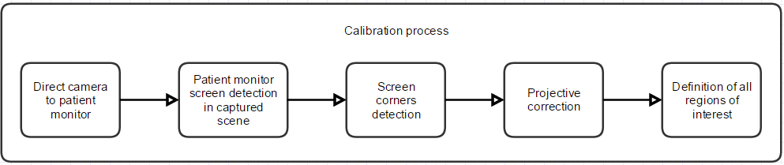

Schema Calibration process for monitor based approach

When we added all regions of interest we can start data acquiring process from patient monitor. This process is almost the same as calibration process, only on the end of its pipeline we add preprocessing and the actual classification. After the classification the last step is storage of classified data and repeat acquisition process for next frame captured by camera. The whole pipeline of data acquisition process is shown in Schema 2.

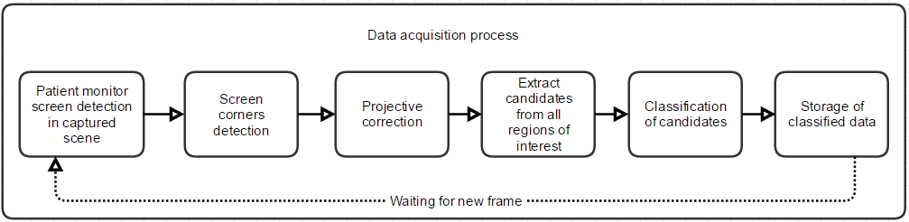

Schema Data acquisition process for monitor based approach

Big advantage of this approach is fact that once when we found a corners of the monitor it’s relatively easy to locate concrete regions of interest. For example when someone step before the patient monitor and moves with it for a small distance. The acquisition process is trying to find the monitor in a whole scene and once when person finally isn’t covering the patient monitor this process find it and continue with acquisition process, because region of interest are on the exact same position on patient monitor screen after projective correction.

First and biggest disadvantage of this process is impossibility to do acquiring process when there is no light in the room where patient monitor is located. That disadvantage is mentioned in requirements below 5.1.1. Another small disadvantage of this process is bigger CPU load, because we need to find patient monitor in every captured frame before actual acquisition process. This problem could be fixed by resizing of the captured scene to smaller scale find patient monitor and rescale it back in high resolution. Also projective correction applied to whole monitor is relatively CPU difficult, because it’s applied to whole captured screen pixel by pixel.

### Requirements

This approach is strictly dependent on the whole patient monitor as I already mentioned in 5.1. The reason is because we need to find corners of the patient monitor for projective correction. Once we don’t have one, or more corners, in the captured scene this approach cannot work further. So that means we need to have whole screen of the patient monitor in the captured scene for the whole time when data acquisition process is in progress.

Next requirement is about light condition in the room. It’s necessary to have some kind of light in the room where patient monitor is located. It’s because we need to find borders of the patient monitor screen. When all lights are off we can’t distinguish where screen starts and end. That means it’s impossible to find corners of this screen for projective correction. This requirement is a big problem, because the extracting from patient monitor it’s better to done during the night. Because the subject is calm in bed and the fluctuation of hospital personal is low.

The captured plane by the camera should be as most as possible parallel to plane of the patient monitor screen. When this condition is met there is less distortion and classify and whole process will be easier.

Monitor must be turned on during the process of calibration. Without that condition it’s impossible to done this step. It’s because the software need to extract some information from monitor, for example size of fonts, position of regions of interest, etc. before acquisition process.

Symbols on patient monitor should be highly contrasted against the background of it. As I mentioned in 2.1 this fact is usually secured by structure of the patient monitor.

Fonts shown on patient monitor are very similar to synthetic fonts. This condition is necessary because classifying of candidates for digits is done by library functions of third parties. In this case it’s Tesseract [11]. This library works in basic with synthetic fonts. As I mentioned in 2.1 patient monitors usually use almost synthetic fonts.

Camera used for capturing has the adequate resolution. That means the camera should capture digits whose height will be minimally 40 pixels in captured scene and this camera should also be focused on them. This condition is because smaller symbols have tendency to connect together and Tesseract also have this condition in recommendations [12].

### Individual steps

In this chapter will be presented and discussed possible methods and algorithms used in monitor based approach. This approach is separated in four main parts. First part is focused on finding of the patient monitor in the scene, or at least in the crop of the scene. That part is essential, because without founded patient monitor screen i.e. corners of the screen we can’t do second part. Second part is projective correction of the patient monitor scree. Next step is region of interest segmentation and in the end we look at actual classification.

#### Patient monitor screen detection

Detection of the patient monitor screen in scene is essential part of this approach. All following steps strictly depend on this step. For detection of the patient monitor screen we can choose many different approaches. In following subchapters I describe few of them.

All of these algorithms can be used on the whole captured scene or on the smaller crop where the patient monitor is located. When we use the whole scene the process take more time and there is also bigger possibility of misinterpretation. Because of that it’s better to use crop of the captured scene. And I work with it in following chapters.

##### Corner detectors

Corner can be intuitively described as a junction of contours. Their advantage is that they are localizable in scene. Generally corners are stable features over changes of viewpoint and different lighting. Another way how to describe corner is that corner is a point which have large variations in the neighborhood in all directions [13]. Sometimes corners are called interest points.

There are several methods how to detect a corner in the scene. Simply we can split corner detectors in few groups. First of them are edge based methods which operate on principle of monitoring the changes in the curvature of edges e.g. Wang Brady method. Another group is group of auto correlate methods. These methods calculate interest points based on moving with captured scene in different directions. The best know method of this group is Harris Stephens method, this method is also probably the best known corner detector at all and that’s why I describe its basics below. There are also some other types of corner detection and for more information please refer to [14] [15].

###### Harris corner detector

This detector works with movement of the captured scene in different directions and calculate gradient in every single point of this scene. Disadvantage of this method are light illusions like crossing between object of interest and its shadow and noise in the scene. Noise can be reduced by Gaussian filter. This method better detects L-corners than T-corners, that’s apparent from the procedure below.

This methods starts with calculation of auto correlate matrix for all points in the captured scene. This matrix is called Hess matrix of second partial derivation. This matrix looks like formula (1) if all second partial derivations exist.

|  |  |  |
| --- | --- | --- |
|  | $$A=\left[\begin{matrix}〈I_{x}^{2}〉 & 〈I_{x} I_{y}〉 \\ 〈I_{x} I_{y}〉 & 〈I_{y}^{2}〉\end{matrix}\right]$$ |  |

Now we can calculate the Eigen values by following formula to distinguish if actual point is corner or not, but this approach is really time consuming because of square root operation. So Harris and Stephens invent the new faster formula which can detect if actual point is corner or not.

|  |  |  |
| --- | --- | --- |
|  | $${ λ}_{1,2}=\frac{〈I_{x}^{2}〉+ 〈I_{y}^{2}〉 ± \sqrt{{\left(〈I_{x}^{2}〉- 〈I_{y}^{2}〉\right)}^{2}+4* 〈 I_{x} I_{y}〉* 〈 I_{x} I_{y}〉}}{2}$$ |  |
|  | $$M=Det\left(A\right)-K*{Trace}^{2}(A)$$ |  |

Formula (3) is compose from determinant of the matrix of second derivations and squared sum of elements on the main diagonal. As you can see in figure is also parameter K, which is settable for optimal results. So we can rewrite part of this formula like this.

|  |  |  |
| --- | --- | --- |
|  |  |  |

|  |  |  |
| --- | --- | --- |
|  |  |  |

After calculation of M we can distuiquish if actual point is corner or not. If calculated values is bigger than defined threshold point is corner and vice versa. More about Harris corner detector you can read in [13]

Example of using Harris detector, and one other corner detector, on captured scene with patient monitor is show in Figure 4. This operation was done in Matlab [16]. On the captured image was applied gaussian filter, grayscale transformation, and locally adaptive black and white thresholidng. I also try different setup for corner detectors but this one give me best results. Test was done on image with resolution 2633px x 2520px, test was also tried on downscaled image. Results was pretty the same.

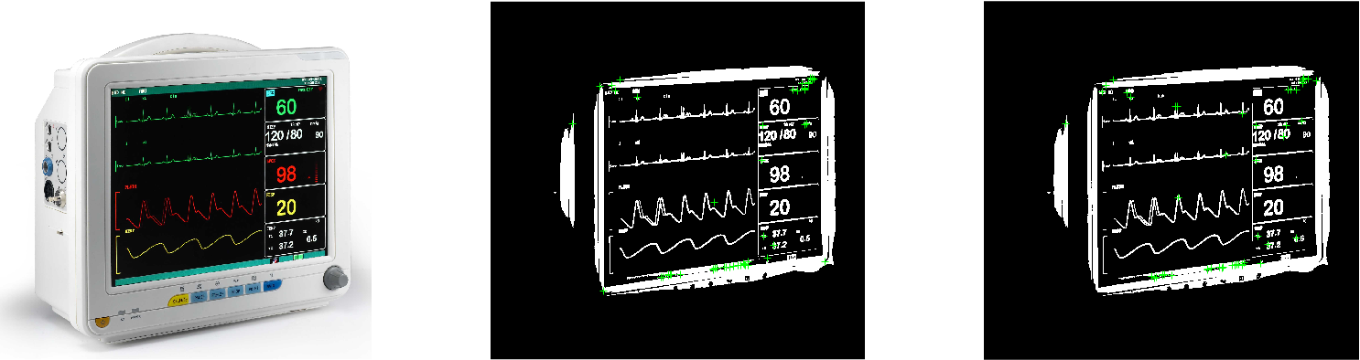

Figure First figure is original image of patient monitor; second is preprocessed patient monitor with founded corner by Harris-Stephens algorithm; on the last one is preprocessed patient monitor with foudned corners by MinEigenFeautures

As you can see in Figure 4 the results are for two different corner detectors almost the same, but two botton corners of the screen missing.

##### Hough transformation

This method is used to detect lines or object composed by lines in captured scene. It also can be used to detect another shapes like circles and ellipse, but in our case we don’t need this possibility. At all Hough transformation is nice option how to segment objects which have simple borders. Big advantage of this method is the possibility of using it also in cases when borders aren’t solid and regular. That means this method is relatively robust.

Every single line in two dimension space can be described by formula (6). Where *r* is angle of the line and $θ$ is distance of the line from the beginning of the coordinate system. All lines can be represented in this form when ( $θ$ ∈ (0, 180) AND r ∈ R) OR ( $θ$ ∈ (0, 360) AND r ≥ 0 [17]. That means every single line in original image can be described as combination of two values *r* and $θ$.

|  |  |  |
| --- | --- | --- |
|  | $$r=x*\cos\left(θ\right)+y*sin⁡(θ)$$ |  |

Before using of Hough transformation it’s necessary to apply some kind edge detector on the image. For more about image edge detection techniques please refer to [18].

Once when we have detected edges we can use transformation from <x, y> space to <r, $θ$ > (Hough) space for every single point in image after edge detector. As I mentioned before every single line can be described as a point in Hough space. So we test all the possible lines for all points in the image in Hough space. For example when we have two points in the image transformed to Hough space with their all possible lines we can detect the line which connect these two points by intersection of these curves. This is best seen in Figure 5.

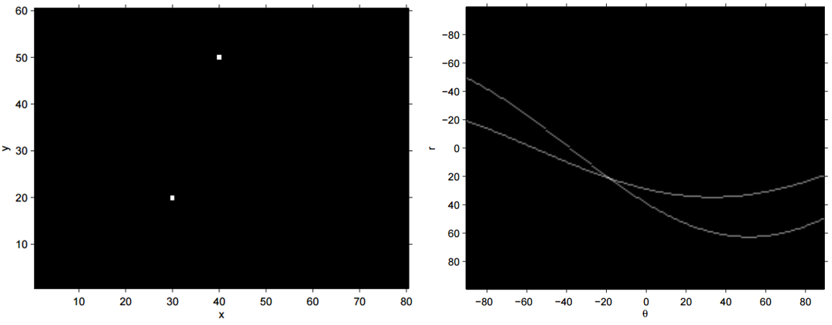

Figure Left: two points in <x, y> space; Right: all possible lines in Hough space <r, $θ$ > through two points on the left. Taken from [17]

In regular image converted to edges we test all possible lines for all detected points. The lines in original image are then detected if accumulation of curves in point in Hough space is bigger than the set threshold. It’s important to mention that Hough space is discrete so, if resolution is 1 degree for $θ$ and 1 pixel for *r* the accumulation will be smaller than when resolution is 10 degree and 10 pixels for *r*. On the other hand with the smaller resolution the precision of line detection decreases.

When we detect few most important lines in image we can simply find its intersection in original image. These intersection should be the corners of the patient monitor screen. In Figure 6 you can see process of Hough transform on image with patient monitor.

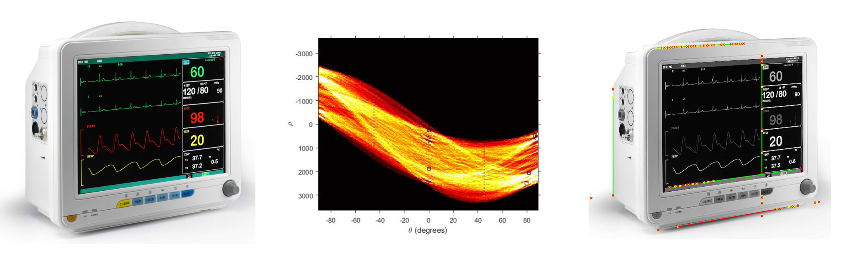

Figure Original image; all possible rotation of lines in points from canny detector in Hough space; in third image you can see only line segments above threshold from Hough space (lines was reduced to line segments by function in Matlab for better presentation

Hough transformation was tested in Matlab and lately also by EmguCv library in C#. On original image was used gray scaling, canny edge detector and function houghLines. Whole process how to find Hough lines in image in Matlab is in [16]

##### Combination of Hough transformation and corner detector

When we have a candidates for corners and most significant lines in captured scene, we can try to combine these two approaches. That means we have a candidates for corners of the patient monitor screen and also we have candidates for borders of the monitor. So when candidate for corner is lying on two candidates for border of the patient monitor screen (lines), it’s probably real corner of the patient monitor screen. This process is tested for all intersection of detected lines and its close neighborhood. When point is located near to this intersection we can classify it as corner of the patient monitor screen.

##### Finding monitor by preprocessing

There is also possibility to use pipeline of operations to extract the patient monitor screen from the captured scene. Whole process is described in Schema 3. This process was designed by me to keep only patient monitor screen in it. Whole process was designed in Matlab [16].

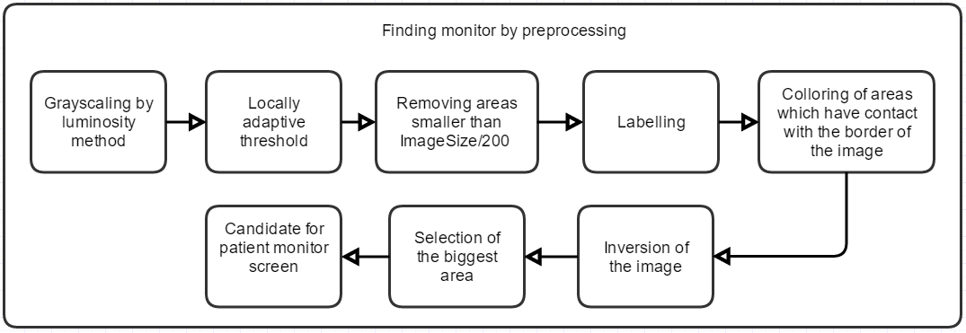

Schema Pipeline of finding monitor by preprocessing approach

First step of this process is gray scaling of the color image. For this operation was used luminosity algorithm which form new value by weighted sum of all three color channels by formula (7) for every single pixel. Once when we have grayscale image we can convert it to black and white image by locally adaptive threshold [19].

|  |  |  |
| --- | --- | --- |
|  | $$luminosity=0.299*R+0.587*G+0.115*B$$ |  |

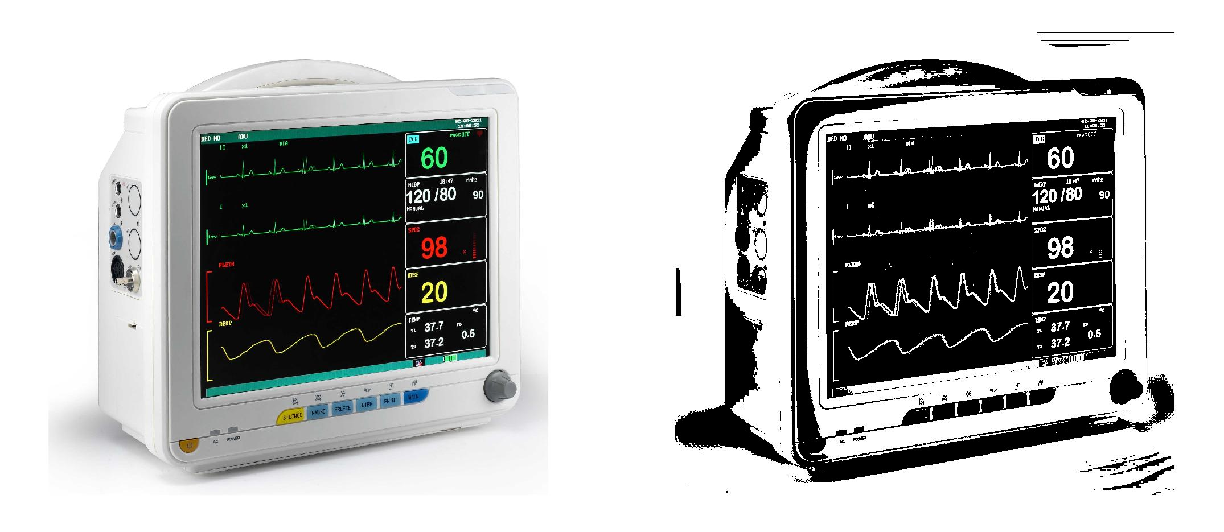

Figure Original image; patient monitor after grayscale and locally adaptive thresholding

Once when we have black and white image we can start filtering areas to obtain only screen of the patient monitor. First step is removal of areas with size smaller than 1/200 of size of the image. That results in image without noise. This process always remove areas on the patient monitor screen like curves and symbols. Because we want a clear shape of the screen.

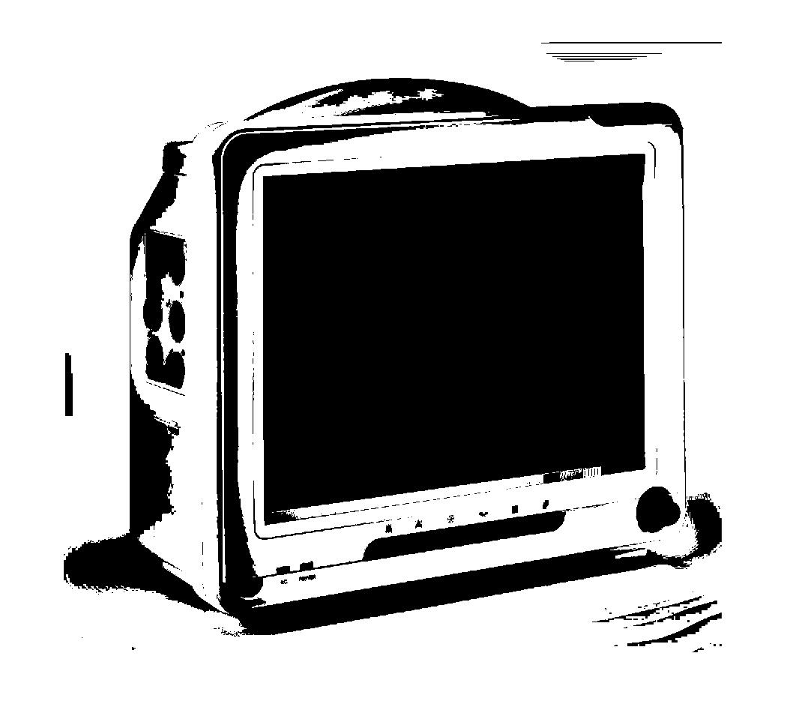

Figure Patient monitor after removing small areas

Next step is removal of all areas which are in contact with border of the captured image. Because we in 5.1.1 define whole monitor have to be captured, there is no possibility that monitor screen is somehow connected with border of the image. For this process it’s necessary to mark all areas in black and image by connected-component labelling [20]. All labels of areas which are in contact with borders of the image are stored in list. After that we can go through whole image and if label of actual pixel is mentioned in list we recolor this area to white. Next step is inversion of the image. Now we have only few areas in the image. For patient monitor screen selection we select the biggest one.

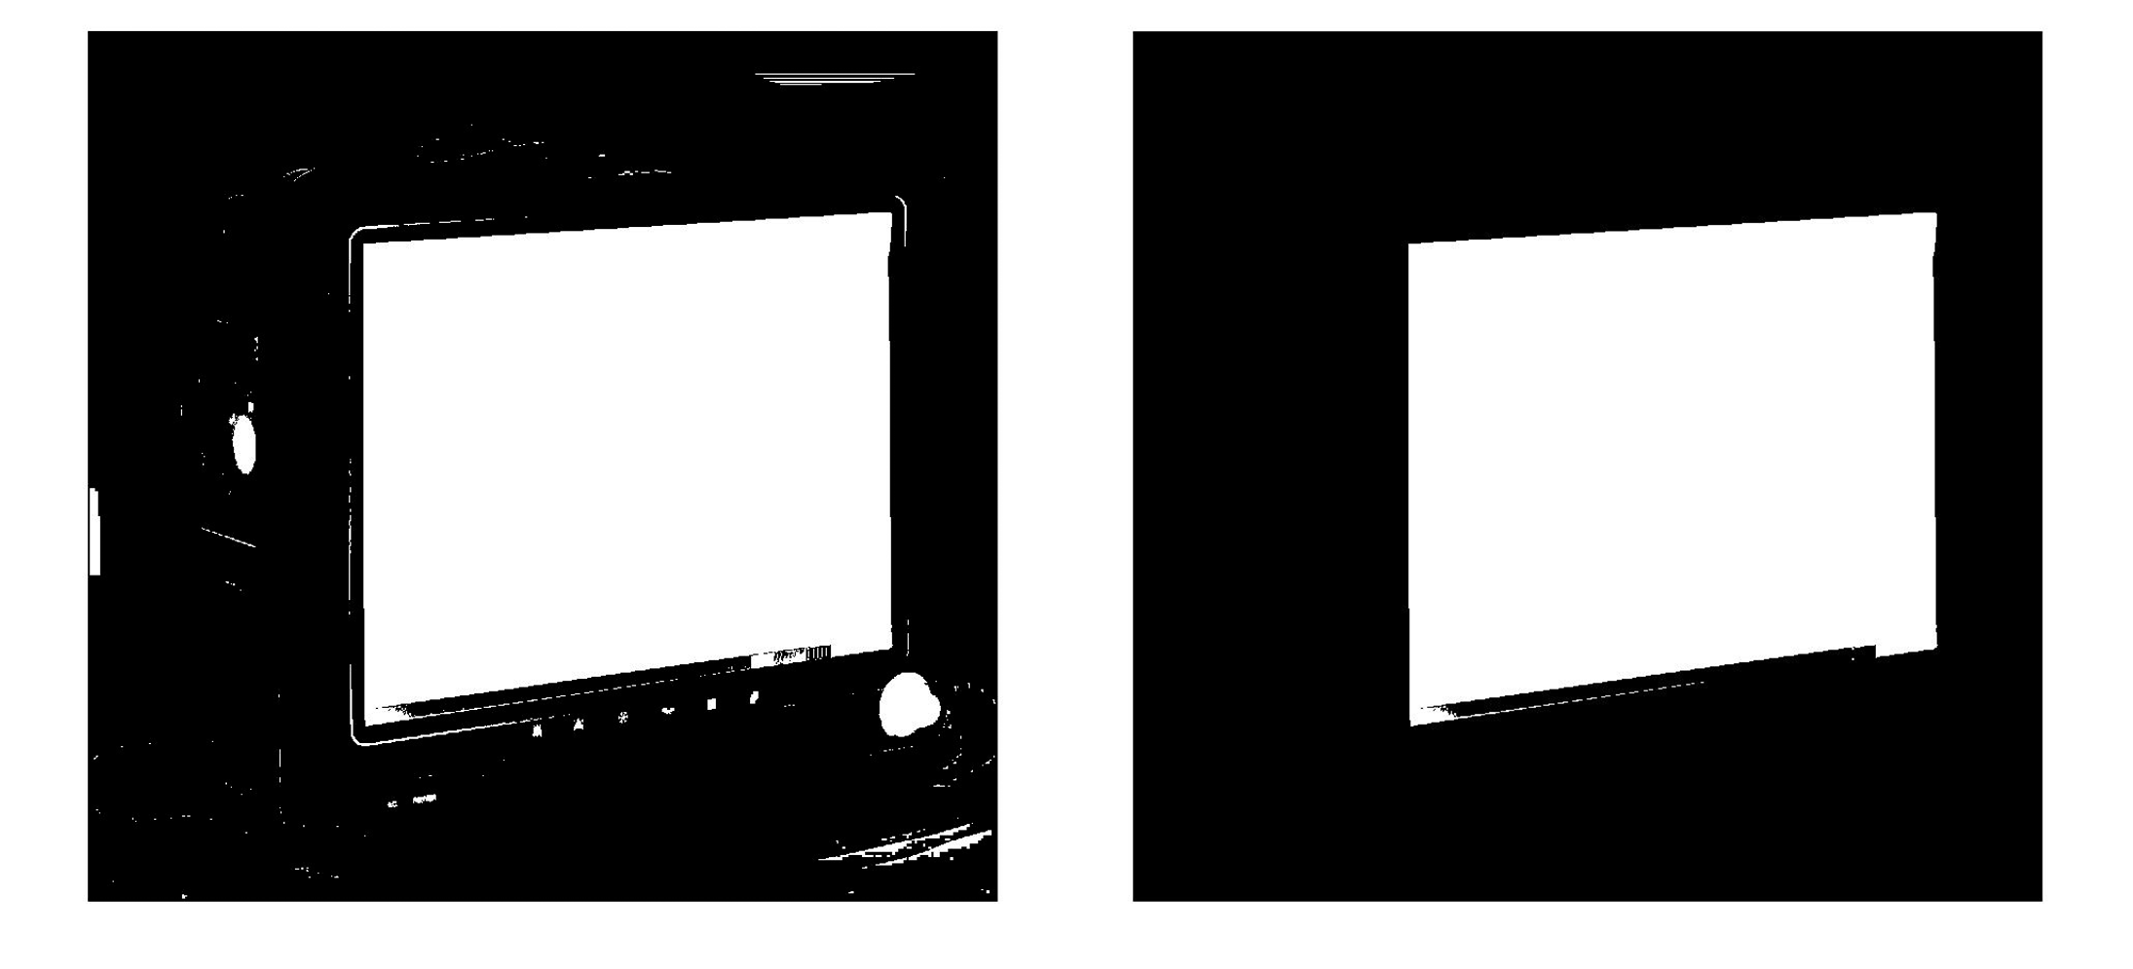

Figure Patient monitor after recoloring all white areas which are in contact with border of image; Selected biggest white area

When we have only one area in the image we can detect corners by coordinates in the image. First step is detection of all positions of pixels in that area. Now we can find where sums of differences of the coordinates in the shape are maximized and minimalized by the corners defined as *[1 1; -1 -1; 1 -1; -1 1].* These points are corners of this area. This process is completely done in Matlab [16].

##### Definition by user

Corners of the patient monitor screen can be also defined by user. Advantage of this process is correct definition of the corners, because they are easily recognizable by human. But there is big disadvantage at that’s impossibility to move with the monitor. Every time when someone move with patient monitor user should have click the new corners of the patient monitor in captured scene. So that means we need a special personal who do this over the whole process of data acquisition.

#### Projective correction

All objects captured by camera are distorted. That’s phenomena occurs because the camera position in space doesn’t fit with requirement mentioned in 5.1.1 almost all cases. Because we want to detect the location of regions of interest on screen under every possible angle and distance of the camera its necessary to remove this distortion.

For projective correction it’s really useful to use homography, sometimes called as projective transformation. Homography is and invertible mapping of point and lines on projective plane *P2*, this is the plane of the camera. That means every 2D point *(x, y)* can be represented as 3D vector *(x1, x2, x3)* where *x = x1/x3* and *y = x2/x3*. Algebraic definition of homography is based on [21] was given by proven following theorem: *A mapping from P2 ! P2 is a projectivity if and only if there exists a non-singular 3x3 matrix H such that for any point in P2 represented by vector x it is true that its mapped point equals Hx.* That means if we want to sufficiently map each point *x* to corresponding point *x’* we need to calculate correspond 3x3 homography matrix. Formula for this fact is shown in formula (8) where *M’* are homogenous coordinates of point in non-distorted image, *M* are homogenous coordinates of point in distorted image, $α$ is optional non-negative constant and *H* is homography matrix. When we apply inverse homography matrix on every distorted pixel we obtain front-parallel image.

|  |  |  |
| --- | --- | --- |
|  | $$α*M^{'}=H*M$$ |  |

Homography matrix is composed from geometric transformations. Ordinary homography matrix is decomposed in three separated matrixes. As you can see in formula (9).

|  |  |  |
| --- | --- | --- |
|  | $$H= H_{S}H_{A}H_{P}$$ |  |

$H_{S}$ represents a similarity transformation, $H_{A}$ represents affinity transformation and $H_{P}$ projectivity. This whole process of homogenous matrix decomposition is nicely described in [22].

Homogenous matrix contains eight degrees of freedom. All these elements which represents these degrees of freedom are independent. The last element of homogenous matrix can be describe as scaling factor that means it’s possible to multiply the homogenous matrix by an arbitrary non-zero constant and projective transform still be the same. That means we need to find these eight independent elements.

As you can see from simplified formula without $α$ in formula (10) and with knowledge mentioned above we need four points in original image and four corresponding points in front-parallel image. First four points in original image was detected by method mentioned in 5.1.2.1. Four points in front-parallel image can be obtained in real world, because we only need the aspect ratio of this screen. Size of the screen isn’t a big problem, because only change is scale factor in homogenous matrix. Second alternative how to obtain front-parallel corners is by calculation. For example the simplest one is average height of patient monitor screen and the same for width. That’s give us at least basic information about aspect ratio of the screen.

|  |  |  |
| --- | --- | --- |
|  | $$\left(\begin{matrix}x' \\ y' \\ 1\end{matrix}\right)= \left(\begin{matrix}h_{11} & h_{12} & h_{13} \\ h_{21} & h_{22} & h_{23} \\ h_{31} & h_{32} & h_{33}\end{matrix}\right)\left(\begin{matrix}x \\ y \\ 1\end{matrix}\right)$$ |  |

Once when we have exactly four point and their correspondences we can rewrite mentioned formula (10) in two equations for every point as you can see in formula (11). Following equations (12), (13), (14) are only rewriting of equation before.

|  |  |  |
| --- | --- | --- |
|  |  |  |

|  |  |  |
| --- | --- | --- |
|  |  |  |

|  |  |  |
| --- | --- | --- |
|  |  |  |

|  |  |  |
| --- | --- | --- |
|  |  |  |

Once when we have equations for all points we can rewrite them into one matrix where we have eight lines. Now we can rewrite the whole equation of homogenous matrix to formula (15) where *h = (h11, h12, h13, h21, h22, h23, h31, h32, h33).* [23]

|  |  |  |
| --- | --- | --- |
|  | $$\left(\begin{matrix}x_{1} & y_{1} & 1 & 0 & 0 & 0 & -{x'}_{1}x_{1} & -{x'}_{1}y_{1} & -{x'}_{1} \\ 0 & 0 & 0 & x_{1} & y_{1} & 1 & -{y'}_{1}x_{1} & -{y'}_{1}y_{1} & -{y'}_{1} \\ x_{2} & y_{2} & 1 & 0 & 0 & 0 & -{x'}_{2}x_{2} & -{x'}_{2}y_{2} & -{x'}_{2} \\ 0 & 0 & 0 & x_{2} & y_{2} & 1 & -{y'}_{2}x_{2} & -{y'}_{2}y_{2} & -{y'}_{2} \\ x_{3} & y_{3} & 1 & 0 & 0 & 0 & -{x'}_{3}x_{3} & -{x'}_{3}y_{3} & -{x'}_{3} \\ 0 & 0 & 0 & x_{3} & y_{3} & 1 & -{y'}_{3}x_{3} & -{y'}_{3}y_{3} & -{y'}_{3} \\ x_{4} & y_{4} & 1 & 0 & 0 & 0 & -{x'}_{4}x_{4} & -{x'}_{4}y_{4} & -{x'}_{4} \\ 0 & 0 & 0 & x_{4} & y_{4} & 1 & -{y'}_{4}x_{4} & -{y'}_{4}y_{4} & -{y'}_{4}\end{matrix}\right)h=0$$ |  |

Once when we have calculated homogenous matrix we can apply it to any coordinate of the point *(x, y)* and do the projective correction by formula (16).

|  |  |  |
| --- | --- | --- |
|  | $$\left[\begin{matrix}x^{'}/ λ \\ y^{'}/ λ \\ λ\end{matrix}\right]=\left[\begin{matrix}h_{11} & h_{12} & h_{13} \\ h_{21} & h_{22} & h_{23} \\ h_{31} & h_{32} & h_{33}\end{matrix}\right]*\left[\begin{matrix}x \\ y \\ 1\end{matrix}\right]$$ |  |

This whole process was tested on image of the patient monitor. As you can see in Figure 10 below projective correction really worked but it’s not absolute. That fact is there because the corners of the monitor have not been found exactly right and real size of patient monitor was calculated from image by average calculation mentioned above.

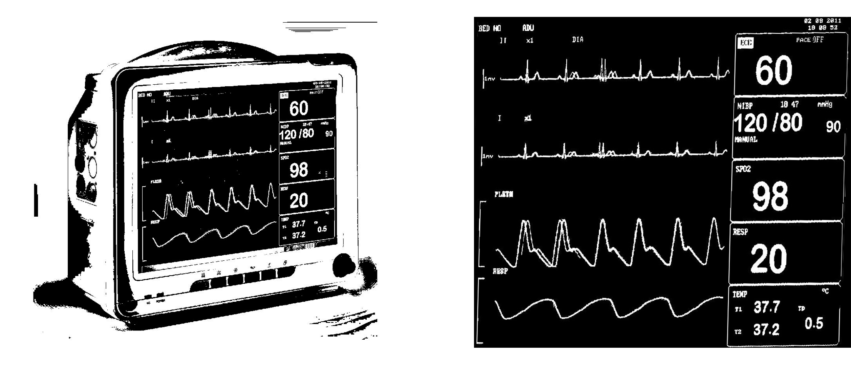

Figure Patient monitor after locally adaptive threshold; projective corrected screen of the patient monitor

#### Selection of region of interest

Patient monitor shown on his screen various types of data. Before we start acquisition process its necessary to select which of these data we want to store. Because we already done projective correction information will be every time at the same spot independently on the position of the camera.

Possible way how to define regions of interest is via rectangle selection. As you can see at Figure 10. Projective correction done its job relatively good so to extract number 60 by rectangle selection won’t be a problem. But it’s necessary to select the region of interest well. For example if on the monitor would be number 6 instead of 60 during the calibration process and rectangle selection would be fitted to number with one digit we will have problems when number with two or more digits appears in this area. Because of that it’s better to define wider and also little bit higher region of interest, due to undefined number of digits and also because small imprecision of projective correction.

Extension of mentioned method could be clicking on shown digit in selected rectangular selection. Once when we have defined region of interest we can mark individual areas inside of it with connected-component labelling like in 5.1.2.1.4. When we clicked on one of these marked areas we can obtain its height and width and look only for areas with similar characteristics inside of the region of interest. This characteristics can be updated during the whole acquisition process, because scale of the digits may vary over time. Second extension could be finding digits only on left and right side of the selected digit to distance equal to width of the selected digit. This can be little bit tricky and I solve the definition of start point during the acquisition process in 6.8.2.

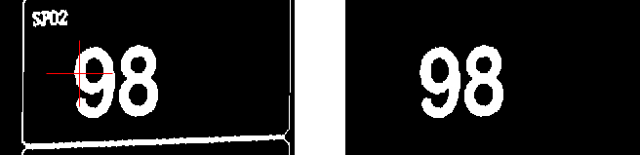

Figure Manually selection of the digit; areas filtered only on appropriate candidates in distance from selected digit

#### Classification of selected candidates

After selection of the regions of interest we have candidates for char recognition i.e. classification. Group which deals with these problem is called optical character recognition (OCR). OCR is a process which has as the input pixels of single, or multiple, characters and output is recognized char. There are several possibilities how to recognize character. Few of these methods needs to be implemented by your own but there are also few libraries which deals with this problem. The biggest of them is open source library Tesseract [11] which I use during testing of this approach. Whole topic of OCR is very well researched and people try to recognize characters for relatively long time [24]. The whole process of classifying is divided in two separated parts: extraction of features and classifying.

##### Feature extraction

Feature extractor derives the features. Features are a set of information which describe the single character. This information should have property, that feature about one character is different from feature of the other character. There are several tactics how to obtain these features and we usually combine many of them for better results. Bigger number of these features improves the accuracy of a classifier, but it will take a long time to extract all of them. I will introduce few of these features below, for more details please refer to [25].

###### Template matching

This way how to obtain features is very popular and very simple. The basic one takes one pixel as one part of feature of char. During the classification every pixel is compare with pixel of learned dataset. If pixels are same we have a match and vice versa. This approach look like it has a very high accuracy, but this is not always true. As example we can take a letter O in one front and classifier which has learnt characters from different font. In that case digit 0 can give us better accuracy than O, but the original letter is O, and that’s the problem. Another problem of this method is high dimension of feature. Let’s have scene with 100x100 pixels. In that case we have feature with 10 000 dimensions. That means it could be really time consuming. This method is really similar to convolution of the image with the convolution mask, where convolution mask is new obtained character and background is set of characters defined before.

###### Structural features

This method is based on structural information about char and decision rules. Structural feature describe the specific properties of char. Basic properties of char may be number of lakes in char, black-white pixels ration, number of corners, etc. There are also more sophisticated features like distance of the first pixel from the left border, distance of the last pixel in row to the right border or number of white-black/black-white crossing in every row. In this case it’s little bit harder to extract features from a scene but the process of classifying is faster [26].

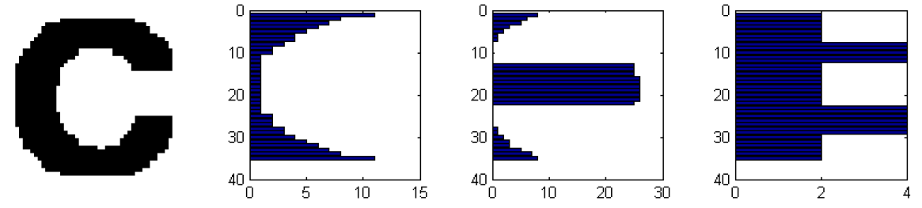

Figure Tested symbol; distance of the first pixel from the left border; distance of the last pixel in row to the right border; number of white-black/black-white crossing in every row [26]

##### Classifier

For classification of digits from patient monitor we can choose supervised learning methods or simple convolution which is already mentioned in 5.1.2.4.1.1. Supervised methods use data with known information about its label. For example we have figure of char A and label of that character is information it’s A. Beside the information it’s A we also have all extracted features about this character which we choose.

We know many supervised classification techniques [27]. As I mentioned before in 5.1.2.4 I used Tesseract library for testing this approach, overview of Tesseract OCR engine is described in [28]. At following lines I try to describe the methods which looks the best for classifying data from patient monitor.

###### Bayesian decision

Bayesian decision is based on multivariate Gaussian distribution [29] [30]. Let’s consider we have character described by two dimensional feature. In that case we use formula (17) to create multivariate Gaussian distribution for chars from train data set.

|  |  |  |
| --- | --- | --- |
|  |  |  |

When the distribution is built, we can use the posterior probability to choose the best suitable char from learn dataset i.e. distribution for tested char. The best suitable char is char with the biggest value at position defined by feature.

###### SVM

Support vector machine (SVM) is classifying based on hyperplane which divides space to separated parts [31]. In case of two dimensional feature vector, hyper plane is a line. This hyperplane is defined step by step by training dataset. The advantage of this method are kernel functions. These function allow us to get features of chars to high dimensions. In high dimension it’s more suitable to distinguish between two chars. Decision to which class the tested char fall is easily based only on formulas (18), (19) and its result where one side of hyperplane is one character and second is second character.

|  |  |  |
| --- | --- | --- |
|  | $$〈w,x_{i}〉+b ≥ +1- ξ_{i}, y_{i}= +1$$ |  |
|  | $$〈w,x_{i}〉+b ≤ -1+ ξ_{i}, y_{i}= -1$$ |  |

The disadvantage of this method is that SVM is only binary classifier i.e. can distinguish only between two classes. In our case we need to distinguish between more than two classes. That mean we need to use more complex approaches. Two basic approaches is One-vs-rest or all-vs-all, these methods fold in group called Multi-class SVM [32]. In the first case we test only one character versus the rest. After testing of all chars at all classifiers we choose the one with the less lost function. All-vs-all approach need to build *K*(K-1)/2* classifiers i.e. all possible combinations of chars. After test of char on all classifiers the one with the most votes win.

## Digits based approach

Second approach has digits as a main domain against the monitor in the previous one. That means it’s not necessary to have the whole patient monitor screen in captured scene. Also we don’t need some light in the room, because when we don’t need to find corners of the monitor we don’t need a distinguishable borders of the patient monitor screen, which were recognizable thanks to light in the room. Digits at the monitor can be described as own light source, so we can recognize them in almost every light condition in the room. This process also use less CPU load, because we use image operations only on the small regions of interest. Also it’s not necessary to detect a patient monitor screen in the whole scene every time when we want to capture new frame.

Whole process of this approach is separated in two main parts. The first of them is calibration before the acquisition process and the second one is actual data acquisition process.

First step of calibration is selection with all requested information on patient monitor. Once when we select this we can select the regions of interest with required data. On all of these regions of interest we apply preprocessing followed by segmentation. All segments are labelled and user of the software select the required data, digit, in these regions of interest by his own. Afterwards candidates for digits are selected. Once when all these steps are done, we can obtain characteristics about the selected digits in all regions of interest and also characteristics about the region itself and store them for upcoming data acquisition process. Whole pipeline of calibration process is shown in Schema 4.

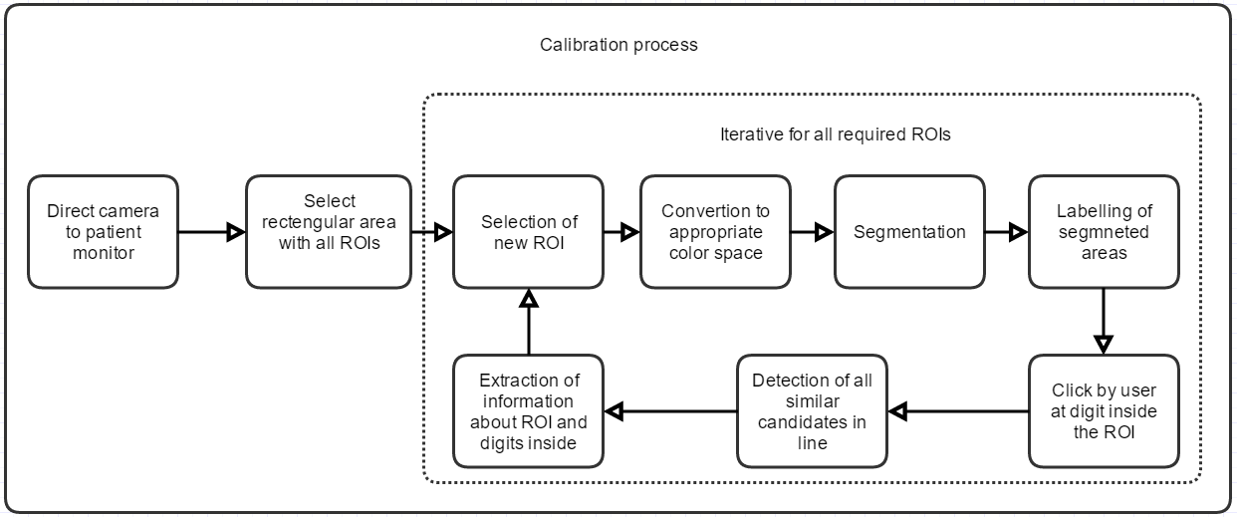

Schema Calibration process for digits based approach

When we have all characteristics about selected regions of interest and also about digits in them, we can start process of data acquisition. First few steps are very similar to calibration process and they are preprocessing and segmentation. After that we finding candidates for digits in region of interest. When we find it we try to find close neighbors which together make up a number. All candidates, that means the first one and also the neighborhood candidates, need to fulfill conditions stored during calibration process. Once when we successfully find all candidates we can redefine bounding box for all connected candidates, new coordinates and size for region of interest and characteristics about the selected digits for next iteration of the acquisition process. Once when we have a bounding box with stored candidates we can use OCR on that bounding box and classify the candidates in it. After that the whole acquisition process start new iteration if difference between two frames in row have difference bigger than set threshold. Bounding boxes with stored candidates are classify every time after defined period of time i.e. when timer tick. Whole process is shown in Schema 5.

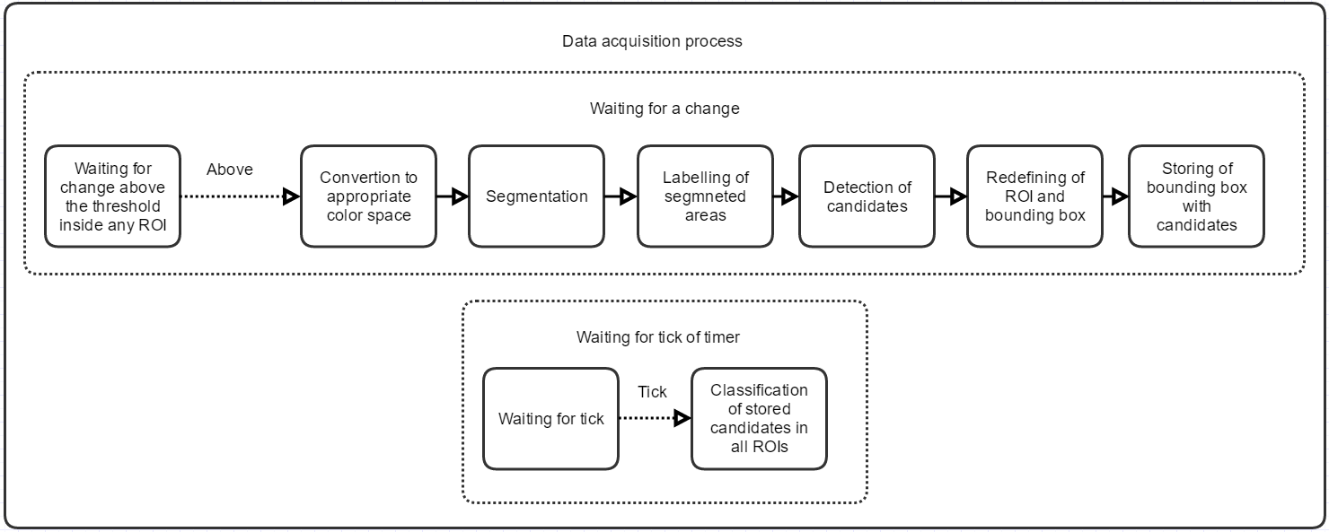

Schema Data acquisition process for digits based approach

This apporach was the selected one to implement as a standalone application. Because of that, every single step and its possible alternatives will be described in separated chapter in 6.

There is also beta backup process which are used if process cannot find a digits inside the regions of interest or after defined period of time. This process start during the calibration where we stored information about the digits in region of interest and try to find all lines of text with these characteristics in the whole scene. When we have all these text lines we can determine its position from the left border of the captured scene and also from the top and this information is saved to all regions of interest. Once when these definitions are done for all regions of interest we can start the acquisition process. If no text was detected in the region of interest for the longer period of time, or every time after defined period of time, it probably means that monitor was move during the time when camera was covered by something. At this time back up process start and same as during the calibration process try to find all lines of text in the scene based on stored characteristics of regions of interest and because we know position from the left and, optional information, position from the top, we can choose the correct one line in the captured scene and that is our required region of interest.

### Requirements

Five requirements of this approach are exactly same as requirements for monitor based approach mentioned in 5.1.1. That’s following requirements: captured plane of the camera should be as most as possible parallel plane of the patient monitor screen, monitor must be turned on during the process of calibration, symbols on patient monitor should be highly contrasted against the background of it, fonts shown on patient monitor are very similar to synthetic fonts and camera used for capturing have the adequate resolution. All these requirements are described in detail in 5.1.1. in last five paragraphs.

Extra requirement is that is necessary to have all the required data for upcoming data acquisition in captured scene by camera. So that means we need to have all required regions of interest in the captured scene for the whole time when data acquisition process is in progress.

# Analysis of digits based approach

In this chapter I describe every single step of the whole pipeline of digits based approach. In every subchapter I mention which method I use in the standalone application and mention if there are any alternatives.

## Selection of area of interest

Nowadays cameras have a various kind of resolution but the most sold are cameras with FullHD resolution i.e. *1920px X 1080 px*. That means the captured scene contain exactly 2 073 600 pixels. During the ordinary operation with the captured scene we have to visit every single pixel at least once, that’s 2 073 600 operation in minimal. In normal case when we capture the scene with the patient monitor, patient monitor usually doesn’t occupy the whole scene.

Left part of Figure 13 showing the whole captured scene with the simulated patient monitor and that means already mentioned 2 073 600 points. In the right figure we can see the selection with all regions of interest with resolution 328px X 419px and that’s 137 432px. As you can easily calculate its only 6.62% of the number of pixels in the whole captured scene. This fact really help us in the case of performance of the software. Because of that it’s practical to work only with this selection.

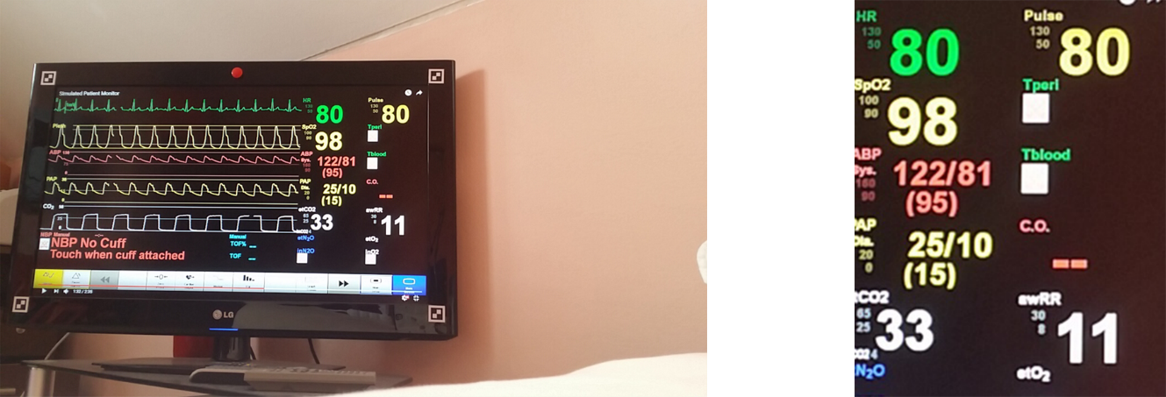

Figure Whole scene with simulated patient monitor; all selected regions of interest

Inside of the software we need to store position and size of this selection. Lately every time when we want a new frame from camera we can crop the image by this selection.

In the implemented software I use this selection only for selection of smaller regions of interest (ROIs). Once when we have this selection we can select the individual ROIs with required data. That means if we want to select for example heart rate, pulse, SpO2 and swRR we select every one of these ROIs separately. Between the selection of actual and next ROI with next data software do a bunch of processes on this ROI, these processes are described in following chapters. In the end the number of selected pixels will be after the whole selection process really low. For mentioned ROIs shown in Figure 14 its equal to equation (20).

|  |  |  |
| --- | --- | --- |
|  | $$\left(107*64\right)+\left(115*67\right)+\left(103*62\right)+\left(121*73\right)=29 772 px$$ |  |

And that’s only 1.43% of the number of pixels in the whole captured scene. It’s necessary to mention that size of the ROI during the calibration process is defined by user. Lately during the acquisition process is the size of ROI redefined automatically. This redefinition is described in 6.8.

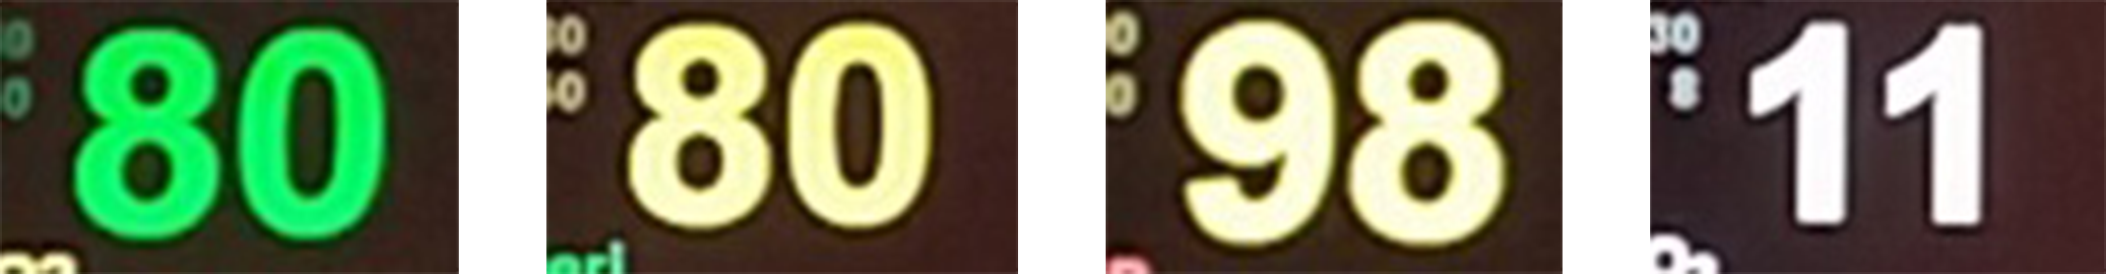

Figure Four selected regions of interest from patient monitor

## Recalculation of coordinates in program

There is also one problem which is need to be solved. When we use the software we want to see the captured scene in same ratio as it was captured and also as big as it possible. That means the coordinates on the display of the computer doesn’t correspond to coordinates in the captured scene. Because of that it’s necessary to recalculate the coordinates form the screen to coordinates of the captured scene.

In C#/EmguCv, which I use to implement the software, I used the zoom as a way of displaying of the captured scene. That means there are two possibilities how the captured scene can look. First of them is that imageBox, which is construct of selected library, has borders on the sides of the captured scene. The second one is almost the same but the imageBox have borders on the top and bottom of the shown captured scene. These two cases are shown in Figure 15.

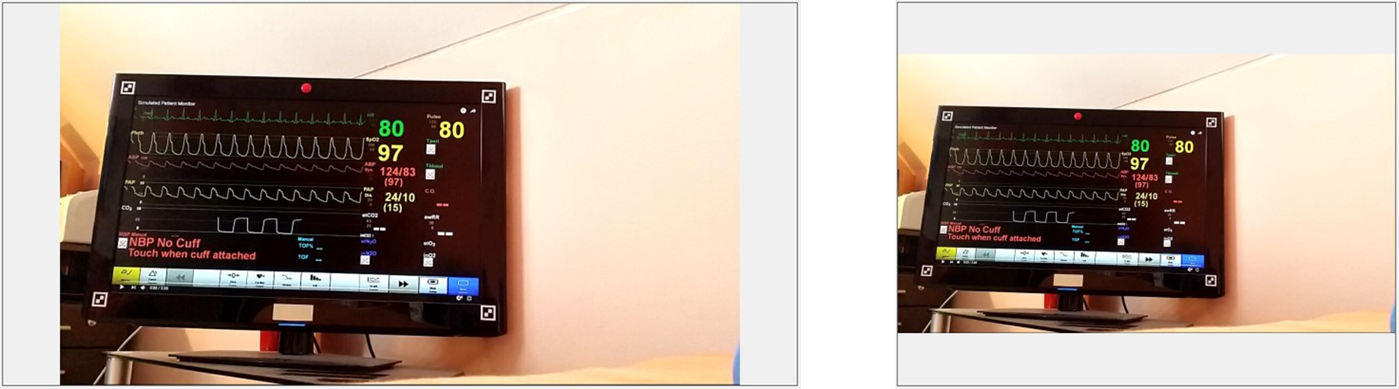

Figure Displaying of captured scene in implemented software: First case borders on sides; Second case borders on the top and bottom

In the first case when borders are on the sides we can recalculate the X and Y coordinates by following formulas (21), (22), (23), (24).

|  |  |  |
| --- | --- | --- |
|  |  |  |

|  |  |  |
| --- | --- | --- |
|  |  |  |

|  |  |  |
| --- | --- | --- |
|  |  |  |

|  |  |  |
| --- | --- | --- |
|  |  |  |

For the second case the formulas are very similar and you can see them below in (25), (26), (27), (28).

|  |  |  |
| --- | --- | --- |
|  |  |  |

|  |  |  |
| --- | --- | --- |
|  |  |  |

|  |  |  |
| --- | --- | --- |
|  |  |  |

|  |  |  |
| --- | --- | --- |
|  |  |  |

## Preprocessing

Preprocessing is essential process before the segmentation. That means we need to select best preprocessing operation for best result of segmentation process. There are several solutions how to do the preprocessing before segmentation or actual OCR process [33][34][35]. This isn’t classical OCR dataset, because classical OCR usually work with the scanned pages of text and this data sometimes have closer to detection of the text in natural scenes, but this is a bold statement since defining a ROI where text can be located and its characteristics are defined during calibration.

### Color space

When the scene is captured it has some specific color space. Ordinary camera capture the scene in RGB space which is three dimensional space with red, green and blue channel. There are many different color spaces [36]. Between the most known belong RGB, HSV and grayscale image.

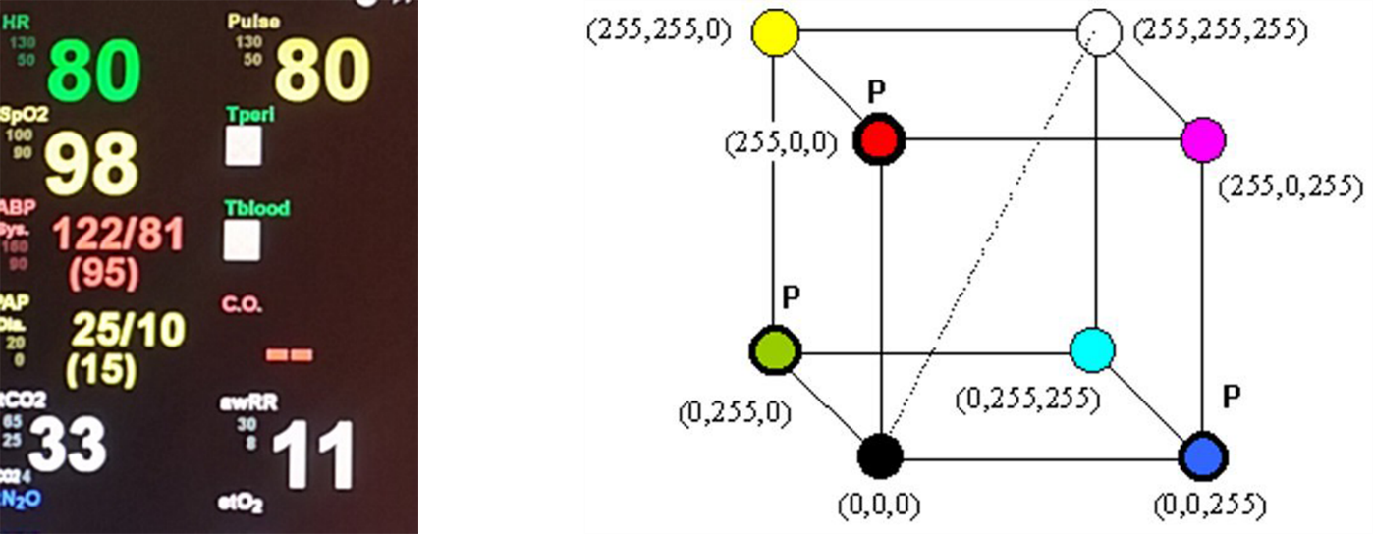

Figure Selected regions of interest in RGB color space; mixing of color channels in RGB space [36]

#### RGB

As I mentioned before ordinary scene is captured by camera in RGB color space. This space have three separated channels where every one of them has value between 0-255. Zero represent black and with bigger value color become lighter and lighter until the number reach 255 which is equal to white. Whole RGB space can be represented as a cube in Figure 16. That means we can decompose this color space in three separate images for every channel. As you can see in Figure 17 using only one channel of these three channels for segmentation is useless, because some information, for example digit 80 in top left corner in the red channel, almost completely missing. However in green channel all information are quite good readable, but it’s strictly depend on the color of the digits in the patient monitor and we can’t count on it. For example one digit can have magenta color and that means with respect to cube in Figure 16 that green channel is equal to zero. [37]

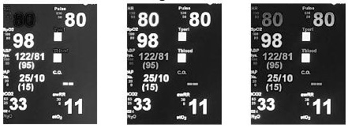

Figure All regions of interest in separated channels for RGB color space: Red; Green; Blue

It’s also possible to do segmentation for very channel separately, but this approach consume at least three time more operations. With this alternative work for example [38] [39].

#### HSV

This color space is quite different against the RGB. Individual letters in its name represent Hue, Saturation and Value. Hue is color type and represent own color of the element it’s represented by an angle with value 0-360 degrees. This value is ordinary normalized in range 0-255 where zero is equal to red. Saturation is representation of the vibrancy of the color. This value is again between 0-255 with less saturation color becoming more faded. Value represent the brightness of the color. Its range is still between 0 and 255. Where zero is fully dark color and 255 is equal to fully bright color. Representation of this color space is cylinder shown in Figure 18. [40]. Conversion from RGB to HSV is described in [41]

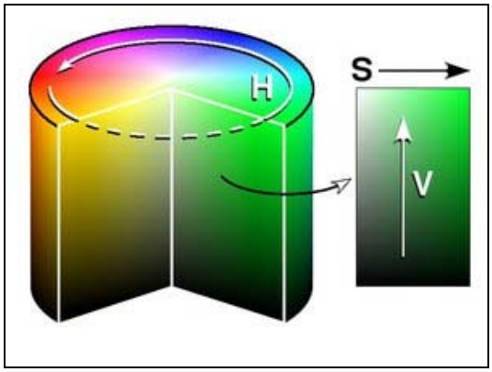

Figure Graphic schema of HSV color space

When we try to decompose image with all regions of interest in these three separated channels we obtain results shown in Figure 19. As you can see in hue channel it’s almost impossible to, even by a human eye, distinguish between the data and background. In saturation channel is situation better because we can distinguish the data at least by eye, but for segmentation it will be really problematics because some digits have around yourself white border some not, also almost all of them have different color. Process of segmentation will be possible but it’s not the easy way with good results. Value channel is really interesting for segmentation, because all digits are nicely high contrasted against the black background. When we look in [41] value channel is also the easiest one of these three to calculate, it’s just simple maximum value from three channels inside the RGB space. So value channel of HSV space seems to be a nice option and some papers choose the HSV space as the best solution

[42].

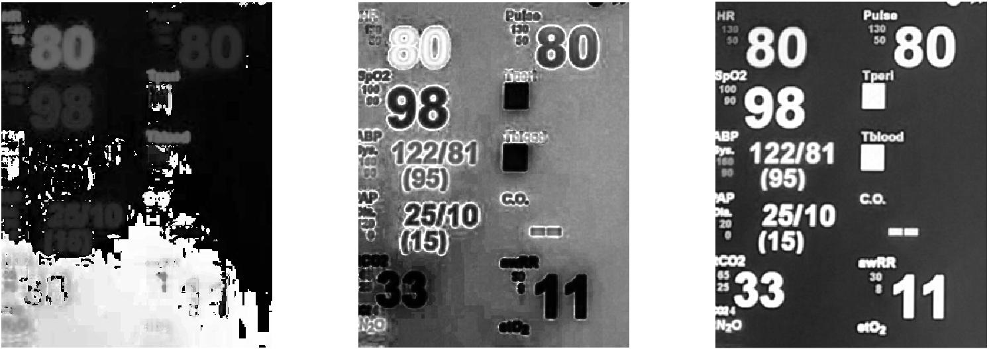

Figure All regions of interest in separated channels for HSV color space: Hue; Saturation; Value

#### Grayscale

Grayscale is color space with only one channel. There are three basic ways how to compute new value of pixel from RGB: lightness, average and luminosity. Lightness works with averaging of max and min value of color channel of pixel. Average method works with simple arithmetical mean across all color channels of pixel. The third one i.e. luminosity is little bit more sophisticated. It’s also work with averaging of all color channels, but every single channel is weighted. This weight is based on number of light sensitive cells on this color in human eye. Formulas for these conversions are shown in formulas (29), (30), (31). In EmguCV library which I use during the implementation is used luminosity method with parameters in formula (31) [43]. [44]

|  |  |  |
| --- | --- | --- |
|  |  |  |

|  |  |  |
| --- | --- | --- |
|  |  |  |

|  |  |  |
| --- | --- | --- |
|  |  |  |

In Figure 20 you can see the difference between the gray scaled image and value channel of HSV space. As you can see little bit better results give us the value channel from HSV space. But because EmguCV work inner easier with gray scaled image and digits in grayscale image are still highly contrasted against the background, I select grayscale color space space for implementation.

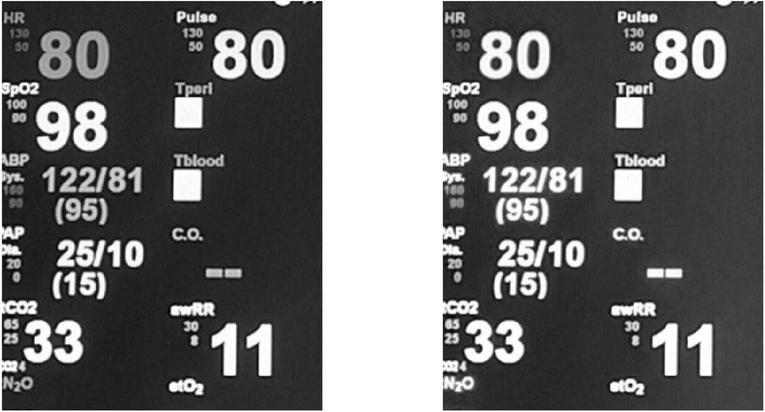

Figure All regions of interest in grayscale image by luminosity; All regions of interest in value channel from HSV space;

### Histogram equalization

In converted grayscale picture values of pixels can be if range 0-255. Ordinary obtained grayscale image doesn’t contain all of these values and that’s the shame. Number of pixels in gray levels can be nicely shown by histogram of the image in Figure 21. As you can see in histogram of this image, image contain only very few values of gray level and the biggest clusters are relatively distant.

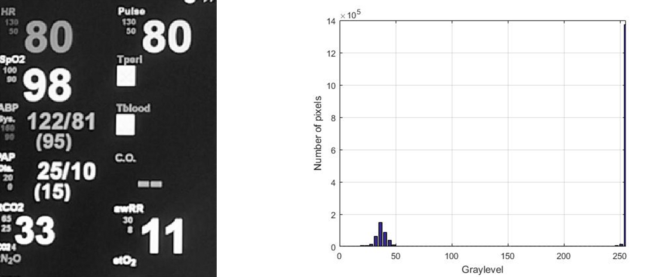

Figure All regions of interest in grayscale; histogram of selection on the left

If we want to use the whole potential of the grayscale color space we can use histogram equalization method. That means we try to spread pixels values over as many pixels values for a given color space as it possible. For more about this method please refer to [45]. As you can see in Figure 22 digits which represent the cluster around the value 45 in Figure 21 were redistributed in the neighborhood. But in the image after applying the histogram equalization process is nicely shown that numbers are after this process only hardly distinguishable against the background. That means histogram equalization is a bad method before segmentation process and two clusters with high distance between them are welcome.

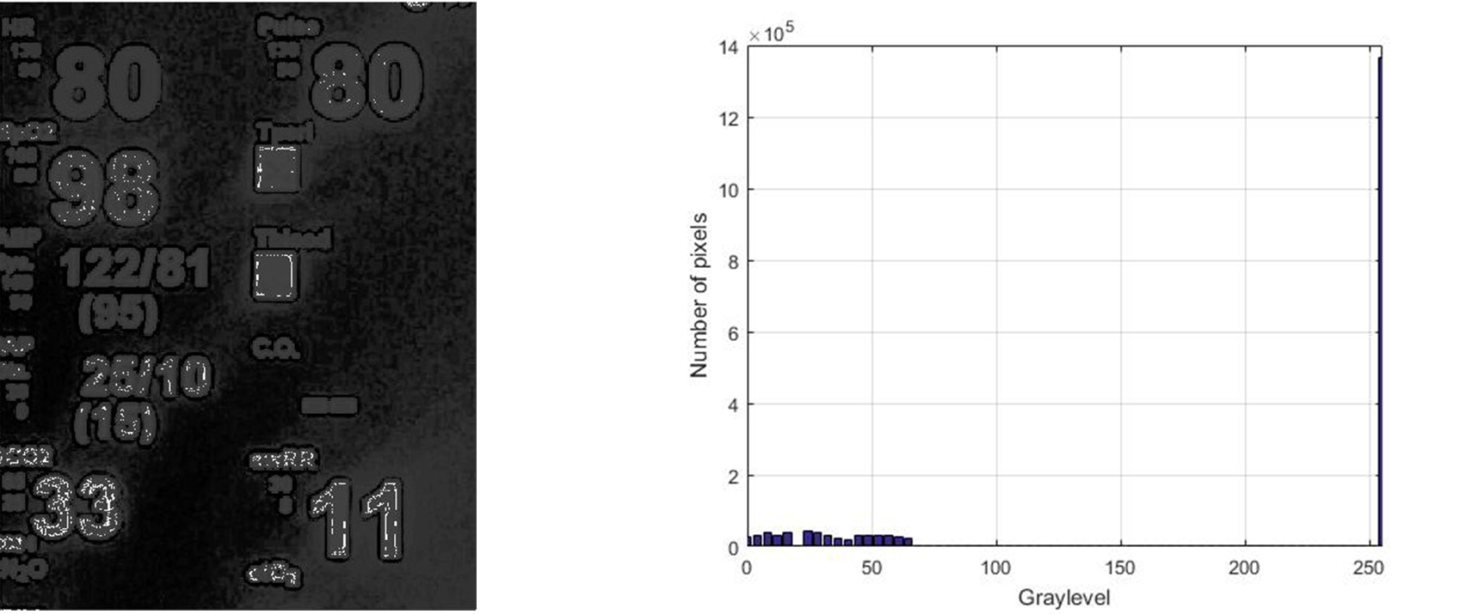

Figure Figure All regions of interest after histogram equalization; histogram of selection on the left

### Noise reduction

Patient monitor is very specific. The biggest specific of this monitor is one colored background. This provide us almost binarized image. Problems of the scene with patient monitor are artefacts which occur when the scene was captured. There are several artefacts which can make the classification worse. There are two basic types of artifacts or noise. The first one is random i.e. independent. This noise is caused by screeches on lens, impurity or quality of CCD sensor. Other source of noise is dependent. This noise is called Gauss and is rise systematically depend on something in the scene. Other source of artifacts are source of light in scene and turning image in grayscale space, which is connected to information reduction. We have two types of noise reduction filters i.e. linear and nonlinear.

Grayscale image of patient monitor ordinary doesn’t contain so much noise so I make just a little briefing through possible solutions.

#### Linear filters

These filters meets the principle of superposition [46]. Usually before the actual filtration a scene is projected to other space. Most often the projection is provided by fast Fourier transformation which get us to space of frequencies [47].

One of the most used filter is low pass filter. This filter exploits the fact that noise in image has always high frequencies. After application of this filter, high frequencies are removed and after the reverse Fourier transformation we have a scene without the high frequency noise. This filter can be also used without the projection to frequency space by convolution the scene with convolution matrix [48].

Other favorite filter is Gaussian filter [48]. This filter work in image space and used convolution mask to filter the scene. This mask is always square and have a structure of Gaussian distribution i.e. the middle part of mask has the biggest value and more closer to the edge we are, the lower values are on the mask. The negative of this approach is blurred image after application as you can see in Figure 24. That fact is undesirable, because digits should have nicely distinguishable border for segmentation and also for OCR process.

Averaging in next suitable method of linear filtering [48]. This process is very similar to Gaussian filtering. We used the mask which we put on correct pixel. The new value of the current pixel is average value of all pixels which are covered by mask. This filter also make the image little bit blurred as you can see in Figure 24.

#### Nonlinear filters

In nonlinear filtering doesn’t work the principle of superposition. The first type of nonlinear filtering is median filter [49]. This filter work almost the same as mentioned average filter, but the new value for current pixel is median of pixels covered by mask. This method is more robust because it doesn’t count with outliers. This filter looks like a best solution, but as I already mention before, using of filters isn’t necessary in our case.

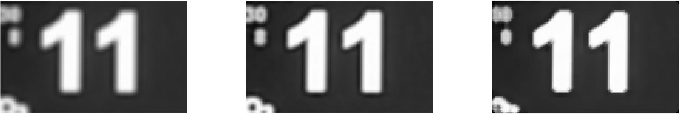

Figure Region of interest after applying filters with kernel 5x5 px. Gaussian; average; median

## Segmentation

For segmentation of the image i.e. distinguishing between the backgrounds we can use one of the three groups which are: threshold based segmentation, edge based segmentation, region based segmentation, matching and clustering techniques. If you want to check list of various segmentation techniques please refer to [50]. Because we already have almost black and white image the best solution seems to be one of thresholding methods. One little bit advance method will be mentioned and it’s MSER.

### MSER

One of the most favorite method is called [maximally stable extremal regions](https://en.wikipedia.org/wiki/Maximally_stable_extremal_regions) (MSER) [51]. This method is ordinary used to detection of text in the reals scenes [26]. It can be also use for detection of traffic signs or other things in captured scene [52]. Principle of detection of MSER can be described as follows. Grayscale image is gradually thresholding with all possible thresholds. Pixels below the threshold are colored to black and pixels above the threshold are colored to white.

If you imagine series of thresholding planes with values begins at 0 at ends with 255 at the whole plane as a video. Video starts as a complete white image. With higher threshold black areas start to appear and begin to grow until the threshold reaches value 255. In that case the image is completely black. All closed areas which appear during the process are maximal regions. Stable regions are moreover stable with high range of threshold values. Formal description of MSER is here [51].

These MSER have some really useful properties. *Invariance to affine transformation of image intensities. Covariance to adjacency preserving (continuous) transformation T : D→D on the image domain. Stability, since only extremal regions whose support is virtually unchanged over a range of thresholds is selected. Multi-scale detection. Since no smoothing is involved, both very fine and very large structure is detected. The set of all extremal regions can be enumerated in O(n log log n), where n is the number of pixels in the image.[*49*]*

As you can see in Figure 25 all digits was nicely founded by this method. But this method seems to be unnecessarily complicated in EmguCV, however it’s one of the great alternative how to deal with a segmentation process. Figure 25 was made by function detectMSERFeatures in Matlab [53].

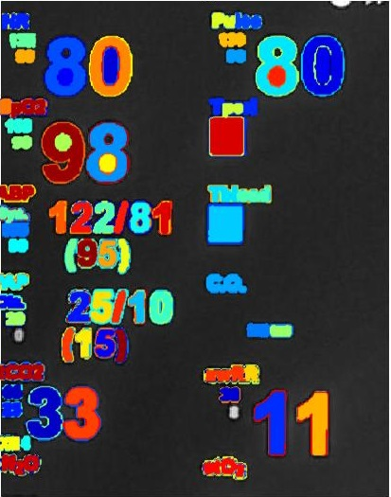

Figure Segmented input image in separated segments by MSER method

### Global thresholding

Global thresholding is the easiest way how to separate image into foreground and background. It can be describe as a one comparison with threshold plane as well as in MSER mentioned in 6.4.1. Pixels below the threshold are colored to black and pixels above the threshold are colored to white.

Threshold value can be chosen by a user or calculated from the image. First option is really useful for scenes with similar light condition for the whole acquisition process. Because the acquisition process can be changed during the acquisition process it’s better to choose some more sophisticated method for selecting this value. Optimal value for thresholding is based on the histogram of the image. There are several techniques how to find the threshold value [55].

One of most favorite techniques is Otsu method [56]. In this method we look at the points like a two separated clusters with diverse range of values. Ordinary these two ranges overlap each other. The main goal of this method is to find the threshold where the sum of foreground and background ranges is at its minimum. This method is iterative and for every possible threshold value do these steps:

1) Separate all pixels into two groups separated by threshold value

2) Calculate the mean in both groups

3) Difference of means square by factor two

4) Multiplying by the number of pixels in each group

Result: Threshold value is that which has max value $σ_{b}^{2}\left(T\right)$

These steps can be described in term of formulas (32-36)

|  |  |  |
| --- | --- | --- |
|  |  |  |

|  |  |  |
| --- | --- | --- |
|  |  |  |

|  |  |  |
| --- | --- | --- |
|  |  |  |

|  |  |  |
| --- | --- | --- |
|  |  |  |

|  |  |  |
| --- | --- | --- |
|  |  |  |

This process is relatively high time consuming so there is a possibility to update only *n* a *μ* in next iteration of the process, when we know how histogram looks. How to calculate the next iteration is shown in formulas (37-40) where $n_{T}$ is the frequency of intensity equal to threshold value.

|  |  |  |
| --- | --- | --- |
|  |  |  |

|  |  |  |
| --- | --- | --- |
|  |  |  |

|  |  |  |
| --- | --- | --- |
|  |  |  |

|  |  |  |
| --- | --- | --- |
|  |  |  |

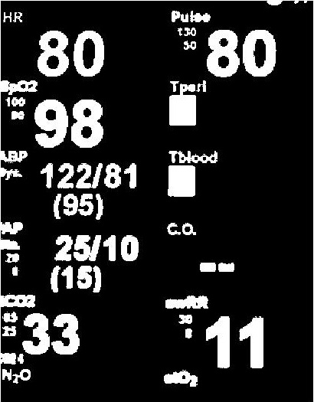

Figure All selected regions of interest after binarization by Otsu method with level set to 0.4902

As you can see in Figure 26, Otsu method give us a nice result. This method seems to be almost the best solution for my implementation. But there is problem with EmguCV which crashes every time when I try to use Otsu binarization method, many people at official forums of EmguCV also notice this. I hope so it will be fixed in upcoming version. Because of that I use Bradley + Wellner methods which is mentioned below in 6.4.3.

### Locally adaptive threshold

Locally adaptive threshold is similar to classic global thresholding. Pixels below the threshold are colored to black and pixels above the threshold are colored to white. The big difference is that threshold for every single pixel is computed separately from his neighborhood. For this purpose was used Bradley local image thresholding method [19]. This method is more robust to illumination changes in the image than classic global thresholding. That is a very pleasant fact, because we are capturing data from a patient monitor screen where reflections can occur.

This method using integral images. This integral image is neighborhood according to which decides whether the resulting pixel will be black or white. First of all we need to compute the sum of grayscale level over a rectangular region of the image. *Without an integral image, the sum can be computed in linear time per rectangle by calculating the value of the function for each pixel individually. However, if we need to compute the sum over multiple overlapping rectangular windows, we can use an integral image and achieve a constant number of operations per rectangle with only a linear amount of preprocessing. [19].*

For this purpose we create a new matrix *I* where on position <x, y> will be the sum of all grayscale levels to the left and above the pixel <x, y> in original grayscale image. This can be calculated by dynamic programing by formula (41). Process of calculation is shown in Figure 27.

|  |  |  |
| --- | --- | --- |
|  | $$I\left(x,y\right)=f\left(x,y\right)+I\left(x-1,y\right)+ I\left(x,y-1\right)-I(x-1,y-1)$$ |  |

Once when we have whole matrix we can simply calculate the sum of grayscale levels in any rectangular selection between <x1, y1> (left-top corner) and <x2, y2> (right-bottom corner) by following calculation (42) from *I* matrix.

|  |  |  |
| --- | --- | --- |
|  | $$\sum_{x=x_{1}}^{x_{2}}{\sum_{y=y_{1}}^{y_{2}}{f\left(x,y\right)=I\left(x_{2},y_{2}\right)-I\left(x_{2}, y_{1}-1\right)-I\left(x_{1}-1, y_{2}\right)+I(x_{1}-1,y_{1}-1)}}$$ |  |

Whole process of calculation of sums is nicely shown in following Figure 27.

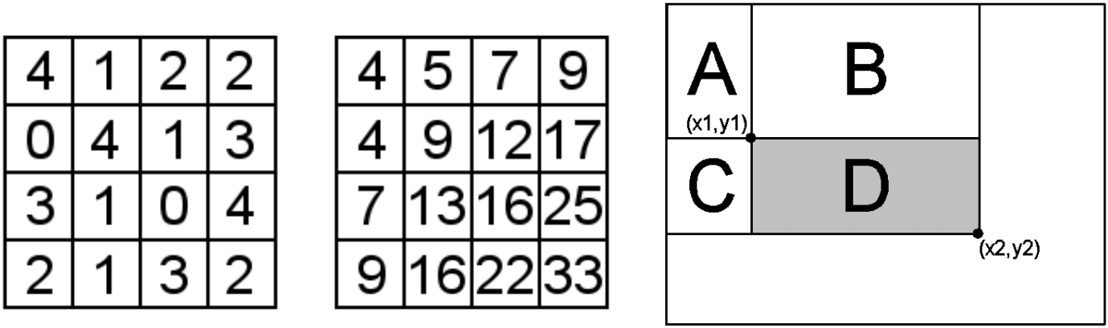

Figure The integral image. A simple input of image values; the computed integral image; using the integral image to calculate the sum over rectangle D [19]

If we have the whole *I* matrix and also rectangle selection we can use the Wellner’s method now [57]. *The main idea in Wellner’s algorithm is that each pixel is compared to an average of the surrounding pixels. Specifically, an approximate moving average of the last s pixels seen is calculated while traversing the image. If the value of the current pixel is t percent lower than the average then it is set to black, otherwise it is set to white. [57]* In modern systems like a Matlab [16] or EmguCV [58] we can use different function above the rectangular selection instead of the average. It could be Gaussian function or median. For this method is really essential size of the neighborhood.

In my application I choose Bradley + Wellner method. As a function above the rectangular selection was selected Gaussian function with size of neighborhood equal to 101. This value was selected for its bets result during the capturing of the video with camera resolution 1280px X 720px. As you can see in following Figure 28 difference of average (mean) or Gaussian function is almost unrecognizable. When we look at the median function the noise around the digits is undesirable for upcoming marking of areas.

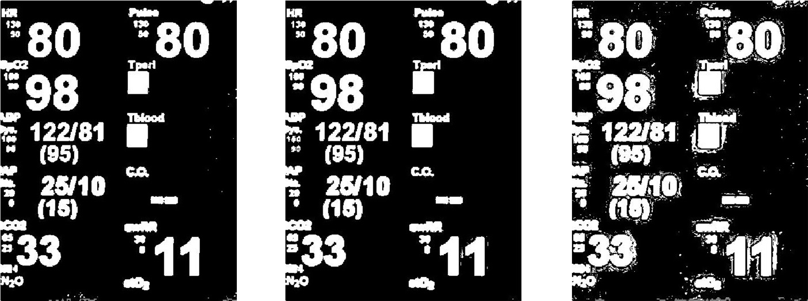

Figure All regions of interest after locally adaptive thresholding by Bradley + Wellner method, with different function above them. Mean; Gaussian; median

## Connected-component labeling

After segmentation process we have two separated groups of pixels. One of them represent background and the other one foreground i.e. data. Because we want to separate every single digit, we have to mark every closed white area in the image. For this purpose we can use connected-component labeling algorithm which is sometimes called **blob extraction or region labeling. This approach is algorithmic application of graph theory w**here subsets of [connected components](http://en.wikipedia.org/wiki/Connected_component_%28graph_theory%29) are uniquely labeled based on a given [heuristic](http://en.wikipedia.org/wiki/Heuristic). This method is based on two pass system [59].

During the first pass algorithm travel through image pixel by pixel from top left corner. Also we made a copy of the original black and white image. If pixel is foreground it checks its 8 or 4-neigborhood. In case no labeled pixel is in this neighborhood, actual pixel gets the new value for a label. If there is one already labeled pixel in this neighborhood, actual pixel gets the same value as founded pixel. If there a two or more pixels with different labels, actual pixel gets the value of the smallest one and all other founded labels are stored in pairs <parent, child> in the memory. Where parent is the smallest value of the label in 8-neighborhood and child is another founded label.

If this happen again for a next label, for example label 2 is a child of label 1 and we now obtain that label 3 is child of label 2. We check the parent list for information if label 2 is a child of some label. Because it is true, label 3 is stored as a child of label 1. Another way how to do this is simply store that label 3 is a child of the label 2. And do the second pass multiple times.

**In the second pass we connect adjoining areas with different labels into one. We go through the labeled image and check if actual pixel label value is child of some other label. If not, we move to the next pixel. But if it’s true we relabel the value of actual pixel to the value of the founded parent.**

**After these two passes, or after first pass and multiple iteration of second pass, we obtain the image with unique label for every closed area in the image. Easy example is provide in** Figure 29**.**

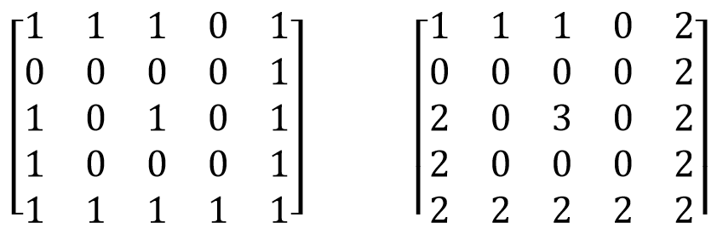

Figure Example of labeling. Original binary image; image after labelling

## Detect the closest right candidate

If we have labeled closed areas inside the image we can detect the candidates for digits. If we look at the Figure 30. There are still more areas which could be misinterpreted as a digit. Also the region of interest is during the calibration process selected by a user. That means ROI can be really big and there could be plenty of candidates for a digits and also many groups of digits. Because of that it’s necessary to select the correct one group of digits.

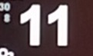

Figure Selected region of interest

This selection is done by a user. User is during the calibration process, immediately after selection of ROI with data, asked to click on, or as close as possible, to required data i.e. digit. When pixel in the ROI on a clicked position is labeled i.e. it isn’t a background this candidate is tested if it’s possible candidate for a digit or not. These test are described in 6.6.1.

If candidate isn’t pass these tests or on the clicked position is a background software try to find the next candidate as close as possible to a clicked point. This process can be described as a snail method. Because the order of tested pixels looks like a snail’s shell. That means we go to the top of the image further one to the right, two down, two left, three top and so on. This process continue until the candidate which meets the test is found. If candidate which meets the test isn’t found. User probably chose the ROI badly, monitor is turned off, etc.

Once when candidate is successfully founded we store average color, width and height of the candidate. Because we know the position of all pixels of the selected label in ROI and also position of the ROI in the whole captured scene we can easily obtain the average color form original colored scene. We also store the position and size of the smallest possible rectangular selection around this candidate i.e. bounding box.

### Test for a closest candidate

It’s a waste of time and resources to try classify by OCR all labeled areas inside of the ROI. That means we need to select only these which could be digits. Digits have some characteristics which makes it possible to describe them. All selected candidates are tested if meets these characteristics. These characteristics can be formed in conditions which build the whole decision tree. When we want to compare the new candidate to these characteristics we need to compute them. Because of that decision three have the characteristics which can be easiest calculate closer to root of the three. With the increasing complexity of the characteristics the distance from the root is bigger. All these test are independent to size of the candidate.

In following subchapter I describe these characteristics. All these characteristics was calculated on all digits i.e. 0-9 and diameters *()/* and I call it lately dataset.For testing all candidates was separated to as small as possible rectangular area with pixels equal only this label. This area is called bounding box. Values of these characteristics are stored in Table 1. It’s necessary to mention that these characteristics will be different for different fonts and also for different position for the camera in space, but conditions in tests was set with a certain reserve.

Table Characteristics of digits on simulated patient monitor

|  |  |  |  |  |  |
| --- | --- | --- | --- | --- | --- |
| Symbol | Aspect ratio | White ratio | Number of lakes | Avg. BW and WB steps | Maximum number of BW, WB steps in one row |
| 1 | 2.190 | 1.875 | 0 | 2.054 | 4 |
| 2 | 1.586 | 1.748 | 0 | 1.760 | 4 |
| 3 | 1.586 | 1.793 | 0 | 2.173 | 4 |
| 4 | 1.382 | 2.054 | 1 | 2.276 | 6 |
| 5 | 1.533 | 1.707 | 0 | 2.173 | 6 |
| 6 | 1.566 | 1.600 | 1 | 2.574 | 6 |
| 7 | 1.491 | 2.336 | 0 | 1.648 | 6 |
| 8 | 1.533 | 1.549 | 2 | 2.782 | 6 |
| 9 | 1.533 | 1.604 | 1 | 2.510 | 6 |
| 0 | 1.533 | 1.627 | 1 | 2.695 | 6 |
| ( | 3.428 | 1.647 | 0 | 1.479 | 6 |
| ) | 3.50 | 1.649 | 0 | 1.1510 | 6 |
| / | 2.473 | 2.072 | 0 | 1.765 | 6 |

#### Aspect ratio

Digits and also all letters are higher than wider. Aspect ratio is height of the candidate divided by its width. As I already mentioned digits are higher than wider, that means aspect ratio will be bigger than 1. Aspect ratio was calculated and condition for pass has been set as follows. It should be bigger than 1.1 and also smaller than 4. If it’s not, it’s not an appropriate candidate for a digit.

#### White ration

This characteristic is calculated as ratio of white pixels in bounding box. Result of that ratio is calculated by following formula (43). White ration should be bigger than 1.1 and smaller than 2.5.

|  |  |  |
| --- | --- | --- |
|  | $$WR= width*\frac{height}{NumberOfNonlabeledPixels}$$ |  |

#### Number of lakes

Some digits can contain one or more unlabeled areas surrounded by them. These areas are called lakes. Symbols in our dataset can contain 0-2 lakes. Lakes was detected by labeling of the inverted bounding box. After that area with the candidate was expanded by few pixels on all sides. Without this step we detect for example for number 8 up to 8 labeled areas, but after the expanding the number of lakes will be equal to three. One extra lake is white background of the digit.

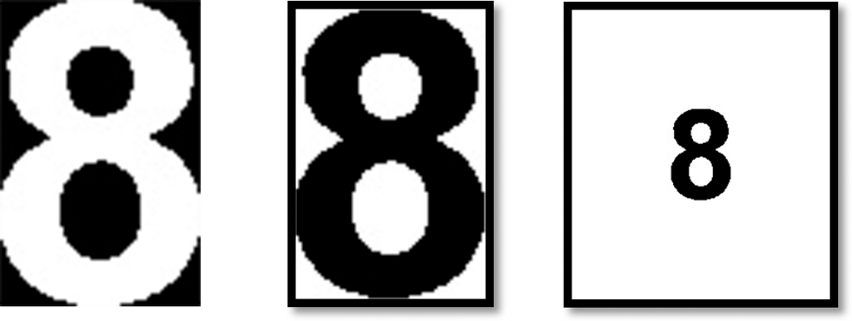

Figure Counting number of lakes in digit process. White digit on black background; inverse digit with eight lakes; inverse digit with added borders with three lakes

#### Black and white steps

Digits and all other symbols in dataset are solid. That means they don’t have a high number of small lakes inside of them and also they aren’t noisy. Because of that we can compute the number of black-white and white-black steps on an each row. Once when we have this, we calculate the average number of these steps in the whole bounding box and also store the maximum of these steps. Number of these steps should be bigger than one and smaller than 3.5. Maximum number of these steps for a dataset should be smaller than 8.

## Selection of candidates connected to selected one

Digits almost never appear on patient monotor independently. That means we need to look for some neighboring candidates around the already selected candidate. Digits which belong together should be in line and also close together.

When we already have one candidate for a digit we can look on the left in the distance equal to founded symbol height. If we found some labeled area in this distance we test it by tests in 6.6.1 and 6.7.1. If its pass through these tests we redefine reference width and height for founding the next candidadate on the left of newfound candidate. Thats is done because, with more digits in one line and projective disortion the very left digit should have quite different size against the first founed candidate. That would not meet the test conditions. In the other case i.e. candidate doesn‘t go through these tests, we still try to find a correct candidate in previously defined distance. Because bad candidate could be only some kind of noise between the digits and there could still be a digit in previously defined distance. This whole procces is iterative until we dont find any candidate on the left which pass through tests.

Once we found all the candidates on the left from the first founded candidate, we try to find all possible candidates for a digits on the right. Before that we need to redefine values of reference height and width by firstly selected candidate values. Furthermore, the process is same as for the process to the left just proceed right.

After we find all the candidates for a digitis on the left and also on the right we redefine new bounding box i.e. smallest possible rectengular selection with the whole line of candidates.

### Test for candidates in line

At first candidate for a digit was tested by a simple test for a size. After that we test the similarity to firstly selected candidate and in the end candidate was tested by all tests in 6.6.1.

#### Size

Because in binarize image could occur noise and other artefacts, it’s useless to test all candidates by a sophisticated tests. If candidate is smaller than 20px it’s probably not a digit. If it’s a digit it means it have 5 x 4px and that’s almost impossible to classify by OCR. Example of resized digit to that size is shown in Figure 32.



Figure Digit with area equal to 20 px

#### Similar size to chosen candidate

We already have one candidate for a digit. That means we can compare some characteristics of that candidate to the tested one. The most basic characteristic is width and height of the candidate. Candidate should be higher than 0.75* reference height and smaller than 1.5 * reference height. Also width of the candidate could be smaller than 1.5* reference height.

#### Similar color to chosen candidate

Reference average color was stored after successful found of first candidate. Once we have this reference color we can split RGB image in separated channels and compare every one of them to reference value. If tested value is inside +/-50 interval in all three channels. Candidate pass through this test.

## Detection of change

After all previous steps we have completed calibration. Camera is focused on all ROIs respectively on all bounding boxes inside of that ROIs. In my application is possible to obtain new frame every second or after a longer period of time. Patient monitor ordinary doesn’t change the value of digits on the screen more than once in a second. That means it will be waste of time and resources to do all image manipulation operations on every frame which camera provides to us.

In my software I store black and white contain after adaptive threshold of every bounding box. When camera capture the new frame I crop this frame by rectangular selection with size and location of stored bounding box. After that adaptive thresholding is applied. After that I compare last stored contain of bounding box with actual cropped black and white selection. If there is change in occurrence which is bigger the five percent, it means something is happening. All frames with this value below five percent was obviously the same.

This detection is done during the acquisition process. That means we already know some characteristics about regions of interest and digits in it. Because of that we test also the first founded candidate to series of test in 6.7.1 with respect to the stored reference values.

### Change of number

First alternative what happen inside the bounding box is just simple change of the number. Because we have the whole number which is composed from multiple digits inside the bounding box. Change one of them cause difference bigger than five percent. In that case first of all we redefine selected region of interest. Top left corner is now lying on different coordinates and size is also different. New size of the ROI is defined by following formulas (44-47).

|  |  |  |
| --- | --- | --- |
|  |  |  |

|  |  |  |
| --- | --- | --- |
|  |  |  |

|  |  |  |
| --- | --- | --- |
|  |  |  |

|  |  |  |
| --- | --- | --- |
|  |  |  |

If one of these coordinates cross the border of the captured scene, new value is set to this border. That ROI is defined only for testing and it isn’t stored inside of class as characteristic of ROI for now. Now we have new ROI and can continue with definition of location of user click. New click is automatically set to center of newly defined ROI. After that we continue with similar steps as during calibration process i.e. connected-component labeling, detect the closest right candidate and selection of candidates connected to selected one. If after all of these steps we found candidates for digits inside of the new ROI we store the new position of the ROI, new bounding box, new calculated reference height, weight and color of the digits inside of bounding box. After that contain of the bounding box is ready to send to classification step and software again waiting for the next difference bigger than five percent.

### Movement of the number

In the second case someone is gently moving with the patient monitor. When digit is moving inside of the bounding box newly captured image inside of that selection is whole moved in some direction. That will result again in difference bigger than five percent. In that case we define new ROI by calculation mentioned in 6.8.1. Because during the gently moving with the patient monitor we can still find candidates for digits in this ROI. After software found them, it define all parameters corresponding to region of interest and digits inside, which are mentioned above in 6.8.1 and store them.

When patient monitor is moving, almost in every case, we need to do the whole process of redefinition of region of interest in several frames one by one until move with this monitor ends and scene is again stable. Software could has problems when moving is too quick. That is because candidates for a digits will be blurred and don’t pass through the tests for these candidates in 6.6.1 and 6.7.1.

### Area of interest is covered by something

Another case what can cause difference bigger than five percent could by something or someone who covers the monitor or monitor is turn off. In that case we again redefine new ROI by formulas in 6.8.1 and try to find a candidates for a digits. Because there are no candidates which pass through tests in that case we know something is happening with the patient monitor i.e. monitor is off or something covering the region of interest. Software doesn’t store the new position of the ROI, new bounding box, new calculated reference height, weight and color of the digits inside of bounding box. But stay with the old ones and wait on the same position until digits will appear again. That change again causes the difference bigger than five percent.

## Classification of candidates

Once when we have selected candidates to digits in bounding box we can try to classify them. Theory of possible methods are already mentioned in 5.1.2.4 so here I describe how it work inside of the implementation. In implementation I use two step classification system. Where first step is Tesseract library. If this library fail in classification I tried to classify candidates by difference with masks.

Classification in implemented software is done only when timer tick. That means all inner processes which are causes by change detection 6.8 are independent to classification. This could be a problem when timer tick and we want to classify the candidates in stored bounding box, but one bounding box contain digit during the redrawing. In that case classifier give us probably bad result. This problem occurs very rarely but there is still this possibility. This problem is shown in Figure 33.

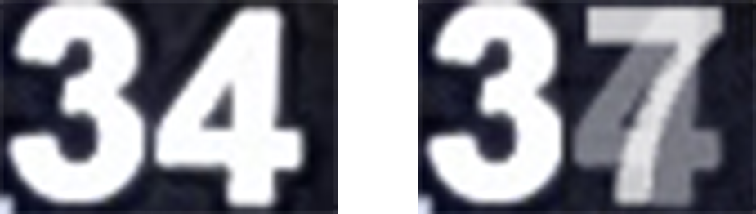

Figure candidates for digits obtained correctly; candidates for digits obtained incorrectly between two values

### Tesseract

At first I try to classify candidates inside of the bounding box by Tesseract library [11]. This library is relatively sophisticated and try to do some preprocessing processes before the actual classification. At first library is trying to find the lines of the text inside of the image. Because our bounding box is as small as possible rectangular selection with all candidates for a digits, we need to expand this bounding box. This process was simply done by expanding of the bounding box in all directions by 100px of black color, because we already have white text on black background. If we keep candidates too close to the border of the bounding box, Tesseract library will a have really big problem with classifying of these candidates.

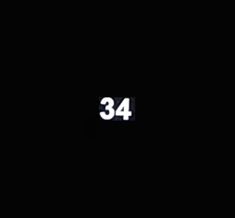

Figure Expanded bounding box for one region of interest

Another step is word recognition. Because we have only one world in bounding box this step is unimportant for us. After that software continue by trying to chopping connected candidates, extracting features and actual classification. For more about all processes please refer to [28].

Big advantage of this library is already completed dataset of training data for classifier. Because on the patient monitor, as I mentioned in 2.1, occurs almost only synthetic fonts I used classical dataset for English which is included in Tesseract. It’s also possible to learn Tesseract directly on our dataset, which give us better results for concrete monitor but this software should worked on different types of monitors.

Another advantage of Tesseract library is that we can define which characters could occur in the image. Because patient monitor has really limited set of symbols, which are mentioned in 6.6.1. Tesseract try to classify candidates only these symbols. If match isn’t above the threshold defined by Tesseract, Tesseract return empty string. In that case I tried the second classification which is difference with stored masks.

### Difference with stored masks

If classification by Tesseract fails I tried to classify by using similarities with stored masks. Before this process we need to make masks with the stored digits. Every of these mask should contain only one white letter on the black background inside of bounding box. Once when we have these masks we need to define which mask contain which symbol. This option is for now done internally in the code by a List. Now we have defined and stored all mask for upcoming comparison.

Bounding box which contain data for classification should by separated to individual candidates at first. This can be easily done by connected-component labeling inside of the bounding box. After that we separate every label with corresponding new bounding box.

Now we need to resize contain of every newly created bounding box to image with size 35 x 35px with maintaining the same aspect ratio. Because symbols are higher than wider we resize every candidate to height 35px and width will be calculated automatically with respect to aspect ratio. After that we add black border with same width to the both sides of resized candidate to complete square to 35 x 35px. This process is shown in Figure 35.

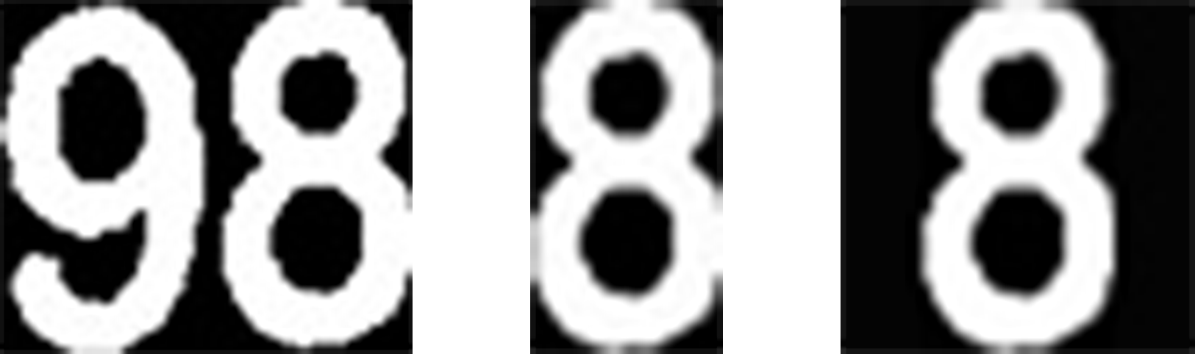

Figure region of interest in bounding box; one separated candidate for digit; one candidate resize to 35x35 px with same aspect ratio as original

Comparison of newly created candidate in 35 x 35px box and mask could begin. If mask doesn’t have the same size as compared candidate, we apply on this mask same resize process which is mentioned above. Now we use simple absolute diff between the mask and candidate. Because we know that borders of the digit captured by camera ordinary isn’t smooth we apply morphological operator called open on it [60]. Morphological open is using in our case circle kernel with diameter equal to 2px. Comparison of mask and candidate is shown in Figure 36.

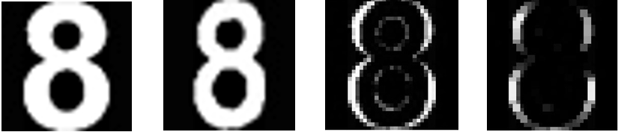

Figure Stored mask with digit 8; candidate for digit; difference between stored mask and candidate; difference after using morphological open

If candidate have difference with mask after these processes smaller than 2 percent we add it to the list of possible digits. After testing of all digits we choose the one with the smallest value of difference from this list. This process is done for all founded candidates in the original bounding box with the whole possible number.

## Saving to file

Once when we have classified data, we can store them. At the moment all data are store in CSV file [61]. This shortcut means comma separated values. On the first line of file you can find names of all ROIs separated by commas. On all other lines are results of classification for these ROIs. Column with the results corresponds to column with the mane of the ROI. Data are stored to CSV file every time when timer tick. That means every time after selected period of time.

## Backup process

In chapter 6.8 I mentioned three different kind of changes, but there is fourth possible type of change. Change when monitor is covered by something and during that someone move with the patient monitor or a camera. After this situation happened, software doesn’t found any candidates in new ROI which corresponds to previous ones. That means process cannot go successfully through tests in 6.6.1 and 6.7.1. It’s obvious because when no candidate is detected inside of the ROI, ROI still be waiting at the same coordinates in the whole scene and waiting until candidates again appears as it mentioned in 6.8. But required data which we previously acquired is moved away during the monitor was covered.

This type of change is the most complicated for digits based approach. My solution which is mentioned below doesn’t work well, because there are few problems. Because of that this solution is not recommended and doesn’t included in the tests in 8.3. This kind of change is much better solved in the monitor based approach 5.1. In that approach if we locate the monitor in the captured scene we can easily locate the concrete information after the projective correction. In that approach it doesn’t matter if we move with the covered monitor or visible monitor.

### Problems

There are few reasons which make it complicated. We don’t want to obtain any information from the monitor, we want the concrete one. That means we can’t just find the closest fine candidate as close as possible to the previous location. As you can see in Figure 37 on patient monitor could be more data with the similar candidates. Because of similarity these candidates could pass tests in 6.6.1, 6.7.1. That means if we change the location of data in scene, when patient monitor is covered, wrong data can be selected as required ones, when patient monitor is revealed.

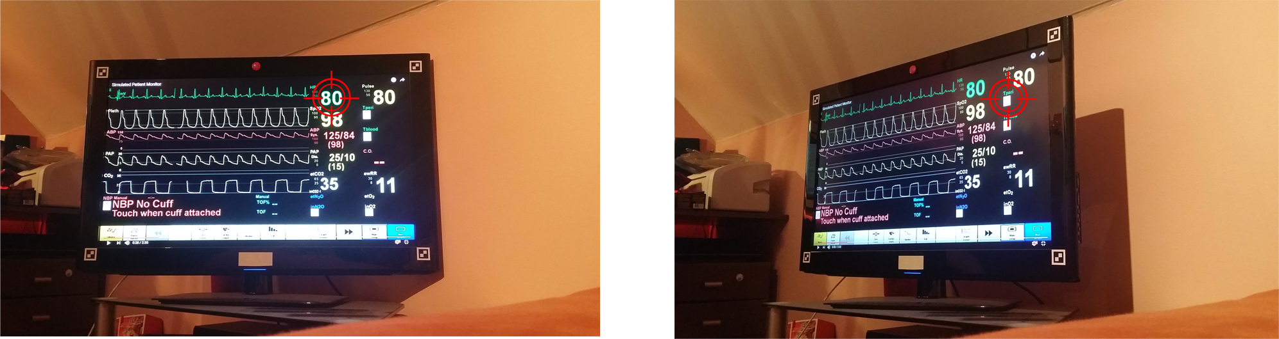

Figure Captured simulated patient monitor by camera from same spot in both cases. Regions of interest are at different positions. Red target is at the same position in both images.

Second problem is the color of the candidates. If monitor is moved away there could occur some reflection, change of light conditions in room or others which change value of separated color channels quite a lot.

Third and also the biggest problem is number of clusters with the candidates. Patient monitor is dynamic hardware. So it’s possible that when the patient monitor was covered, medical personal activate or deactivate some other parameter on the monitor. That means there is one more, or one less, cluster of candidates in the captured scene. Another option is that during the patient monitor was covered someone put the next similar monitor in the scene. That’s also mean new clusters with candidates. There are few more situation when new candidates can occur or disappear.

### Definition of possible candidates

This process start immediately after the calibration and also can be done with some interval during the acquisition process. Once when we have all characteristics about the regions of interest and also about digits inside it, we can start this process. It necessary to find all possible clusters of candidates in the whole scene and their position in the scene before the actual acquisition process starts. Cluster of candidates is set with minimally two candidates which standing on the same lane. All steps mentioned below are done for all defined regions of interest by a user.

First of all it’s necessary to find all possible candidates in the whole captured scene which are similar to digits inside of the ROI. This step is very similar to whole process of digits based approach 5.2. First step is grayscale of the whole captured scene same as in 6.3.1.3. After that we binarize the scene by locally-adaptive threshold 6.4.3. Now we have two separated layers i.e. foreground and background. All areas in the binarized scene are labeled by a connected-component labeling 6.5. Tests in 6.6.1 and 6.7.1 are applied to labeled areas. In the end of this pipeline we have all candidates for a digits which are similar to digits inside of the ROI.

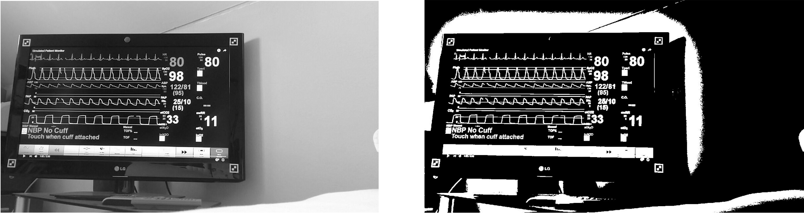

Figure Grayscale captured scene; binarized scene by locally adaptive thresholding

Almost at every patient monitor digits are shown in at least pairs. We connect together candidates for digits in clusters i.e. lines. Every single candidate has its own centroid. Centroid is the [arithmetic mean](https://en.wikipedia.org/wiki/Arithmetic_mean) position of all the points in the shape. Candidates in one line should be relatively close to each other horizontally, if patient monitor is horizontally located. So if distance between two candidates in horizontal axis is lower than two times size of the candidate they should be in one line. This distance was calculated by following formula (48).

|  |  |  |
| --- | --- | --- |
|  |  |  |

Other condition that must be met is position in vertical axis. If centroid of newly founded candidate for a neighbor on the line is located between the most top and most bottom coordinate of second candidate. They are on the same line. After testing all candidates to all candidates we have candidates separated in clusters i.e. lines.

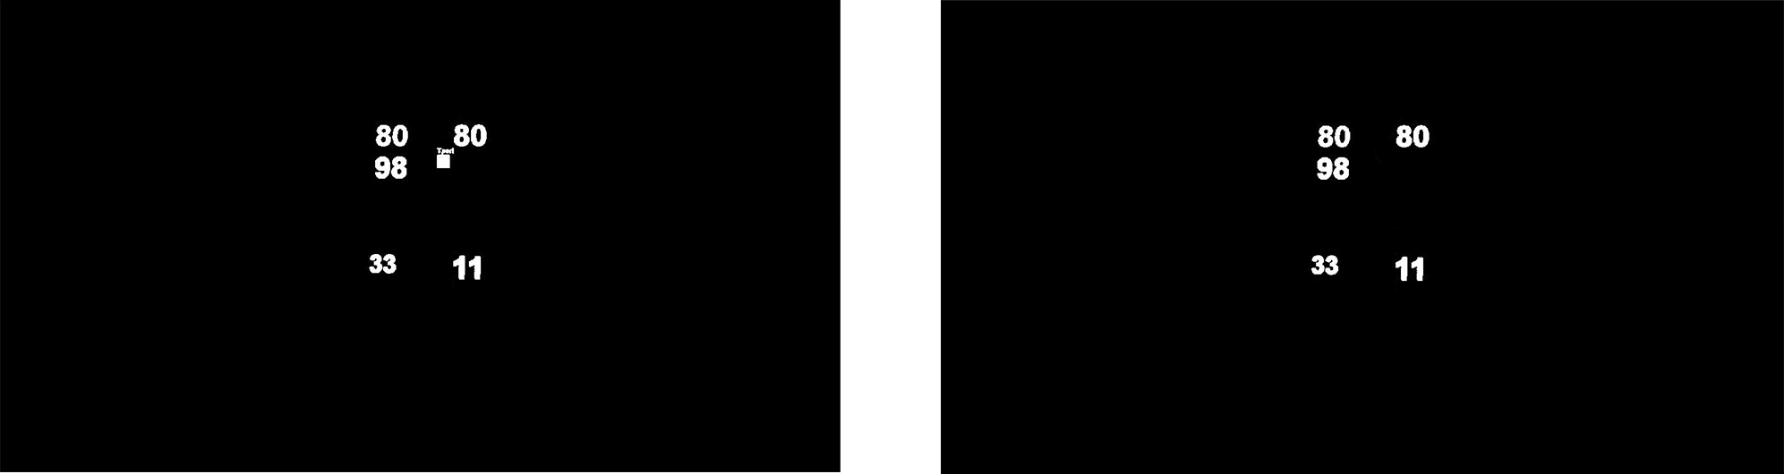

Figure Selected candidates with characteristics similar to candidates in actual region of interest; candidates filtered to only candidates in clusters i.e. lines

Every one of these clusters can contain two or more candidates. Because we want to locate the whole cluster in the captured scene, we need some characteristic of this cluster. Fine parameter is centroid of the whole cluster. Centroid is calculated by formulas below (49), (50).

|  |  |  |
| --- | --- | --- |
|  |  |  |

|  |  |  |
| --- | --- | --- |
|  |  |  |

Now we can determine position of clusters in the vertical and horizontal axis in pairs <horizontalPosition, verticalPosition>. We obtain both of these information, but the position in horizontal axis is more important. Because the position in vertical axis should change during the rotation around the vertical axis with the patient monitor in the scene. Rotation around the horizontal axis appears highly unlikely. This fact is nice to see in Figure 37. Where on the left figure both number 80 are on the same line, but in the second one yellow 80 is definitely above the green one.

Once when we have information about the positions of the clusters, we compute the distance of all clusters to centroid of actual ROI by formula (51). Once we found the closest one we store in this ROI position in vertical and horizontal axis for upcoming backup process.

|  |  |  |
| --- | --- | --- |
|  |  |  |

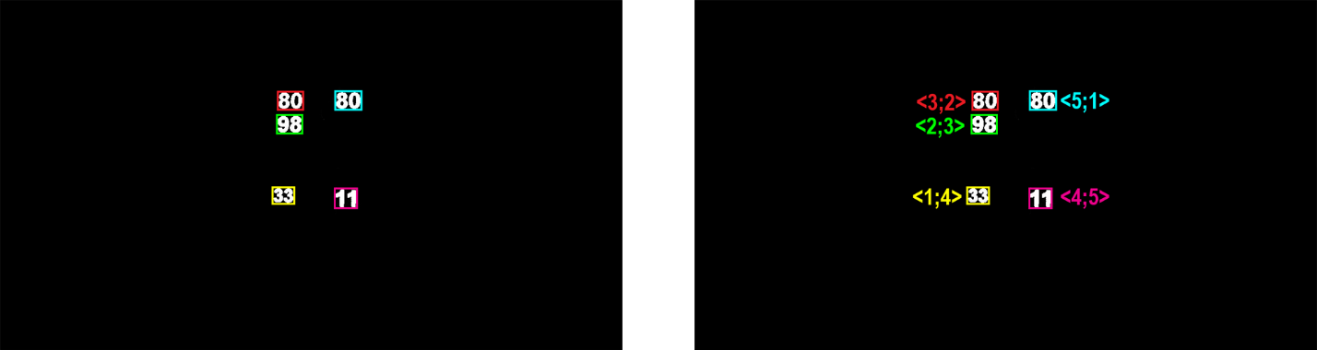

Figure Selected groups of candidates; selected groups of candidates with its position in scene <horizontal, vertical>

### Backup process

Back up process can be activated every time after defined period of time, for control if every ROIs are located right and looking on a right data in the scene. On the other side back up process could be activated only if some ROI doesn’t contain candidates for digits for a long period of time. In my implementation I choose the first option.

When backup process is activated same process as during definition of possible candidates 6.11.2 are done on the whole captured scene i.e. grayscale, binarization, connected-component labeling, filtration of candidates by tests, construction of clusters, definition of their centroids, founding of position in both axis. That’s the last same step.

After that we look in the ROI for location in horizontal and vertical axis. That position was stored there during the definition of possible candidates process. At first we look which cluster is at the same position in horizontal axis. If this cluster have neighbors which have centroid located inside of its width in horizontal axis. All these clusters are candidates for the right one. If not selected cluster is the right one.

Now we can look at the positions of centroids of selected candidates to right clusters. We look on vertical position extracted from ROI, where this information was stored before, and select that cluster. If other selected candidates to right clusters centroids are located inside of the height of that cluster in vertical axis. We still have more than one candidate to right cluster. In the other case we select the right one.

If we still have more than one candidate for a right cluster we select one which have best position in horizontal axis. Because as I already mentioned above in 6.11.2, position in vertical axis could be incorrect. Process of founding green 80 is nicely shown in Figure 41 and Figure 42.

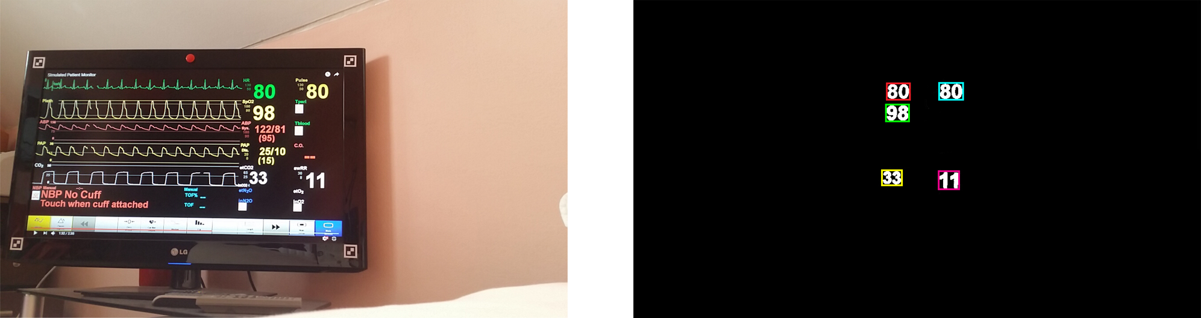

Figure Original captured scene; selected candidates for clusters with similarities to digits in lost region of interest

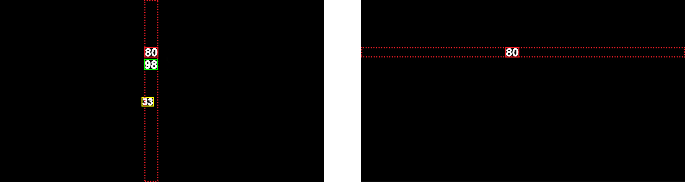

Figure All possible candidates in horizontal axis; all possible candidates in vertical axis after horizontal axis filtering

If we select the right cluster, we can redefine location and size of the ROI by parameters of the cluster. New size of ROI is calculated from size of cluster, because size of cluster represents in essence bounding box for digits. Size of the new ROI is calculated same as in 6.8.1.

## Summary of used methods in upcoming application

In chapter 6 I presented several methods and algorithms which can be used during the digits based approach. Few of them are ideal for data acquisition from patient monitor and few not. Following chapter sum finally selected methods and processes.

### Calibration

At first I select rectangle area with all required regions of interest on patient monitor screen. For this step there are no alternatives. This process is described in chapter 6.1.

After this step it’s necessary to select each region of interest. When one region of interest is selected by rectangular selection it’s converted to grayscale by luminosity method mentioned in 6.3.1.3. Once we have a grayscale region of interest we convert it to black and white image by locally adaptive thresholding by Bradley + Wellner. As a function above the rectangular selection was selected Gaussian function with size of neighborhood equal to 101. This method is mentioned in 6.4.3. After locally adaptive thresholding of selected region of interest segment it to foreground and background.

Foreground of region of interest contain more than just candidates for digits. This could be noise, other artefacts, other candidates for digits, etc. We mark each area in foreground by unique identifier. For that purpose is used Connected-component labeling mentioned in 6.5.

After labeling first correct candidate, selected by user, and its neighbors on line are selected exactly as it described in 6.6 and 6.7. After that we have all what is necessary for upcoming data acquisition process. All processes mentioned in three paragraphs above, included that one, are done for all selected regions of interest. Whole process is shown in Schema 6.

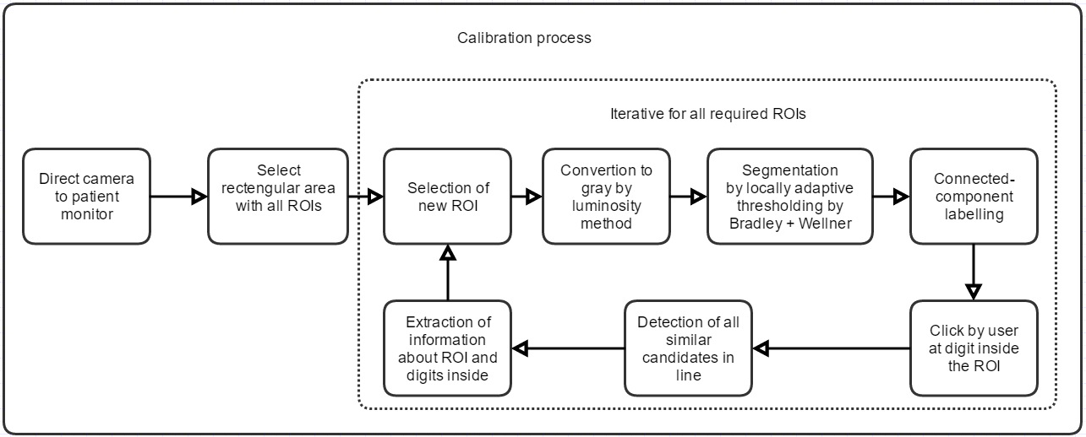

Schema Calibration process for digits based approach with selected methods

If beta back up process is used, software find all possible candidates for all regions of interest. That means each region of interest contain information about its position in vertical and horizontal axis before actual data acquisition. Beta back up process is described in detail in 6.11.

### Data acquisition process

During the actual data acquisition is detected change in each region of interest. If this change is above selected threshold, appropriate action is done. Used detection of change is exactly same as detection mentioned in 6.8.

When timer tick at user defined time, software try to classify each region of interest by Tesseract. If Tesseract fails, software tries to use difference with stored masks as a classifier. If this method also fail result of that region of interest is equal to NaN. This is done for all regions of interest. For more detail please refer to 6.9.

Calssified values are saved to CSV file. For more detail about CSV please refer to 6.10. Whole pipeline of data acquisition process is shown in Schema 7.

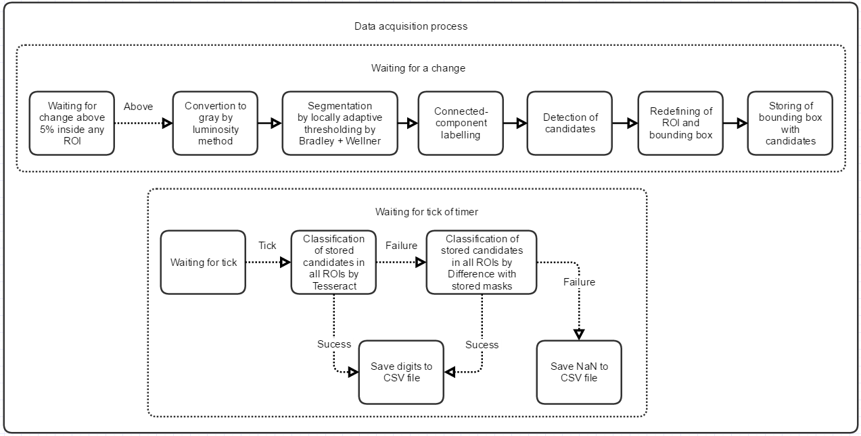

Schema Data acquisition process for digits based approach with selected methods

If beta back up process is in use and tick violate its use, methods in 6.11.3 are used. That means we try to find the appropriate cluster of candidates at newly captured scene by positon in horizontal and vertical axis. This position was saved to all regions of interest during the calibration.

# Future extensions

This diploma thesis is just a first step into optical data acquisition via camera from patient monitor. There was mentioned two approaches how to obtain textual information from patient monitor. But there are still many thing which could be included in the software as an extra, like a multi-camera approach or curves acquisition. Other thing can be done more precisely, this thing are for example classification and methods to separate digits from the captured scene. In following subchapters I go through possible extension with the greatest attention to multi-camera approach and curves acquisition.

## Curves acquisition

On the patient monitor are not only digits but also curves. This curves are really useful for medical personal and can show many different trends. The most known is Electrocardiography i.e. EKG or ECG [62]. On EKG doctor can check for example if PQRST cycle looks like the one for health person. At all, information stored in curves stands for depositing. Once when we deposit them, we can use some statistical analysis on them.

Curves on patient monitor can be described as a graphs. There is software which can extract data from images of graphs. For example im2graph [63], WebPlotDigitalizer [64] and others. These software are very similar to what we want to do as a future extension, but there are few differences. All these software used the defined axes or you need to define them before the acquisition. Also these programs work on static scenes, that means we obtain the data from them only once with the same ratio. There are also more problems like that, these problems are described in 7.1.2.

### Curves on patient monitor

On market, and in hospitals, is many different types of patient monitors. They use different ways how to show curves on patient monitor. Some of them contain some kind of axis some of them contain multiples axes. When some of them absolutely doesn’t contain any axes. Example of different styles of curves showing is in Figure 43. When I do a survey through a web the most used style is style without axis. However this survey it isn’t conclusive.

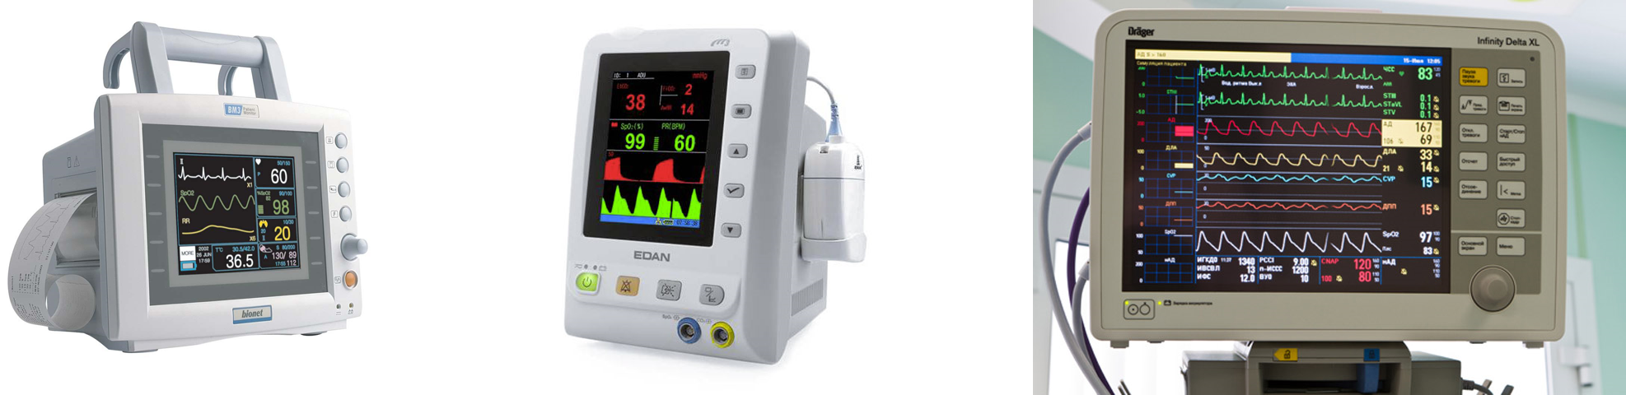

Figure Different types of patient monitors with different way how to show curves on their screens

First what should be mentioned is the style of curve redrawing on patient monitor. We have two basic types of redrawing. The first one and more present in patient monitors is when curve is redraw gradually by a small black window. This small window travel iterative from the left to the right along the curve. Every time when that windows appear on a curve new information is shown on the left side of that window. This window can be called as some kind of redrawing window and it’s represented by a black window which cover the curve. This redrawing is nicely shown in Figure 44.

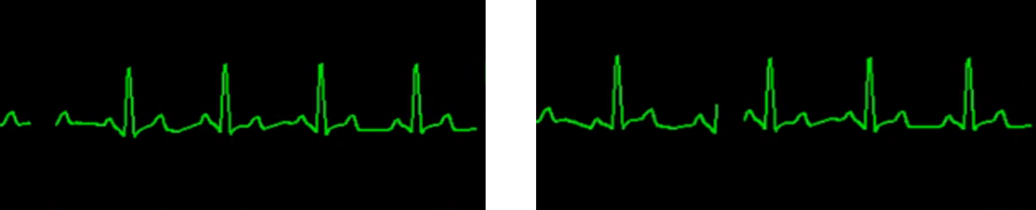

Figure EKG curve with different position of redrawing window

Second possible approach of redrawing is by a moving of the whole curve on the patient monitor. That means when we need to show a new information in form of curve we move the whole curve to the right and show the new information on the left. Same amount of curve which is added to the left is deleted from the right side of curve. At all it looks like a whole curve is moving to the right.

### Problems with curves

Curves on patient monitor aren’t regular static graphs and that cause many problems. In this chapter I describe these problems and show possible solutions.

#### Axis problem

Patient monitors at almost all cases doesn’t have any axes for a curves. As you can see in Figure 43 patient monitor can contain some lines which looks like axes, but ordinary these axes don’t have any description about the values, units and scale. Some monitors absolutely don’t have any lines on the screen. Because of that we can’t simply subtract the value from the curve, because we don’t know the value in horizontal and vertical axis.

First solution seems to be definition of axis for all curves by a borders of the captures scene. This will be ok, but we must meet few conditions. Monitor and camera have to be set perfectly parallel on each other. That means top and bottom border of the captured scene by a camera must by parallel to top and bottom edge of the patient monitor screen. That is related to that scene must be static i.e. no one can ever move with the monitor or camera during the acquisition process. Once when we meet these conditions, we can extract curve value in horizontal and vertical axis, where pixel of curve is located. In the end this approach is bad for normal use, because the scene isn’t ordinary static.

Second solution is based on definition of axes for all curves by a borders of the screen. This approach seems to be very ok, if we use a monitor based approach 5.1. Monitor is projective corrected on every frame so borders and curves should at the same position in these frames. If we move with the monitor, or camera, projective correction set screen back to rectangle every time and we can simply extract value of curve in both axes. Projective correction also solve the scale problem when patient monitor is closer or further. Because every time we correct the patient monitor screen to rectangular with the same size. This approach seems to be most suitable solution and user can define the scale of the both axes.

Last solution is definition of every single axes for every monitor manually by a user. This approach is usually used in mentioned programs in 7.1. All processes mentioned below are done on projective corrected image. We simply set two points for horizontal axis and two points for vertical axis with the corresponding values. Because we don’t know these values, as a best solution seems to be (0, 1) interval. Once we defined all axes for all curves we can just simply extract information from them, because these axis will be also projective corrected every time when patient monitor screen is corrected. This approach is fine, but because we don’t know the values on axis we can use the previous one. In the previous one there is less work for the PC and also for a user.

#### Crossing curves

On some monitors curves can cross with axes or other lines on the patient monitor. This problem is really important, because these lines looks almost like a required curves. Shown curves ordinary don’t look like a line, but for example when heart rate is equal to zero curve will be the line and that doesn’t mean it’s not a required curve. These lines should be misinterpreted as a required curves. These lines are nicely shown in detail in Figure 45.

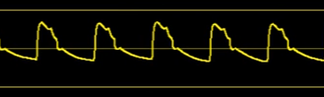

Figure Crossing curves from background of the patient monitor with required curve which we want to obtain

That what is typical for these lines is they are all the time at the same position. That mean every time when we try to acquire data form the patient monitor these lines will be the same and that’s the solution. We can store a mask before the required curves appear and use that mask as a background which we every time subtract from the actually captured frame. After that the image obtain only the curve with some artefacts after the subtraction. Sometimes it’s not possible to acquire mask without the curves. In that case we use a bunch of frames from previous seconds and do a unification on them. All these frames should have same only these lines, which means we got the mask and we can continue with process same as I mention above.

### Curves acquisition

The curves acquisition is quite similar to monitor based approach 5.1. In this approach I contemplating with patient monitor with lines on screen and redraw window. There are more approaches how to obtain curves and this is only one of them. At all we can use more methods which are mentioned in previous chapters or some others in every single step of curve acquisition.

First of all we need to find the corners of the monitor. If we have the corners of the monitor we can do a projective correction. After that correction, user define the regions of interest with curves and software set left and bottom edge of patient monitor screen as vertical and horizontal axis and user set their scale.

Now we move to actual acquisition and need to extract only curve from ROI. At first we grayscale contain of ROI or use the value channel from HSV space. If we done with this, we use some kind of binarization method. Because the curve could be relatively long, and some part of patient monitor screen could be occupied by light reflection. Locally adaptive threshold 6.4.3 seems to be best option. Sometimes curve can be discontinuous. That problem will be solved by morphological close which connect the close objects.

Now we have all candidates for curves in the ROI so we need to filter some of them out. At first we try to filter the constant lines in the ROI. These lines can be removed by method mentioned in 7.1.2.2. After that curve can be cut by removed lines. That means we want to connect them back. For that we again use morphological close. Other thing that is typical for curves is their bounding box area of their bounding box is many time bigger than occupied area inside of it. Also size of the bounding box should cover at least approximately 1/20 of the ROI. Yes this condition should cut out the small pieces at the end or start of the required curve in some situations. However we obtain curves at least every second, and redraw time of the whole curve is longer. Another way how to filter curves is by stroke width variation. Because curves have almost the same with all along the curve. This method is used ordinary for extracting text in natural scenes [65].

After these basic filters we should have only two curves separated by a redraw window mentioned in 7.1.1. This window is essential for upcoming storing process. We want to store only new data from every frame from the curve. We need to connect the old one curve which is already stored to the new one obtained from actual frame. Redrawing window help us with this problem. We store the position of this window every time when we save data from curve to the database. Because we know the window is moving from the left to the right. We also know that curve between the old position of redrawing window and new position of that window is new part of the curve. So we can store only the new data.

Filtrated curves on the patient monitor isn’t smooth and there could still be some other parts in ROI which are connected to curves. Value in horizontal and vertical axis is simply calculated by following formulas (52), (53).

|  |  |  |
| --- | --- | --- |
|  |  |  |

|  |  |  |
| --- | --- | --- |
|  |  |  |

Horizontal position is median of point in curve from horizontal neighborhood with size equal to appropriate value which is depend on the resolution. Vertical position is defined in the same way but in vertical neighborhood. We also can use mean value, but median value is more robust to outliers. If we solve this for one point we move one pixel further in horizontal axis.

The storage of curve is opened problem. Because when we want to storage curve point by point it takes a huge place on hard drive. This is a general problem of time series. For example one hour of EKG takes 1 Gigabyte [66]. We can save only some features about the curves like max value, min value, autocorrelation, zero crossings, ARIMA, etc. or space curve with lines. Sometimes is necessary to storage the whole data point by point.

## Multi-camera usage

With the multiple sources of data we obtain more robust results. That also work for multi-camera approach. If we use multiple cameras for data acquisition from patient monitor, we can use multiple data sources in every single step of this acquisition process. For more cameras which are focused to patient monitor are better to use different position in the room where patient monitor is located. If both cameras will be on the almost same spot that means all processes on obtained frames will be also almost the same. Locate cameras in different positions in the space, also provide bigger possibility that if patient monitor is covered by something for first camera, this obstacle probably doesn’t block the view of the second one.

### Possible situations

Every single camera of multi-camera approach work itself i.e. all of these cameras has its own thread. In the end of acquisition pipeline results from all cameras are compared and best option for result is select. After the actual acquisition can occur more situations and depending on this situation we select the best option. All these options are mentioned below in 7.2.1. All situations will be described for two camera system, but usage in multi-camera system is almost the same.

#### Two same results

If both threads after the classification contain the same result solution is easy. Final result of classification is the value which is classified by both threads.

#### Two different results

If one camera classify one value and the other classify different one we have to aggregate the result. Simplest way is comparison of classification error of both threads. Afterwards we select the result from the classifier with lower classification error. More sophisticated solution is classifying of both bounding boxes with candidates with another type of classifier. After that we compare the sums of classification error for all obtained results. Option with the lowest sum is afterwards select as a final result.

#### One result and no candidates

This situation means that one camera source is covered by something, or monitor is off, and the other not. Final result is the result from the thread which contain the result.

#### One result and candidates without label

In this situation one camera could not classify and other yes. In that case we use one extra classifier to classify both bounding boxes again. After that we compare the sums of classification error for all obtained results. Nonempty option with the lowest sum is afterwards select as a final result.

#### Candidates without label and no candidates

In that case we try to use new classifier to the candidates without label. If that classifier give us a result we use that one as a final result, if not result is NaN.

#### No candidates at all

That means both cameras are covered by something or monitor is turned off. In that case the final result is NaN.

### Use during the backup process

Multi-camera system could be also useful during the backup process 6.11.3. If one camera for a long period of time doesn’t extract any candidates for a digits. Camera or monitor was probably moved away, meanwhile something covering it. That means we try to use a backup process.

At the end of this process we have separated clusters of candidates for ROIs. One of these clusters is selected for concrete ROI. Once when this cluster is selected we can switch this ROI to test mode for few upcoming second. If classified data from test ROI for one camera correspond to classified data from second camera, backup process select the right ROI for cluster and we switch this ROI to normal mode. If results from these two ROIs are different we redefine test ROI to new cluster from backup process. This process continue until all clusters are correctly paired with their ROIs.

## Other extensions

In this chapter I try to introduce other possible extensions. All of these extensions are almost in every case connected to the problem in application.

### Separation of candidates

This is in my opinion the biggest problem of this diploma thesis. Because when we are testing candidates by tests in 6.6.1 and 6.7.1. We assume that these candidates are separated characters with specific characteristics. In case that two or more letters are connected we don’t accept these candidates.

Solution for this could be erosion with appropriate kernel. This solution is useful only in cases if connection between the characters are significantly smaller than stroke width of the letters. If stroke width has similar size as connection between the characters. Erosion start to erode also characters itself.

Nice solution of candidates separation was published by Lukas Neumann [26]. In this method we measure distance between top and low pixel in every column, in projective corrected candidate. After that we find a local minimums and try to cut candidates gradually in these extremes and classify newly created candidates. Example is nicely shown in Figure 46.

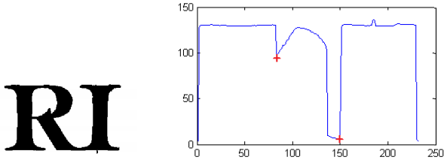

Figure Connected candidates for symbols; graph of distance between top and low pixel in every column with local minimums [26]

### Combining of both approaches

Both of mentioned approaches for data acquisition have its own advantages and disadvantages. If we combine these two approaches in one and use advantages from both of them we obtain better results.

Monitor based approach is better, if someone is moving with the patient monitor, meanwhile something is covering it. Also from curve acquisition in 7.1, this approach is many time more suitable. On the other side this approach is relatively time and source consuming and we can use it only when border of the patient monitor screen is recognizable.

Digits based approach is faster and should work with similar accuracy in case of digits acquisition. We can also use it during the night, when light conditions in the room is dark. But curve acquisition is almost impossible and backup process doesn’t work so well.

In the end that means if we want to extract only digits from the patient monitor and no back up process is needed we use digits based approach. If it’s necessary to use back up process we use monitor based approach, if borders of patient monitor screen are recognizable. In the other case we use backup process from digits based approach. In the end if we want to acquire curves as well we need to use monitor based approach. It’s also possible to use both approaches separately on two threads and combine the data from both of them in essential parts like results of classifiers.

### Communication along the network

Now all classified digits from patient monitor are stored to CSV file [61]. It will be nice to make a client and server for this application. Client will be installed on some distance PC which could set calibration and start acquisition on the server. Server will be installed on the gizmo with camera in the room where patient monitor is located. Once when client set all required settings on the host actual acquisition process begin. Client-server could be implemented as a thick or fat client [67]. Because sending image via internet or internal network is a big amount of data, thick client looks like a better option. All acquired data, or frames, will be sent to client PC via TCP/IP [68].

That means it won’t be necessary to visit room with the patient monitor every time when we want to start data acquisition process.

### Detection of separators

On patient monitor can appear in addition to digits also separators. In this thesis I work with three kind of them. These are braces and slash. On the patient monitor can occur different types of separators. Most important are comma or dot. Problem with both of these separators it’s their big similarity with noise in the scene. That means it’s necessary to implement filters which try to find these separators.

# Implementation

Digits based approach was implemented as a standalone application in programing language C#. I use some third party libraries, which are mentioned below in 8.2. For graphical user interface (GUI) of the application was selected windows forms. Newer version of making GUI in C# called Windows Presentation Foundation isn’t supported by an EmguCV library. GUI is resizable and should show information readable on almost all computer screens.

The main goals of the application were two. First of them is quality of classified digits from patient monitor. User do several setting during calibration process every time before actual acquisition for more robust results. The second one was performance, because in near feature it will be fine to use Mono C# compiler [69] and transform this application to mini PC like Raspberry pi with connected camera.

*Raspberry Pi is a credit-size single board computer developed in United Kingdom by Raspberry Pi Foundation to promote teaching on basic computer science in schools and in*[*developing countries*](https://en.wikipedia.org/wiki/Developing_countries) *[70].* Five millions Raspberry Pis have been sold before Febura 2015, that makes this mini PC best-selling British computer [74]. Average price for the newest model Raspberry Pi 3 is about $40 (3.1.2017). Camera, case and other accessories isn’t included with Raspberry Pi. Raspberry Pi has classical USB 2.0 connector so it’s possible to connect camera via this connector. On this mini PC is possible to run many types of operating systems, for example: Raspbian, Fedora, Ubuntu Mate, Kali Linux, Windows 10 for IoT, etc. Raspberry Pi doesn’t have a performance as currently sold average personal computers. That’s the reason why all image transformation are done on the smallest possible selections. Raspberry Pi 3 Model B contain ARMv7 Processor rev 4 (v7l), which has performance equal to 1.09 GFLOPS per one core [75][76]. PC mentioned in 9, where experiments we conducted has 4.35 GFLOPS per core [76].

For more details about Raspberry Pi please refer to [70].

Application was implemented for 64bit windows systems. This application also should work with 32bit windows systems, but it’s necessary to download 32bit version of libraries mentioned below in 8.2. If you want to run this application on other systems its necessary to use different library for selection of camera source and do appropriate adjustments in code.

Camera is selected from all successfully installed cameras on the system.

## Brief description of implemented code

In this chapter I describe most essential classes implemented inside the application.

### Graphical interface

Graphical interface of implemented application is composed from seven windows forms. Every one of them have different function in application.

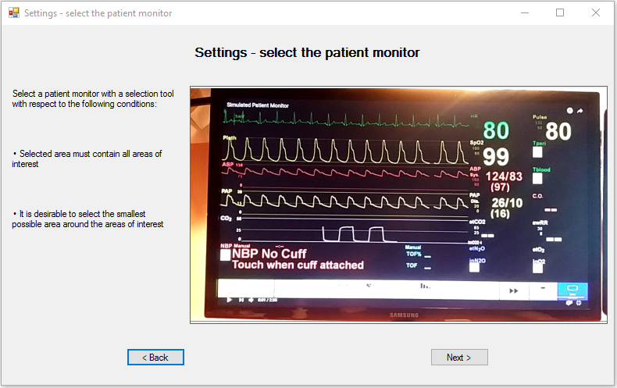

Figure Example from GUI of implemented application

#### frmMain

This form work like a main menu of whole application. There are only two possibilities what to do. First is start of calibration process before data acquisition and second is exit of the application.

#### welcomeSettings

At this form user of the application is welcome and should continue.

#### selectCameraSettings

In this form is the user prompted to select one installed camera from shown combo box. Information about installed cameras on system is provided by library DirectShowNet mentioned in 8.2.2. For this purpose is called class cameraSettings 8.1.2.1. When camera is selected its socket is same to new instance of class camera 8.1.2.2.

#### setCameraInSpaceSettings

In this form user can see video signal provided by selected camera and recommendations for setting up camera in space. Frames are captured every time when application in idle state. Frame acquisition and its show in imageBox provide methods from EmguCv library 8.2.1.

#### roiSettings

In this form user select all ROIs in captured scene by rectangular selection. For this purpose are used action click, unclick and move while holding left mouse button. Left click by a mouse is defined as start of the selection. Move while holding left mouse button is recognize as a size change of selection. Unclick of left mouse button is defined as end of selection. Coordinates are recalculated to regular image by 6.2. This manipulation is implemented inside the class coordinatesManipulation mentioned in 8.1.2.5. Final selection with its coordinates is saved to appropriate instance of class camera 8.1.2.2.

#### additionSettings

In this form user set name of upcoming CSV file, rate of classification and if beta back up process should be turn on or not. All these options are saved to appropriate instance of class camera 8.1.2.2.

#### addAreasSettings

This form provide what is described in Schema 6 inside the part with name *Iterative for all required ROIs*. Every time when new ROI is selected this form call class labelSettings 8.1.2.3 which create a new instance of class label 8.1.2.4. All internal image manipulation are done externally in actual label class 8.1.2.4. If next button is clicked actual data acquisition process starts.

#### checkTrackingSettings

This form provide us information about actual contain of selected ROIs. All internal processes are called from this class. These are wait for ticks, checking if change inside any ROIs isn’t above the selected threshold and saving to CSV file. If button End session is clicked whole data acquisition process ended.

### Internal classes

These classes ensures the functionality of the application.

#### cameraSettings

This class is a factory for a class camera 8.1.2.2. This class also provide a list of all cameras installed on system by library DirectShowNet mentioned in 8.2.2. Information about index of active camera is stored in this class.

#### camera

Each instance of this class represents one camera. In this class are stored information about the calibration process.

#### labelSettings

This class is a factory for a class label 8.1.2.4. This class can add and remove selected ROIs.

#### label

Each instance of this class represent one selected ROI. All image manipulation processes which are associated with concrete ROI are done in this class. This class also contain all information about the ROI and digits inside. Function in this class corresponds to methods in 6.12. Except the classification and saving to the file.

#### coordinatesManipulation

This class do exactly what is described in chapter 6.2.

#### saveToFile

Methods in this class is called when timer in application tick. That means application tries to classify contain of all bounding boxes by Tesseract. If Tesseract fails application tries to classify candidates by difference with stored masks. Work of this class is described in Schema 7 in part called *Waiting for tick of timer.*

#### backUpProcess

This class do what is described in chapter 6.11.

## Libraries

### EmguCv

Because program working with images manipulation all the time, we also use cross platform .NET wrapper to the OpenCV library called EmguCV [58]. This library pack contain several image manipulation functions. Because it isn’t clear OpenCV but only a wrapper EmguCV sometimes didn’t work as should. There is also problem with functions from this lbrary where some of them are missing in used version for implementation, but older versions contain them. Used version was 3.1.0.2282

### DirectShowNet

DirectShowNet library [71] provide application all successfully installed cameras on the windows system. This version of used library is 2.1.0.0.

## Tests

Testing of monitor based approach methods and also testing for the second approach was done in software called Matlab from company Mathworks [16]. All these tests were done on static images. Big advantage of Matlab is image processing toolbox. This toolbox contain almost all image manipulations methods used in my thesis.

# Experiments

Implemented application was tested on simulated patient monitor. For this purpose was chosen Laerdal software [72]. This tool is a complex bundle of applications which can simulate various situation during the whole medical process. Patient monitor simulated by this software has same occurrence as classical patient monitor.

All experiments were captured by 720p camera (1280x720 px) which transmitted signal to personal computer via Wi-Fi. For all tests were used same simulation of patient monitor with length equal to 156s. Tests were done under various conditions and during the different daytime. That’s the reason why I choose Laerdal solution, because we can run simulation of patient monitor how we want.

During the experiments was tracked five source of data, parameters, on patient monitor. These data correspond to heart rate (HR), pulse, blood oxygen level (SpO2) and ambulatory blood pressure (ABP) in two options. First three parameters are easier to recognize and last two are more difficult. Last two parameters are smaller and doesn’t contain only digits but also delimiters. Figures of all parameters will be shown at every experiment with information about their size.

## Tracked outcomes

During experiments was evaluated several outcomes. In this chapter I describe them and show how they are calculated. Reference data was obtained from simulated patient monitor by a human. After that collected values was checked five times for error of human factor close to zero.

### Success rate

This outcome is percentage of corrected classified values during the whole simulation.

|  |  |  |
| --- | --- | --- |
|  | $$SR=\left(\frac{count\left(correctResults\right)}{count\left(allResults\right)}\right)*100$$ |  |

### Success rate after correction

In experiments I obtained that delimiters are a big problem of classification. For example value which should be equal to 123/80 is classified as 123180. Because of that I do an easy post processing on data and correct these facts. It’s possible because every ROI have some specification and for example value 123180 is absolute nonsense for ABP. Systolic pressure must be bigger than diastolic that means 123/180 is bad result. Also another position of slash in this result is nonsense. Final result is that slash was misclassified as digit one. All following outcomes are calculated on post processed results.

Success rate after correction is percentage of corrected classified values during the whole simulation after post processing. This outcome is the most important outcome at all and give us an idea of the result of experiments.

|  |  |  |
| --- | --- | --- |
|  | $$SRAC=\left(\frac{count\left(correctResultsAC\right)}{count\left(allResults\right)}\right)*100$$ |  |

### No text

This outcome is percentage of results with none founded candidates for digits.

|  |  |  |
| --- | --- | --- |
|  | $$NT=\left(\frac{count\left(NoText\right)}{count\left(allPPResults\right)}\right)*100$$ |  |

### No result

This outcome is percentage of results which have after Tesseract and difference with stored masks no result.

|  |  |  |
| --- | --- | --- |
|  | $$NR=\left(\frac{count\left(NoResult\right)}{count\left(allResults\right)}\right)*100$$ |  |

### Difference with stored masks

This outcome is percentage of results which was classified by difference with stored masks after Tesseract classifier fails.

|  |  |  |
| --- | --- | --- |
|  | $$DSM=\left(\frac{count\left(testedByDWSM\right)}{count\left(allResults\right)}\right)*100$$ |  |

### Difference with stored masks – success rate

This outcome is percentage success rate of difference with stored mask on result which was classified by this classifier.

|  |  |  |
| --- | --- | --- |
|  | $$DSMSR=\left(\frac{count\left(testedByDWSM \& correctResultsAC\right)}{count\left(testedByDWSM\right)}\right)*100$$ |  |

### Tesseract

This outcome is percentage of results which was classified only by Tesseract.

|  |  |  |
| --- | --- | --- |
|  | $$T= \left(\frac{count\left(testedByTesseract\right)}{count\left(allResults\right)}\right)*100$$ |  |

### Tesseract – success rate

This outcome is percentage success rate of Tesseract on result which was classified by this classifier.

|  |  |  |
| --- | --- | --- |
|  | $$TSR= \left(\frac{count\left(testedByTesseract \& correctResultsAC\right)}{count\left(testedByTesseract\right)}\right)*100$$ |  |

## Experiments

### One meter – light on

In this test camera was located one meter far from simulated patient monitor. Plane of the patient monitor was almost parallel to captured plane by camera. Light in the room was turned on. During the whole test camera and patient monitor was on the same position.

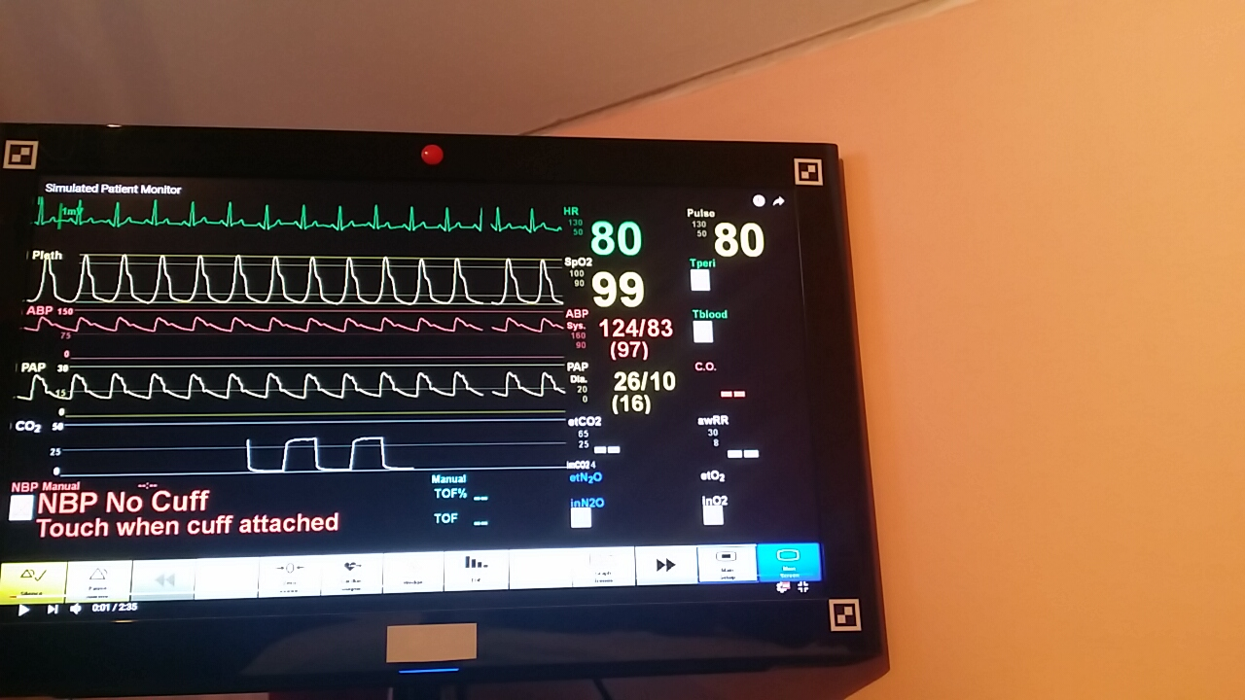

Figure Captured scene from one meter with light on

#### Scanned parameters



Figure All scanned parameters in their bounding boxes from one meter with light on captured before acquisition process. HR; Pulse; SpO2; APB_1; APB_2

Table Size of digits for experiment from one meter with light on

|  |  |  |
| --- | --- | --- |
| **Parameter** | **Avg. height of digit** | **Avg. width of digit** |
| **HR** | 34 | 24 |
| **Pulse** | 35 | 24 |
| **SpO2** | 36 | 24 |
| **APB_1** | 18 | 12 |
| **APB_2** | 16 | 11 |

#### Results of experiment

Table Results of experiment from one meter with light on

|  |  |  |  |  |  |  |  |  |
| --- | --- | --- | --- | --- | --- | --- | --- | --- |
| **Parameter** | **SR** | **SRAC** | **NT** | **NR** | **DSM** | **DSMSR** | **T** | **TSR** |
| **HR** | 100 | 100 | 0 | 0 | 0 | NaN | 100 | 100 |
| **Pulse** | 99.367 | 99.367 | 0 | 0 | 0 | NaN | 100 | 99.367 |
| **SpO2** | 100 | 100 | 0 | 0 | 0 | NaN | 100 | 100 |
| **APB_1** | 1.266 | 84.177 | 11.392 | 0 | 0 | NaN | 88.608 | 95 |
| **APB_2** | 87.342 | 87.342 | 0 | 0 | 0 | NaN | 100 | 87.342 |
| **Total** | **77.595** | **94.177** | **2.278** | **0** | **0** | **NaN** | **97.722** | **96.342** |

#### Conclusion

From results of this experiment in Table 3 you can see that success rate is sufficient. For bigger numerical values without delimiters SR is above the 99 percent. Interesting result is difference between the success rate before and after correction at APB_1. This big difference means that almost all slashes was misinterpreted as digit one. No text at ABP_1 was caused by connection of digit with the slash. As you can see in and Table 2, distance between these characters isn’t bigger than 3px.

### One meter – light on – angle

In this test camera was located one meter far from simulated patient monitor. Plane of the patient monitor screen was placed under angle equal to 45 degrees to plane of the scene captured by camera. Light in the room was turned on. During the whole test camera and patient monitor was on the same position.

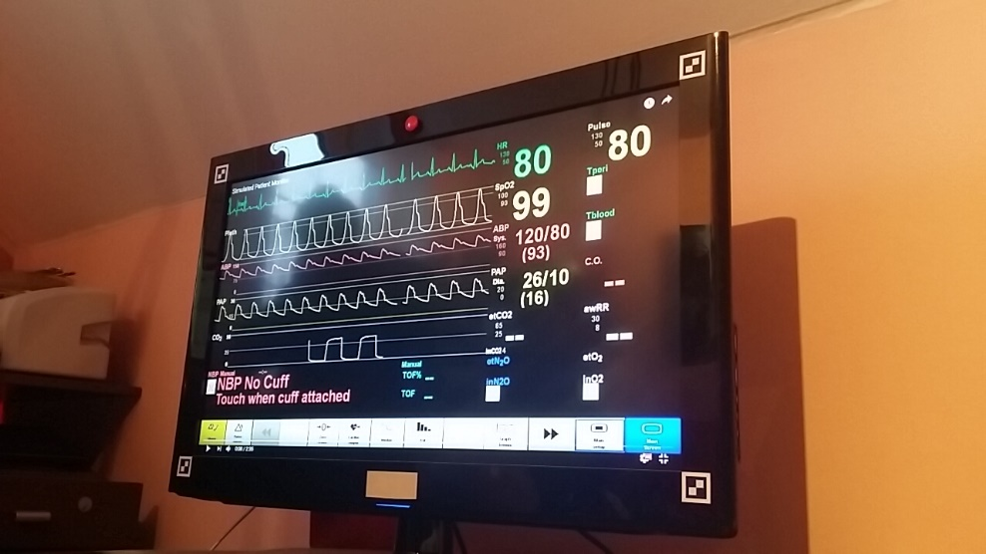

Figure Captured scene from one meter with light on under angle 45 degrees

#### Scanned parameters



Figure All scanned parameters in their bounding boxes from one meter with light on under angle 45 degrees captured before acquisition process. HR; Pulse; SpO2; APB_1; APB_2

Table Size of digits for experiment from one meter with light on under angle 45 degrees

|  |  |  |
| --- | --- | --- |
| **Parameter** | **Avg. height of digit** | **Avg. width of digit** |
| **HR** | 36 | 21 |
| **Pulse** | 39 | 25 |
| **SpO2** | 38 | 22 |
| **APB_1** | 19 | 11 |
| **APB_2** | 16 | 10 |

#### Results of experiment

Table Result of experiment from one meter with light on under 45 degrees

|  |  |  |  |  |  |  |  |  |
| --- | --- | --- | --- | --- | --- | --- | --- | --- |
| **Parameter** | **SR** | **SRAC** | **NT** | **NR** | **DSM** | **DSMSR** | **T** | **TSR** |
| **HR** | 97.468 | 97.468 | 1.266 | 0.633 | 0 | NaN | 98.101 | 99.355 |
| **Pulse** | 89.873 | 89.873 | 1.266 | 3.797 | 0 | NaN | 94.937 | 94.667 |
| **SpO2** | 98.101 | 98.101 | 0 | 1.266 | 0.633 | 0 | 98.101 | 100 |
| **APB_1** | 68.354 | 69.620 | 10.759 | 0 | 0 | NaN | 89.241 | 78.014 |
| **APB_2** | 93.671 | 93.671 | 0 | 0 | 0 | NaN | 100 | 93.671 |
| **Total** | **89.494** | **89.747** | **2.658** | **1.139** | **0.127** | **0** | **96.076** | **93.141** |

#### Conclusion

In this experiment digits was affected by projective distortion. As you can see in Table 5 overall success rate is lower than in case 9.2.1. What is really interesting is recognition of slash in almost all cases. Another interesting fact is the lower success rate at parameter Pulse than HR and SpO2. Because Pulse is the biggest and closest one to the camera.

### One meter – light off

In this test camera was located one meter far from simulated patient monitor. Plane of the patient monitor was almost parallel to captured plane by camera. Light in the room was turned off. During the whole test camera and patient monitor was on the same position.

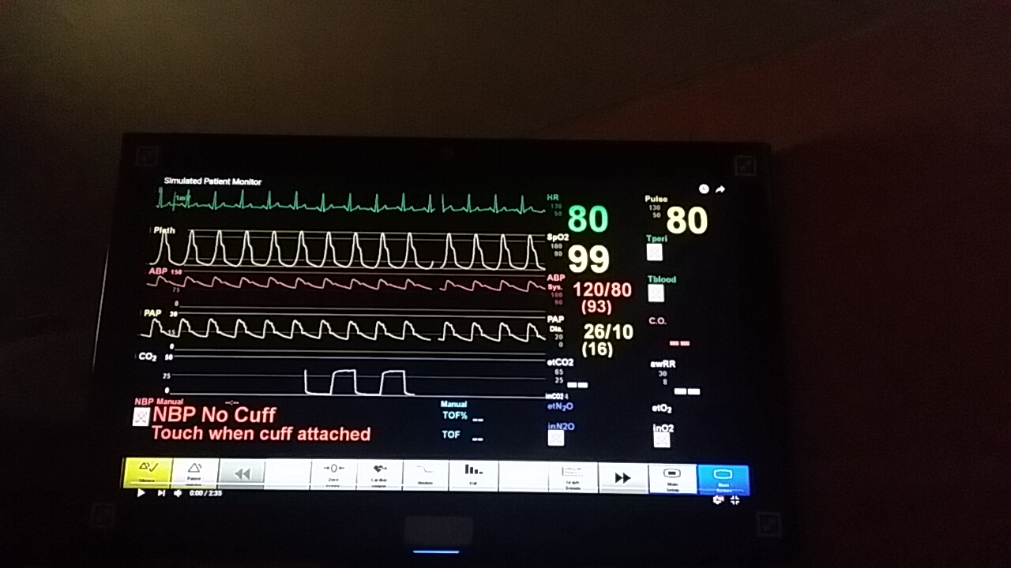

Figure Captured scene from one meter with light off

#### Scanned parameters



Figure All scanned parameters in their bounding boxes from one meter with light off captured before acquisition process. HR; Pulse; SpO2; APB_1; APB_2

Table Size of digits for experiment from one meter with light off

|  |  |  |
| --- | --- | --- |
| **Parameter** | **Avg. height of digit** | **Avg. width of digit** |
| **HR** | 34 | 22 |
| **Pulse** | 34 | 23 |
| **SpO2** | 35 | 23 |
| **APB_1** | 17 | 11 |
| **APB_2** | 16 | 11 |

#### Results of experiment

Table Results for experiment from one meter with light off

|  |  |  |  |  |  |  |  |  |
| --- | --- | --- | --- | --- | --- | --- | --- | --- |
| **Parameter** | **SR** | **SRAC** | **NT** | **NR** | **DSM** | **DSMSR** | **T** | **TSR** |
| **HR** | 98.101 | 98.101 | 1.2666 | 0 | 0 | NaN | 98.734 | 99.3589 |
| **Pulse** | 99.367 | 99.368 | 0 | 0 | 0.633 | 0 | 99.367 | 100 |
| **SpO2** | 84.177 | 89.241 | 0.633 | 0 | 13.924 | 36.634 | 85.443 | 98.519 |
| **APB_1** | 48.734 | 54.430 | 22.785 | 0 | 0 | NaN | 77.215 | 70.492 |
| **APB_2** | 42.405 | 42.405 | 0 | 0 | 0 | NaN | 100 | 42.405 |
| **Total** | **74.557** | **76.708** | **4.937** | **0** | **2.911** | **18.180** | **92.152** | **82.154** |

#### Conclusion

When light conditions in room are low overall success rate is smaller than in case when light is on. As you can see from Table 7, biggest influence on bad results has parameter APB_2 and its misclassification by Tesseract. Another issue is connection of slash with digit which evaluate to NoText result at APB_1 parameter, because connected symbols don’t fulfill test conditions in 6.6.1 and 6.7.1.

### One meter – light off – angle

In this test camera was located one meter far from simulated patient monitor. Plane of the patient monitor was placed under angle equal to 45 degrees to plane of the scene captured by camera. Light in the room was turned off. During the whole test camera and patient monitor was on the same position.

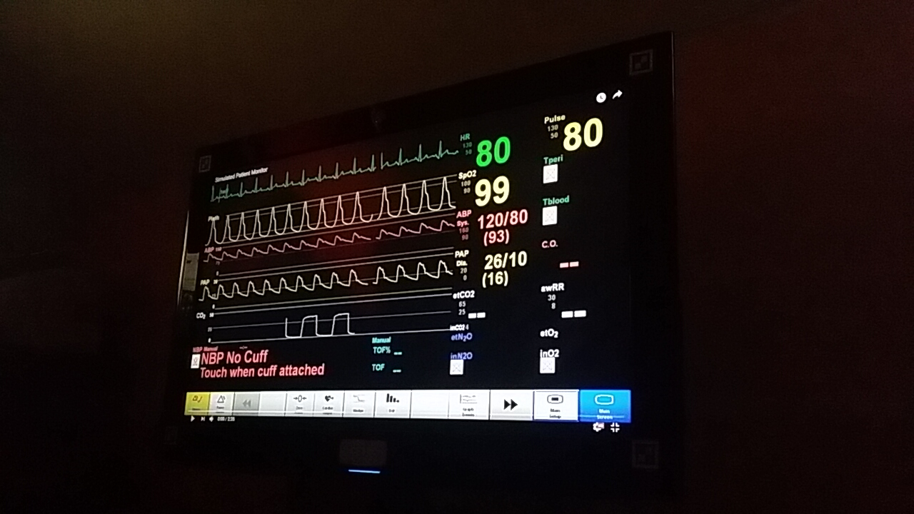

Figure Captured scene from one meter with light off under angle 45 degrees

#### Scanned parameters



Figure All scanned parameters in their bounding boxes from one meter with light off under angle 45 degree captured before acquisition process. HR; Pulse; SpO2; APB_1; APB_2

Table Size of digits for experiment from one meter with light off under angle 45 degrees

|  |  |  |
| --- | --- | --- |
| **Parameter** | **Avg. height of digit** | **Avg. width of digit** |
| **HR** | 37 | 22 |
| **Pulse** | 39 | 25 |
| **SpO2** | 37 | 22 |
| **APB_1** | 19 | 10 |
| **APB_2** | 16 | 9 |

#### Results of experiment

Table Results of experiment from one meter with light off under angle 45 degrees

|  |  |  |  |  |  |  |  |  |
| --- | --- | --- | --- | --- | --- | --- | --- | --- |
| **Parameter** | **SR** | **SRAC** | **NT** | **NR** | **DSM** | **DSMSR** | **T** | **TSR** |
| **HR** | 100 | 100 | 0 | 0 | 0 | NaN | 100 | 100 |
| **Pulse** | 98.101 | 98.101 | 1.900 | 0 | 0 | NaN | 98.101 | 100 |
| **SpO2** | 98.101 | 98.101 | 1.900 | 0 | 0 | NaN | 98.101 | 100 |
| **APB_1** | 63.924 | 68.987 | 23.418 | 0 | 0 | NaN | 76.582 | 90.083 |
| **APB_2** | 65.822 | 65.822 | 21.519 | 0 | 0 | NaN | 78.481 | 83.870 |
| **Total** | **85.190** | **86.202** | **9.747** | **0** | **0** | NaN | **90.253** | **94.790** |

#### Conclusion

In that case Tesseract works really well. Overall success rate of Tesseract is above 94 percent and also parameter APB_2 which have low Tesseract success rate in case 9.2.3 has score above 83 percent in this test. That means if correct candidates was founded in ROIs, they were almost every time correctly classified. Only problem was again fulfill test conditions in 6.6.1 and 6.7.1.

### Two and half meter – light on

In this test camera was located two and half meter far from simulated patient monitor. Plane of the patient monitor was almost parallel to captured plane by camera. Light in the room was turned on. During the whole test camera and patient monitor was on the same position.

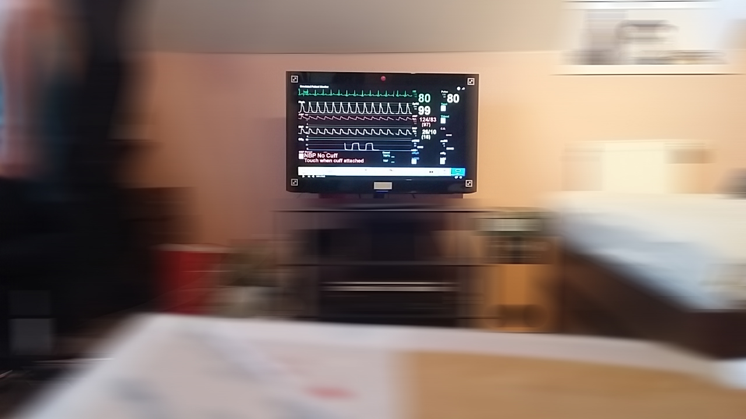

Figure Captured scene from two and half meter with light on. Surroundings was blurred because of privacy.

#### Scanned parameters



Figure All scanned parameters in their bounding boxes from two and half meter captured before acquisition process. HR; Pulse; SpO2; APB_1; APB_2

Table Size of digits for experiment from two and half meter with light on

|  |  |  |
| --- | --- | --- |
| **Parameter** | **Avg. height of digit** | **Avg. width of digit** |
| **HR** | 15 | 9 |
| **Pulse** | 16 | 10 |
| **SpO2** | 15 | 6 |
| **APB_1** | 7 | 4 |
| **APB_2** | 6 | 4 |

#### Results of experiment

Table Results of experiment from two and half meter with light on

|  |  |  |  |  |  |  |  |  |
| --- | --- | --- | --- | --- | --- | --- | --- | --- |
| **Parameter** | **SR** | **SRAC** | **NT** | **NR** | **DSM** | **DSMSR** | **T** | **TSR** |
| **HR** | 59.494 | 59.494 | 8.861 | 27.848 | 0 | NaN | 63.291 | 94 |
| **Pulse** | 20.886 | 20.886 | 63.291 | 1.899 | 0 | NaN | 34.810 | 60 |
| **SpO2** | 20.886 | 20.886 | 67.089 | 0.633 | 0 | NaN | 32.279 | 64.706 |
| **APB_1** | 0 | 0 | 99.367 | 0 | 0 | NaN | 0.633 | 0 |
| **APB_2** | 0 | 0 | 99.367 | 0 | 0 | NaN | 0.633 | NaN |
| **Total** | **20.253** | **20.253** | **67.595** | **6.076** | **0** | NaN | **26.329** | **54.677** |

#### Conclusion

Overall success rate of this test is really low. At first the success rate of APB_1 and APB_2 is equal to zero. These parameters are hardly recognizable by human as you can see in Figure 57. And they are connected all the time, so they don’t fulfill test conditions in 6.6.1 and 6.7.1. Also three first parameters looks really bad for classification and they don’t fulfill these test conditions. In the end that means we need a better camera or data acquisition from this distance is useless.

### One meter – light on - cover

In this test camera was located one meter far from simulated patient monitor. Plane of the patient monitor was almost parallel to captured plane by camera. Light in the room was turned on. During the whole test camera was covered three times, over all for 25% of simulation time.

#### Scanned parameters

Scanned parameters is very similar to parameters in 9.2.1.1.

#### Results of experiment

For this experiment was calculated one extra outcome. This outcome is success rate after correction only when patient monitor is exposed.

|  |  |  |
| --- | --- | --- |
|  |  |  |

Table Results of experiment from one meter with light on and covering the patient monitor screen three times during the experiment

|  |  |  |  |  |  |  |  |  |  |
| --- | --- | --- | --- | --- | --- | --- | --- | --- | --- |
| **Parameter** | **SR** | **SRAC** | **NT** | **NR** | **DSM** | **DSMSR** | **T** | **TSR** | **SRACE** |
| **HR** | 67.089 | 67.089 | 31.012 | 0 | 0 | NaN | 68.987 | 97.248 | 89.452 |
| **Pulse** | 70.253 | 70.253 | 24.051 | 0 | 0 | NaN | 75.949 | 92.500 | 92.500 |
| **SpO2** | 29.747 | 29.747 | 26.582 | 0 | 37.342 | 64.407 | 36.075 | 82.456 | 39.663 |
| **APB_1** | 0 | 30.380 | 43.038 | 0 | 0 | NaN | 56.962 | 53.333 | 40.507 |
| **APB_2** | 64.557 | 64.557 | 25.949 | 0 | 0 | NaN | 74.051 | 87.179 | 86.079 |
| **Total** | **46.329** | **57.215** | **30.127** | **0** | **7.468** | **64.407** | **62.405** | **82.543** | **69.640** |

Graph Absolute success rate throughout the experiment from one meter with light on and covering the patient monitor screen three times during the experiment

#### Conclusion

As you can see in Table 12 total outcome of NT is equal approximately to 30. That’s fine because 25 is the minimal value, because monitor was covered for 25% time of the simulation. NT value for Pulse parameter is lower than 25 by one percent. That is because something in thing which cover the monitor fulfill test conditions in 6.6.1 and 6.7.1 for limited time.

Overall success is equal to 46 percent, if we recalculate this value to monitor without covering the success rate is equal approximately to 70 percent. This result is that low because application need some time to recalibration and also some parameters doesn’t have good success rate from Tesseract and difference with mask. For example success rate of DSM of parameter APB_1 is only 64%.

From graph Graph 1 you can see that regular success rate of exposed patient monitor is between 60 and 100 percent. If monitor, or camera, is covered by something success rate is equal to 0. That trend occurs three times during the simulation.

### One meter – light on - move

In this test camera was located one meter far from simulated patient monitor. Light in the room was turned on. During the whole test patient monitor screen plane was rotated around vertical axis between 0 to 45 degrees. This angle is between plane of patient monitor screen and plane captured by camera.

#### Scanned parameters

Scanned parameters is combination between 9.2.1.1 and 9.2.2.1 during the experiment. It depend on the actual angle of patient monitor screen.

#### Results of experiment

Table Results of experiment from one meter with light on and moving with patient monitor between angle 0-45 degrees during the whole experiment

|  |  |  |  |  |  |  |  |  |
| --- | --- | --- | --- | --- | --- | --- | --- | --- |
| **Parameter** | **SR** | **SRAC** | **NT** | **NR** | **DSM** | **DSMSR** | **T** | **TSR** |
| **HR** | 53.165 | 53.165 | 27.215 | 0 | 0 | NaN | 72.785 | 73.043 |
| **Pulse** | 61.392 | 61.392 | 16.456 | 0 | 0 | NaN | 83.544 | 73.485 |
| **SpO2** | 74.684 | 74.684 | 0 | 0 | 5.696 | 33.334 | 39.873 | 79.194 |
| **APB_1** | 2.532 | 9.493 | 56.329 | 3.165 | 0.633 | 0 | 39.873 | 23.810 |
| **APB_2** | 4.430 | 4.430 | 55.063 | 2.532 | 1.266 | 0 | 41.139 | 11.112 |
| **Total** | **39.240** | **41.013** | **31.013** | **1.139** | **1.519** | **11.111** | **66.329** | **52.129** |

#### Conclusion

From Table 13 is evident that success rate of all parameters is low. That’s caused by actual moving with patient monitor during the whole simulation. If we look at example in Figure 58 everything is now clearer. Symbols are connected and also doesn’t have its specific characteristics. If move is relatively slow, application still can recognize candidates for digits and send them to classifier.

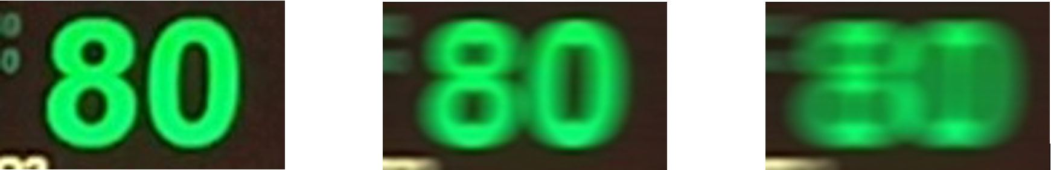

Figure Captured digit in static scene; Captured digit during gently moving with patient monitor or camera; Captured digit during quick moving with patient monitor or camera

### One meter – light on – move/pause

In this test camera was located one meter far from simulated patient monitor. Light in the room was turned on. During the test monitor screen plane was rotated three times around vertical axis between 0 to 45 degrees. This angle is between plane of patient monitor screen and plane captured by camera.

#### Scanned parameters

Scanned parameters is combination between 9.2.1.1 and 9.2.2.1 during the experiment. It depend on the actual angle of patient monitor screen.

#### Results of experiment

Table Results of experiment from one meter with light on and moving with patient monitor between angles 0-45 degrees three times during the experiment

|  |  |  |  |  |  |  |  |  |
| --- | --- | --- | --- | --- | --- | --- | --- | --- |
| **Parameter** | **SR** | **SRAC** | **NT** | **NR** | **DSM** | **DSMSR** | **T** | **TSR** |
| **HR** | 81.646 | 81.656 | 13.924 | 0 | 0 | NaN | 86.076 | 94.853 |
| **Pulse** | 79.114 | 79.114 | 17.722 | 0 | 0 | NaN | 82.278 | 96.154 |
| **SpO2** | 86.076 | 86.076 | 0 | 0 | 11.392 | 33.334 | 88.608 | 97.143 |
| **APB_1** | 37.975 | 49.367 | 17.0886 | 0 | 0 | NaN | 82.911 | 59.542 |
| **APB_2** | 61.392 | 61.392 | 21.519 | 0 | 0 | NaN | 78.481 | 78.226 |
| **Total** | **69.241** | **72.278** | **14.051** | **0** | **2.278** | **33.334** | **83.671** | **85.183** |

Graph Absolute success rate throughout the experiment from one meter with light on and moving with patient monitor between angles 0-45 degrees three times during the experiment

#### Conclusion

At first from Graph 2 you can see that regular success rate of exposed patient monitor is between 60 and 100 percent. If monitor is moving success rate fall down. That trend occurs three times during the simulation.

As you can see in Table 14 parameter SpO2 have candidates for digits for the whole simulation. But almost same amount of NoText for HR, or Pulse, fall for SpO2 in difference by stored mask, because candidates didn’t have sufficient quality for Tesseract.

## Performance

All experiments was tested on personal computer with CPU Intel(R) Xeon(R) CPU E3-1231 v3 @ 3.40GHz (8CPUs) and 16384MB ram. This processor has performance equal to 4.35 GFLOPS per core [76]. In upcoming graphs you can see the CPU load and memory usage in different situations.

### One meter – light on

Performance shown below was tested on experiment similar to 9.2.1.

#### CPU load

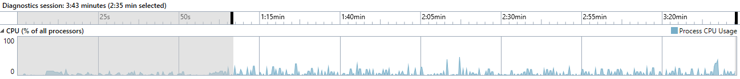

Graph CPU load of all processors during the experiment from one meter with light on. Gray area is CPU load during the calibration and after the experiment

As I mentioned before data are classified at concrete ticks. As you can see in selected area these ticks correspond to peaks. These peaks have high between 8-30%. Their average value is approximately 18%. If no tick is detected the usage of monitor is close to zero. That means detection of change and connected processes are really low CPU consuming.

CPU load for situations during the low light conditions and from different angle is quite similar.

#### Memory usage

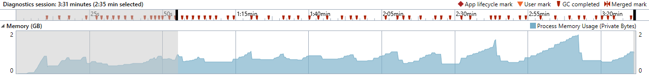

Graph Memory usage for experiment from one meter with light on. Gray area is memory usage during the calibration and after the experiment

In this graph you can see that the amount of memory used during the acquisition process is relatively high. But when we look at documentation of C# garbage collector we can found that *Garbage collection occurs when the system has low physical memory* [73]*.* That means if we have less psychical memory on our system, garbage collector tries to solve this problem by suitable calling of itself. Because of that I don’t show memory usage for following performance tests.

All usage of garbage collector are shown in Graph 4 on time axis above the memory usage by red mark.

### One meter – light on – cover

Performance shown below was tested on experiment similar to 9.2.6. Time of covering is 1:20-1:40 and 1:50-2:10.

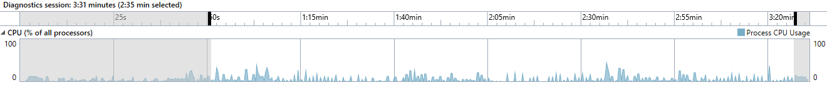

Graph CPU load of all processors during the experiment from one meter with light on and covering of patient monitor screen two times during the experiment. Gray area is CPU load during the calibration and after the experiment

In Graph 5 above you can see that there isn’t any magnificent difference in CPU load when monitor is covered by something. Peaks have similar height as in case 9.3.1.

### One meter – light on – move

Performance shown below was tested on experiment similar to 9.2.8. Time of moving is 1:10-1:30 and 2:00-2:20.

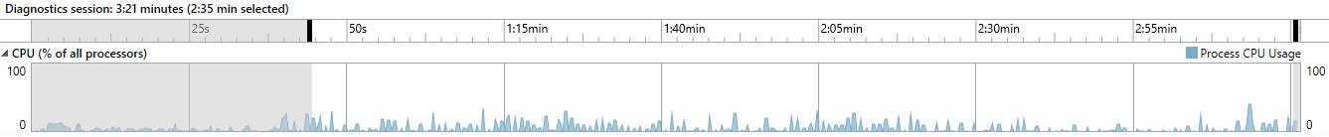

Graph CPU load of all processors during the experiment from one meter with light on and moving patient monitor two times during the experiment. Gray area is CPU load during the calibration and after the experiment

From Graph 6 we can see that peaks have similar height as in previous cases 9.3.1 and 9.3.2. When user move with patient monitor no magnificent difference in CPU load appears. Only peaks are little bit wider, but no so significantly.

# Conclusion

In this thesis I designed two approaches how to acquire data, especially digits, from patient monitor. As a final approach which was implemented as a standalone application was selected digits based approach. This approach was primary selected because it can be used for data acquisition when light conditions in the room, where patient monitor is located, is low. Compared to that monitor based approach need distinguishable borders of the patient monitor screen during the whole acquisition process, which are in case of low light conditions in the room unrecognizable.

During the design of approaches was mentioned and tested several methods. All of these methods were applied on scenes with patient monitor. After this I discuss suitability of these methods for data acquisition from patient monitor. For selected approach was selected the best suitable methods. These methods give us best results in concrete step of the approach or it’s the best solution for used programing language and libraries.

Data acquisition from patient monitor via camera is suitable solution, but there are few conditions which must be met. At first it’s a resolution of obtained digits. If we don’t have appropriate resolution and separable digits, application doesn’t work well. This can be achieved through different things. First of them is small distance of camera to patient monitor. As you can see in tests from one meter, success rate of these test are relatively high. In fact that means camera should be placed on a tripod close to patient monitor, but this is a bad solution, because tripod will bother personnel during the work. Other solution is handle mounted straight on the patient monitor. This handle will capture data from the top of the patient monitor. Second possible way how to achieve appropriate resolution is use of high quality camera. In that case we can capture patient monitor from a distance. In my opinion if we spend money for high quality camera we can spend them rather for video grabbers. Obtained video signal from them isn’t burdened by any distortion. That results in better quality of classification. With a small recode of the implemented application, application can be applied on video signal obtained by grabbers and we get universal acquisition tool.

Application was tested also for classical situations in room where monitor is located. These situation are covering of the patient monitor, moving with monitor and moving with monitor when monitor is covered. Covering of the monitor work quite well, unless the thing which cover the monitor doesn’t contain candidates for digits. Second situation is solved relatively well if moving with monitor is gently. The last situation is solved in beta backup process. This process have several problems and in real situations won’t work well. Because of that I suggested certain extensions.

These extension are combination of these two approaches in one, because each of them is better in some situations. For example monitor based approach has no problem with move of monitor while something covering it. Also curve acquisition is an important part of data shown on patient monitor screen, which we want to store. As a last one is there multi-camera approach which give us more robust results.

In the end I have to say that data acquisition from patient monitor via camera is possible and suitable, but the results are highly dependent on quality of captured video and situation in the scene. Because of that in my opinion there are better possibilities how to obtain data from patient monitor. They are more expensive but more robust and cable is cable. Finally, these data is about our health and they should be, if possible, the best possible.

# References

[1] Zákon č. 268/2014 Sb., Zákon o zdravotnických prostředcích a o změně zákona č. 634/2004 Sb., o správních poplatcích, ve znění pozdějších předpisů

[2] Bionet BM5 (2012) Available at: http://www.kardiobtl.cz/download/1322666993_a640/BM5.jpg (Accessed: 3 January 2017).

[3] Promos spol. S r.o. - iM20 (2016) Available at: http://www.promos-vm.cz/im20.php (Accessed: 3 January 2017).

[4] technika, B. zdravotnická (2016) BTL získala certifikaci ISO 9001 a 13485. Available at: http://www.kardiobtl.cz/produkty/pacientske-monitory/bionet-bm3-plus/ (Accessed: 3 January 2017).

[5] ARO - DIP | ARO (2015) Available at: http://aro.fnplzen.cz/sites/default/files/users/aro/IMG_6771.jpg (Accessed: 3 January 2017).

[6] N, K.P. (2016) View details of Philips IntelliBridge enterprise. Available at: http://www.usa.philips.com/healthcare/product/HC830070/intellibridge-enterprise-interoperability-solution (Accessed: 3 January 2017).

[7] MediCollector (2014) Record bedside patient monitor vital signs data. Available at: http://www.medicollector.com/ (Accessed: 3 January 2017).

[8] Guo, F. and Loparo, K.A. (2014) Development of the real-time data acquisition system for Philips patient. Available at: https://etd.ohiolink.edu/!etd.send_file?accession=case1405963966&disposition=inline (Accessed: 3 January 2017).

[9] Rockstroh, M., Wittig, M., Franke, S., Meixensberger, J. and Neumuth, T. (2015) Video-based detection of device interaction in the operating room, Biomedizinische Technik. Biomedical engineering, 61(5), pp. 567–576.

[10] Copyright (2002) Gynecological ultrasound video capture and storage. Available at: https://www.epiphan.com/solutions/high-resolution-ultrasound-video-capture-using-epiphan-video-grabbers/ (Accessed: 3 January 2017).

[11] GitHub (2016) Tesseract-ocr. Available at: https://github.com/tesseract-ocr (Accessed: 3 January 2017).

[12] tesseract-ocr (2016) Tesseract-ocr/tesseract. Available at: https://github.com/tesseract-ocr/tesseract/wiki/ImproveQuality (Accessed: 3 January 2017).

[13] Collins, Robert (2015) Lecture 6: Harris Corner Detector, CSE486, Penn State.

[14] Parks, D., Gravel, J. (2002) Corner Detectors, Available at: <http://www.cim.mcgill.ca/~dparks/CornerDetector/index.htm> (Accessed: 8 December 2016)

[15] HÝNA, Petr. Detekce rohů v obraze. [s.l.], 2007. 54 s. VUT Brno. Bakalářská práce.

[16] MathWorks, T. (1998) Makers of MATLAB and Simulink - MATLAB & Simulink. Available at: http://www.mathworks.com/ (Accessed: 3 January 2017).

[17] 09gr820 (2009) Line detection by Hough transformation. Available at: http://web.ipac.caltech.edu/staff/fmasci/home/astro_refs/HoughTrans_lines_09.pdf (Accessed: 3 January 2017).

[18] J. Matthews., L. G. Roberts (2002) An introduction to edge detection: The sobel edge detector. Available at: [**http**://www.generation5.org/content/2002/im01.asp](http://www.generation5.org/content/2002/im01.asp) (Accessed: 6 December 2016)

[19] Bradley, D. and Roth, G. (2007) Adaptive Thresholding using the integral image, Journal of Graphics, GPU, and Game Tools, 12(2), pp. 13–21.

[20] Haralick, Robert M., and Linda G. Shapiro, Computer and Robot Vision, Volume I, Addison-Wesley, 1992, pp. 28-48.

[21] R. Hartley and A. Zisserman. Multiple View geomerty in Computer Vision. Cambridge University Press, second edition, 2003

[22] Dubrofsky, E. (2007) Homography estimation, Carleton University. Available at: https://www.cs.ubc.ca/grads/resources/thesis/May09/Dubrofsky_Elan.pdf (Accessed: 3 January 2017).

[23] Fisher, Bob (2006) Computing plane projective Transformations  Available at: http://homepages.inf.ed.ac.uk/rbf/CVonline/LOCAL_COPIES/EPSRC_SSAZ/node11.html (Accessed: 3 January 2017).

[24] S. Mori, C. Y. Suen and K. Yamamoto, "Historical review of OCR research and development," in Proceedings of the IEEE, vol. 80, no. 7, pp. 1029-1058, Jul 1992.

[25] TRIER D., ØIVIND, TAXTT, TORFINN in JAIN K., ANIL (1995) Feature extraction methods for character recognition-a survey. Oslo: Department of Informatics, University of Oslo. Available at: http://citeseerx.ist.psu.edu/viewdoc/download?doi= 10.1.1.51.7439&rep=rep1&type=pdf (Accessed: 9 November 2016)

[26] Neumann, L. (2010) Vyhledávání a rozpoznání textu v obrazech reálných scén, Czech technical university in Prague. Available at: https://cmp.felk.cvut.cz/awards/neumann-msc10.pdf (Accessed: 3 January 2017).

[27] Richards, J.A. (2012) Supervised classification techniques, in Remote Sensing Digital Image Analysis. Springer Nature, pp. 247–318.

[28] R. Smith. An Overview of the Tesseract OCR Engine, Proceedings of the Ninth International Conference on Document Analysis and Recognition (ICDAR 2007) Vol 2 (2007), pp. 629-633.

[29] Zanibbi, Richard “Bayesian decision Theory” CSE486, Rochester Institute of Technology. Lecture, Available at: <https://www.cs.rit.edu/~rlaz/PatternRecognition/slides/Bayesian.pdf>

[30] Koski, T. (2013) Multivariate Gaussian distribution auxiliary notes for time series analysis, SF2943 spring 2013., KTH Royal Institute of Technology, Stockholm. Available at: http://www.math.kth.se/matstat/gru/sf2943/gaussvect2943.pdf (Accessed: 3 January 2017).

[31] N. Cristianini and J. Shawe-Taylor. An introduction to Support Vector Machines. Cambridge University Press, March 2000.

[32] Wang, Z. and Xue, X. (2014) Multi-class support vector machine, in Support Vector Machines Applications. Springer Nature, pp. 23–48.

[33] Bieniecki, W., Grabowski, S. and Rozenberg, W. (2007) Image Preprocessing for improving OCR accuracy, 2007 International Conference on Perspective Technologies and Methods in MEMS Design

[34] Fast, B.B., Allen, D.R., B, B., Allen and R, D. (1995) Patent US5594815 - OCR image preprocessing method for image enhancement of scanned documents. Available at: https://www.google.com/patents/US5594815 (Accessed: 3 January 2017).

[35] Alginahi, Y. (2010) Preprocessing techniques in character recognition, in Character Recognition. InTech.

[36] Joblove, G.H. and Greenberg, D. (1978) Color spaces for computer graphics, ACM SIGGRAPH Computer Graphics, 12(3), pp. 20–25.

[37] Color and image processing (2003) Available at: http://courses.cs.vt.edu/~cs4624/s98/sspace/imgproc/ (Accessed: 3 January 2017).

[38] Forssén, P.-E. (2011) Maximally stable Colour regions for recognition and matching. Available at: http://www.cs.ubc.ca/~perfo/papers/forssen_cvpr07.pdf (Accessed: 3 January 2017).

[39] Kristensen, F., Nilsson, P. and Öwall, V. (2006) Background segmentation beyond RGB, 3852, pp. 602–612. doi: http//dx..org/10.1007/11612704_60.

[40] Converting from RGB to HSV (2005), University of Illinois at Urbana-Champaign. Available at: http://coecsl.ece.illinois.edu/ge423/spring05/group8/finalproject/hsv_writeup.pdf (Accessed: 3 January 2017).

[41] Ford, Adrian, Roberts, Alan (1998) Colour space conversions. Available at: <http://www.poynton.com/PDFs/coloureq.pdf>

[42] Jeon, G. (2013) Measuring and comparison of edge detectors in color spaces, International Journal of Control and Automation, 6(5), pp. 21–30.

[43] (2013) Miscellaneous image Transformations — OpenCV 2.4.13.2 documentation. Available at: http://docs.opencv.org/2.4/modules/imgproc/doc/miscellaneous_transformations.html#void%20cvtColor%28InputArray%20src,%20OutputArray%20dst,%20int%20code,%20int%20dstCn%29 (Accessed: 3 January 2017).

[44] Kanan C, Cottrell GW (2012) Color-to-Grayscale: Does the Method Matter in Image Recognition? PLoS ONE 7(1): e29740.

[45] Enchance contrast using histogram equalization - MATLAB histeq (2012) Available at: https://www.mathworks.com/help/images/ref/histeq.html?searchHighlight=histeq&s_tid=doc_srchtitle (Accessed: 3 January 2017).

[46] Girod, Bernd (2013) Linear image processing and filtering, Stanford university. Available at: http://web.stanford.edu/class/ee368/Handouts/Lectures/2014_Spring/Combined_Slides/8-Linear-Image-Processing-Combined.pdf (Accessed: 3 January 2017).

[47] Gvynn, Earl, F. (2017) Fourier analysis and image processing, Stowels institute for medical research. Available at: <http://research.stowers-institute.org/efg/Report/FourierAnalysis.pdf> (Accessed: 3 January 2017).

[48] Corso, Jason (2014) Linear filters and image processing, University of Michigan. Available at: <https://web.eecs.umich.edu/~jjcorso/t/598F14/files/lecture_0924_filtering.pdf> (Accessed: 3 January 2017).

[49] (2010) Image filtering, The University of Auckland. Available at: https://www.cs.auckland.ac.nz/courses/compsci373s1c/PatricesLectures/Image%20Filtering_2up.pdf (Accessed: 3 January 2017).

[50] Poppe, Ronald (2015) Segmentation, University Utrecht. Available at: http://www.cs.uu.nl/docs/vakken/ibv/reader/chapter10.pdf (Accessed: 3 January 2017).

[51] J. Matas, Robust wide-baseline stereo from maximally stable extremal regions, Image Vis. Comput., vol. 22, no. 10, pp. 761–767, Sep. 2004

[52] Greenhalgh, J. and Mirmehdi, M. (2012) Real-time detection and recognition of road traffic signs, IEEE Transactions on Intelligent Transportation Systems, 13(4), pp. 1498–1506.

[53] Detect MSER features and return MSERRegions object - MATLAB detectMSERFeatures (2012) Available at: https://www.mathworks.com/help/vision/ref/detectmserfeatures.html (Accessed: 3 January 2017).

[55] Morse, Bryan, S. (2000) Lecture4: Thresholding, Brigham Youth University. Available at: http://homepages.inf.ed.ac.uk/rbf/CVonline/LOCAL_COPIES/MORSE/threshold.pdf (Accessed: 3 January 2017).

[56] Otsu, N. (1979) A threshold selection method from gray-level Histograms, 9(1), pp. 62–66.

[57] Wellner, P.D. (1993) Adaptive Thresholding for the DigitalDesk.

[58] Emgu CV: OpenCV in .NET (C#, VB, C++ and more) (2008) Available at: http://www.emgu.com/ (Accessed: 3 January 2017).

[59] Sinha, U. (2016) Connected component Labelling: Pixel neighbourhoods and connectedness - AI Shack - tutorials for OpenCV, computer vision, deep learning, image processing, neural networks and artificial intelligence. Available at: http://www.aishack.in/tutorials/pixel-neighbourhoods-connectedness/ (Accessed: 3 January 2017).

[60] CS/BIOEN 4640 (2012) Morphological Operators, The University of Utah, Available at: http://www.coe.utah.edu/~cs4640/slides/Lecture11.pdf (Accessed: 3 January 2017).

[61] CSV, comma separated values (RFC 4180) (2012) Available at: http://www.digitalpreservation.gov/formats/fdd/fdd000323.shtml (Accessed: 3 January 2017).

[62] Bioengineering i6460 Bioelectricity (2012) The University of Utah. Available at: http://www.sci.utah.edu/~macleod/bioen/be6460/notes/W12-ECG.pdf (Accessed: 3 January 2017).

[63] Vaingast, S. (2015) Im2graph. Available at: http://www.im2graph.co.il/ (Accessed: 3 January 2017).

[64] Rohatgi, A. (2010) WebPlotDigitizer - extract data from plots, images, and maps. Available at: http://arohatgi.info/WebPlotDigitizer/ (Accessed: 3 January 2017).

[65] Epshtein, B., Wexler, Y. and Ofek, E. (2010) Stroke width transform - Microsoft research. Available at: https://www.microsoft.com/en-us/research/publication/stroke-width-transform/ (Accessed: 3 January 2017).

[66] Keogh, Emonn, Time series, University of Califormia (Accessed: 24 November 2016).

[67] McKenna, Frank, Thin-client vs fat-client computing (2002) Knowledgeone Corporation, Available at: http://www.knowledgeonecorp.com/news/pdfs/Thin%20client%20vs%20Fat%20client%20Computing.pdf (Accessed: 3 January 2017).

[68] Joseph, Davies G., Thomas, Lee F., Microsoft Windows Server 2003 TCP/IP Protocols and Services

[69] Project, M. (2014) C# compiler. Available at: http://www.mono-project.com/docs/about-mono/languages/csharp/ (Accessed: 3 January 2017).

[70] Raspberry Pi (2017) in Wikipedia. Available at: https://en.wikipedia.org/wiki/Raspberry_Pi (Accessed: 3 January 2017).

[71] DirectShowNet library (2005) Available at: http://directshownet.sourceforge.net/ (Accessed: 3 January 2017).

[72] Medical, L. (2010) Products and promotions. Available at: http://www.laerdal.com/ (Accessed: 3 January 2017).

[73] Microsoft (2011) Fundamentals of garbage collection. Available at: https://msdn.microsoft.com/en-us/library/ee787088(v=vs.110).aspx (Accessed: 3 January 2017).

[74] Gibbs, Samuel (2015-02-18). Raspberry Pi becomes best selling British computer, The Guardian. (Retrieved : 28 December 2016).

[75] Ltd, P.F. (2009) *A comprehensive raspberry pi 3 benchmark*. Available at: https://www.element14.com/community/community/raspberry-pi/blog/2016/02/29/the-most-comprehensive-raspberry-pi-comparison-benchmark-ever (Accessed: 4 January 2017).

[76] Sebastien (2015) *CPU performance*. Available at: http://wuprop.boinc-af.org/cpu_list.php (Accessed: 4 January 2017).